Pyvot QA Assignment — BUGGY Defect & Observation Log

Purpose
This document records defects and observations identified by comparing the BUGGY Toolshop application/API against the CLEAN environment, which is treated as the behavioral oracle.
The purpose of this analysis is to distinguish:
- genuine reproducible regressions,
- cascading automated test failures caused by a single root cause,
- documentation discrepancies,
- and behavioral/data differences that do not yet have enough evidence to be classified as defects.
The current findings are based on manual CLEAN-vs-BUGGY API comparison and the Playwright regression execution.

BUG-001 — Product API omits in_stock field
Classification: Confirmed Defect
Severity: High
Priority: High
Area: Product API / Response Contract
Endpoint: GET /products
Environment: BUGGY
Reproducibility: Consistently reproducible

Description
The BUGGY version of the Product API does not return the in_stock boolean field that is present in the CLEAN API response.
The CLEAN environment establishes in_stock as part of the product response contract and returns it as either:
"in_stock": true
or:
"in_stock": false
In the BUGGY environment, product objects instead contain a numeric stock field, for example:
"stock": 11
but the in_stock field is completely absent.
This causes consumers that rely on the established CLEAN API contract to be unable to determine product stock state using in_stock.

Preconditions
- CLEAN API is accessible.
- BUGGY API is accessible.
- Product data is available through GET /products.

Steps to Reproduce
- Send a GET /products request to the CLEAN API.
- Inspect any standard non-rental product, such as Combination Pliers or Sledgehammer.
- Observe that the response contains an in_stock boolean field.
- Send the same GET /products request to the BUGGY API.
- Inspect a product with available stock.
- Observe that the response contains a numeric stock value but does not contain in_stock.

Expected Result
BUGGY should preserve the product response contract established by CLEAN and return the in_stock boolean field.
Example:
{
"name": "Sledgehammer",
"is_rental": false,
"co2_rating": "D",
"in_stock": true
}

Actual Result
BUGGY returns a stock quantity but omits the in_stock property.
Example pattern:
{
"name": "Sledgehammer",
"stock": 11,
"is_rental": 0,
"co2_rating": "D"
}

Impact
This is a high-impact API contract regression because several automated flows dynamically discover valid products using the CLEAN contract:
p.in_stock
Because p.in_stock is undefined in BUGGY, product discovery fails even when the product has available stock.
This causes cascading failures in several areas, including:
- cart scenarios,
- quantity boundary tests,
- checkout setup,
- invoice setup,
- financial validation,
- discount scenarios,
- and UI flows that depend on API-created test data.
These cascading failures should not be counted as separate defects when they share this same root cause.

Automation Evidence
Representative failure:
No in-stock, non-rental product found.
or:
No non-eco, in-stock, non-rental product found.
The automated helper should not be changed from p.in_stock to p.stock > 0 simply to make BUGGY tests pass, because doing so would hide the regression in the BUGGY response contract.

Screenshot Evidence
Screenshot 1 — CLEAN GET /products response
Attach screenshot showing product response containing in_stock: true/false.
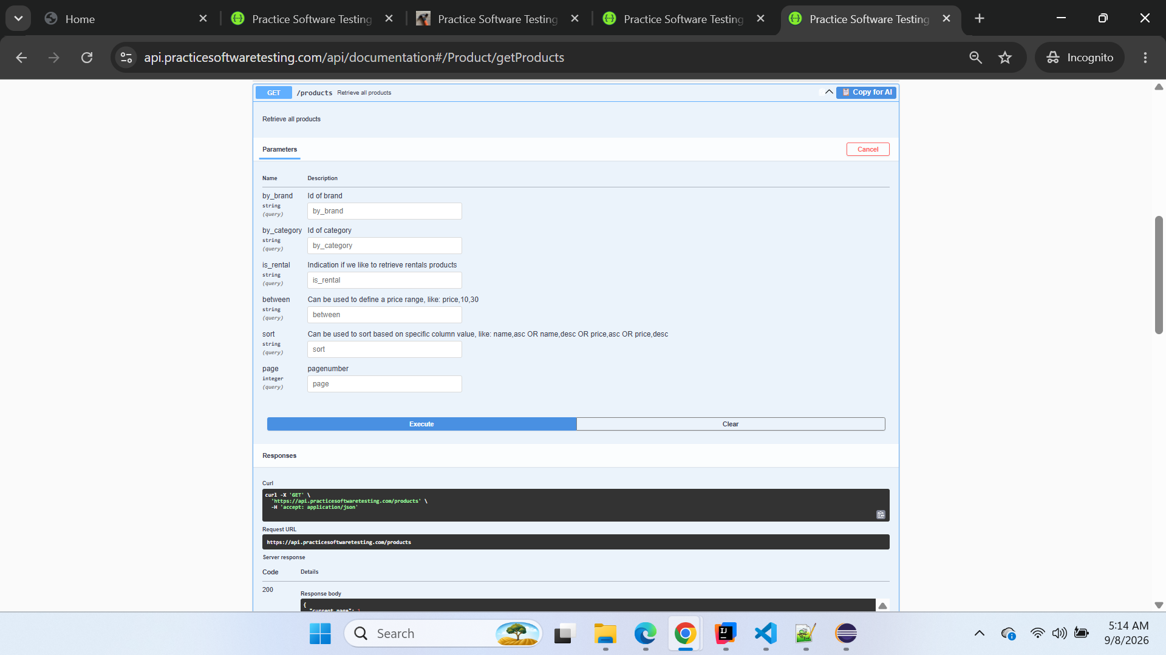

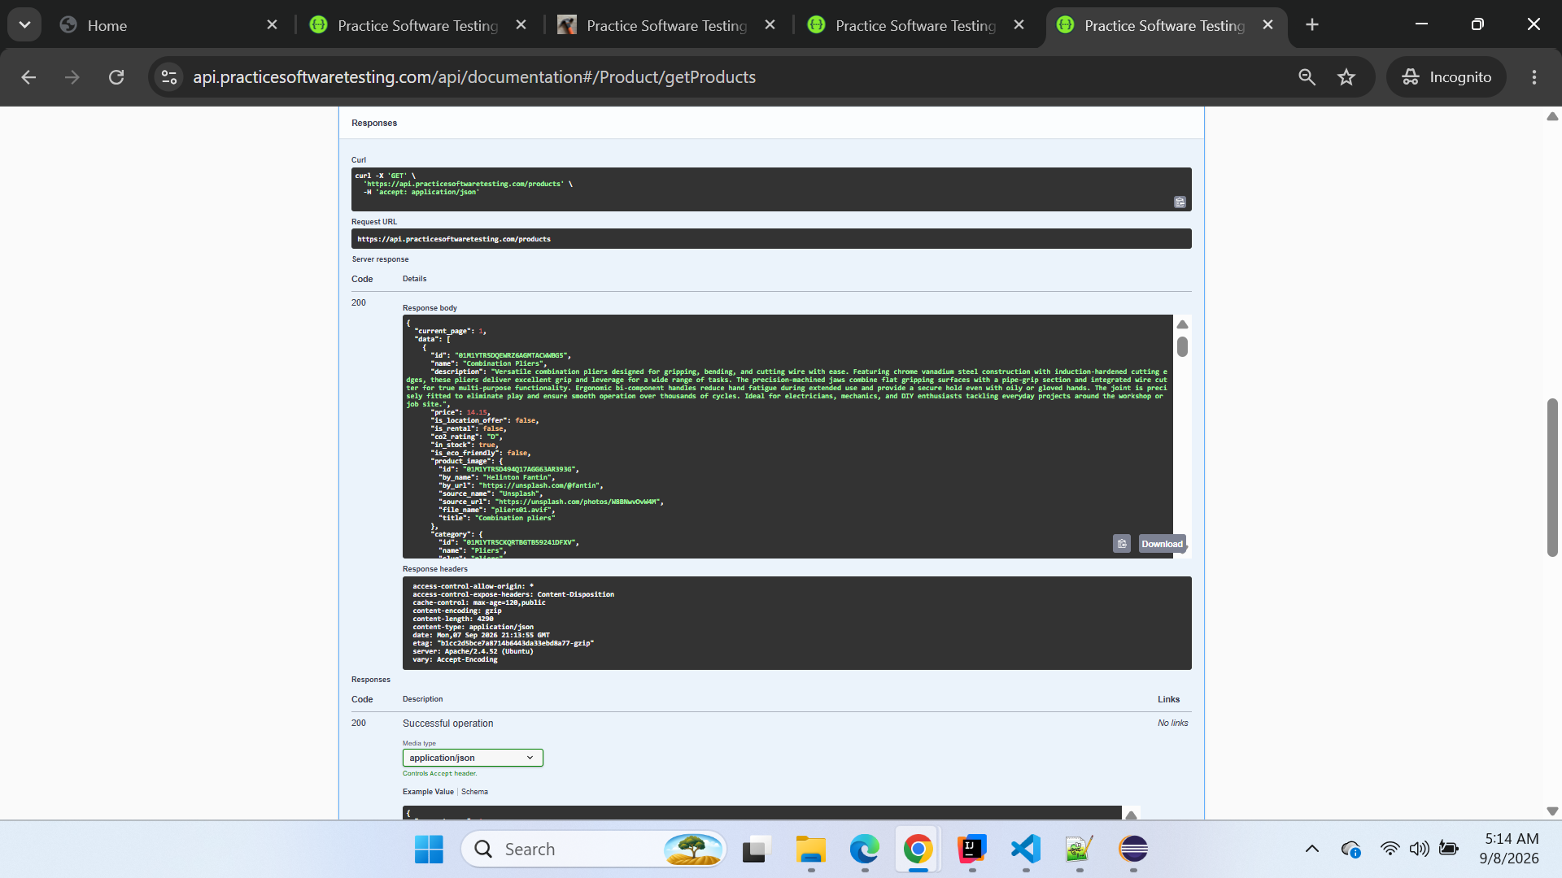

Code | Details
200 | Response body  Download  {  "current_page": 1,  "data": [  {  "id": "01M1YTR5DQEWRZ6AGMTACWWBG5",  "name": "Combination Pliers",  "description": "Versatile combination pliers designed for gripping, bending, and cutting wire with ease. Featuring chrome vanadium steel construction with induction-hardened cutting edges, these pliers deliver excellent grip and leverage for a wide range of tasks. The precision-machined jaws combine flat gripping surfaces with a pipe-grip section and integrated wire cutter for true multi-purpose functionality. Ergonomic bi-component handles reduce hand fatigue during extended use and provide a secure hold even with oily or gloved hands. The joint is precisely fitted to eliminate play and ensure smooth operation over thousands of cycles. Ideal for electricians, mechanics, and DIY enthusiasts tackling everyday projects around the workshop or job site.",  "price": 14.15,  "is_location_offer": false,  "is_rental": false,  "co2_rating": "D",  "in_stock": true,  "is_eco_friendly": false,  "product_image": {  "id": "01M1YTR5D494Q17AGG63AR393G",  "by_name": "Helinton Fantin",  "by_url": "https://unsplash.com/@fantin",  "source_name": "Unsplash",  "source_url": "https://unsplash.com/photos/W8BNwvOvW4M",  "file_name": "pliers01.avif",  "title": "Combination pliers"  },  "category": {  "id": "01M1YTR5CKQRTBGTB59241DFXV",  "name": "Pliers",  "slug": "pliers"  },  "brand": {  "id": "01M1YTR506NYHVR3Z08J2NS8HV",  "name": "ForgeFlex Tools"  }  },  {  "id": "01M1YTR5DWHXGCSPJZ1P8ANHV9",  "name": "Pliers",  "description": "Reliable general-purpose pliers crafted from drop-forged carbon steel for long-lasting durability in demanding working conditions. The serrated jaws provide a firm grip on a variety of materials including wire, nails, small fasteners, and irregularly shaped objects. Comfortable rubber-coated handles absorb vibration and reduce hand fatigue during extended use, while the non-slip surface ensures confident handling. The precision pivot joint maintains alignment under load, delivering smooth, controlled jaw action with every squeeze. Heat-treated steel construction resists wear and deformation even under heavy use. A must-have foundational tool for any workshop, equally suited for professional tradespeople and home repair projects.",  "price": 12.01,  "is_location_offer": false,  "is_rental": false,  "co2_rating": "D",  "in_stock": true,  "is_eco_friendly": false,  "product_image": {  "id": "01M1YTR5D494Q17AGG63AR393H",  "by_name": "Everyday basics",  "by_url": "https://unsplash.com/@zanardi",  "source_name": "Unsplash",  "source_url": "https://unsplash.com/photos/I8eTuMmxIfo",  "file_name": "pliers02.avif",  "title": "Pliers"  },  "category": {  "id": "01M1YTR5CKQRTBGTB59241DFXV",  "name": "Pliers",  "slug": "pliers"  },  "brand": {  "id": "01M1YTR506NYHVR3Z08J2NS8HV",  "name": "ForgeFlex Tools"  }  },  {  "id": "01M1YTR5E0V379SPB8JS4PF0R9",  "name": "Bolt Cutters",  "description": "Heavy-duty bolt cutters engineered to slice through hardened bolts, chains, padlocks, and wire fencing with minimal effort. The compound leverage mechanism multiplies your cutting force by a factor of 30, enabling clean cuts through materials up to 10mm in diameter. Hardened alloy steel blades are precisely ground and heat-treated to maintain a sharp edge through years of repeated use on tough materials. Ergonomic rubber grips and the generous 750mm handle length provide excellent control, leverage, and reach during overhead or awkward-angle cuts. An adjustable blade tension screw lets you fine-tune the jaw alignment for optimal cutting performance. Built for demolition crews, locksmiths, fencing contractors, and maintenance professionals who need reliable cutting power day after day.",  "price": 48.41,  "is_location_offer": true,  "is_rental": false,  "co2_rating": "D",  "in_stock": true,  "is_eco_friendly": false,  "product_image": {  "id": "01M1YTR5D494Q17AGG63AR393J",  "by_name": "Michael Dziedzic",  "by_url": "https://unsplash.com/@lazycreekimages",  "source_name": "Unsplash",  "source_url": "https://unsplash.com/photos/pM9pkc9J918",  "file_name": "pliers03.avif",  "title": "Bolt cutters"  },  "category": {  "id": "01M1YTR5CKQRTBGTB59241DFXV",  "name": "Pliers",  "slug": "pliers"  },  "brand": {  "id": "01M1YTR506NYHVR3Z08J2NS8HW",  "name": "MightyCraft Hardware"  }  },  {  "id": "01M1YTR5E3M7FW3ENVAXHTZZ78",  "name": "Long Nose Pliers",  "description": "Precision long nose pliers with narrow tapered jaws designed for reaching into tight, confined spaces and bending fine wire with accuracy. Made from chrome vanadium steel with induction-hardened cutting edges that cleanly sever copper, brass, and steel wire without crushing or fraying. The slim jaw profile tapers to a fine point, making these pliers indispensable for electrical terminal work, jewelry making, and intricate mechanical repairs. Bi-component comfort grips minimize hand strain during detailed tasks requiring a steady hand and controlled pressure. The leaf-spring joint returns the handles to the open position automatically, speeding up repetitive tasks. A must-have precision tool trusted by electricians, electronics technicians, and hobbyists worldwide.",  "price": 14.24,  "is_location_offer": false,  "is_rental": false,  "co2_rating": "D",  "in_stock": false,  "is_eco_friendly": false,  "product_image": {  "id": "01M1YTR5D494Q17AGG63AR393K",  "by_name": "Brett Jordan",  "by_url": "https://unsplash.com/@brett_jordan",  "source_name": "Unsplash",  "source_url": "https://unsplash.com/photos/GamuDTVm02g",  "file_name": "pliers04.avif",  "title": "Long nose pliers"  },  "category": {  "id": "01M1YTR5CKQRTBGTB59241DFXV",  "name": "Pliers",  "slug": "pliers"  },  "brand": {  "id": "01M1YTR506NYHVR3Z08J2NS8HW",  "name": "MightyCraft Hardware"  }  },  {  "id": "01M1YTR5E6NFWQ3VTYF096HDYQ",  "name": "Slip Joint Pliers",  "description": "Adjustable slip joint pliers that feature a two-position pivot mechanism for switching between regular and wide jaw openings to accommodate different fastener sizes. The PVC-coated handles offer a comfortable, non-slip grip while the precisely machined jaws securely grasp round, flat, and hexagonal objects without slipping. Constructed from durable drop-forged carbon steel that has been heat-treated to withstand heavy daily use in professional environments. The curved jaw section grips pipes and cylindrical objects, while the flat front surface handles nuts, bolts, and sheet materials. A wire cutter integrated near the pivot handles light cutting tasks without reaching for a separate tool. Perfect for plumbing, automotive, HVAC, and general maintenance work where a single versatile gripping tool saves time.",  "price": 9.17,  "is_location_offer": false,  "is_rental": false,  "co2_rating": "D",  "in_stock": true,  "is_eco_friendly": false,  "product_image": {  "id": "01M1YTR5D494Q17AGG63AR393M",  "by_name": "Yasin Hasan",  "by_url": "https://unsplash.com/@yasin",  "source_name": "Unsplash",  "source_url": "https://unsplash.com/photos/dwlxTSpfKXg",  "file_name": "pliers05.avif",  "title": "Slip joint pliers"  },  "category": {  "id": "01M1YTR5CKQRTBGTB59241DFXV",  "name": "Pliers",  "slug": "pliers"  },  "brand": {  "id": "01M1YTR506NYHVR3Z08J2NS8HW",  "name": "MightyCraft Hardware"  }  },  {  "id": "01M1YTR5E9ZPRZ3X2N6DW2H3E4",  "name": "Claw Hammer with Shock Reduction Grip",  "description": "Ergonomic claw hammer featuring an advanced shock reduction grip system that absorbs up to 70% of impact vibrations, protecting your wrist, elbow, and shoulder during prolonged nailing sessions. The 450g carbon steel head is precision-balanced and heat-treated for maximum hardness, ensuring accurate nail driving with minimal effort on every swing. The curved claw design effortlessly removes nails without damaging surrounding wood surfaces, making it equally useful for construction and renovation work. A fiberglass-reinforced handle combines lightweight strength with exceptional durability that far outlasts traditional wooden handles. The overmolded soft-grip zone conforms to your hand shape for a custom-feeling, fatigue-free hold throughout long working days. Recommended for professional framing, carpentry, and renovation projects where operator comfort matters as much as striking performance.",  "price": 13.41,  "is_location_offer": true,  "is_rental": false,  "co2_rating": "D",  "in_stock": true,  "is_eco_friendly": false,  "product_image": {  "id": "01M1YTR5D494Q17AGG63AR393N",  "by_name": "iMattSmart",  "by_url": "https://unsplash.com/@imattsmart",  "source_name": "Unsplash",  "source_url": "https://unsplash.com/photos/jaLaLQdkBOE",  "file_name": "hammer01.avif",  "title": "Claw Hammer"  },  "category": {  "id": "01M1YTR5CJJ7KMVCPACW7J2FDS",  "name": "Hammer",  "slug": "hammer"  },  "brand": {  "id": "01M1YTR506NYHVR3Z08J2NS8HV",  "name": "ForgeFlex Tools"  }  },  {  "id": "01M1YTR5EBSMZKH9FHC67Q740E",  "name": "Hammer",  "description": "A dependable standard claw hammer suitable for driving and removing nails in everyday construction, carpentry, and home improvement projects. The 350g carbon steel head is drop-forged and heat-treated for maximum hardness, then fitted to a traditional wooden handle that provides natural shock absorption with each strike. Well-balanced weight distribution between the head and handle ensures accurate strikes with minimal wrist effort, reducing fatigue during repetitive nailing tasks. The polished face resists rust and provides a smooth surface that drives nails cleanly without leaving marks on finish materials. A gently curved claw provides reliable nail extraction leverage without excessive force. This versatile hammer belongs in every toolbox, from professional carpentry workshops to home garages and apartment maintenance kits.",  "price": 12.58,  "is_location_offer": false,  "is_rental": false,  "co2_rating": "D",  "in_stock": true,  "is_eco_friendly": false,  "product_image": {  "id": "01M1YTR5D494Q17AGG63AR393P",  "by_name": "Jozsef Hocza",  "by_url": "https://unsplash.com/@hocza",  "source_name": "Unsplash",  "source_url": "https://unsplash.com/photos/D3nouOYbALc",  "file_name": "hammer02.avif",  "title": "Hammer"  },  "category": {  "id": "01M1YTR5CJJ7KMVCPACW7J2FDS",  "name": "Hammer",  "slug": "hammer"  },  "brand": {  "id": "01M1YTR506NYHVR3Z08J2NS8HV",  "name": "ForgeFlex Tools"  }  },  {  "id": "01M1YTR5EG4SVJWNGRTH7FBB5D",  "name": "Claw Hammer",  "description": "Traditional claw hammer with a polished carbon steel head engineered for driving and removing nails with precision and confidence. The rubber-wrapped handle provides a secure, comfortable grip even in wet, dusty, or cold conditions where bare metal or wood handles would slip. At 500g, it offers the ideal balance between striking power and maneuverability for general carpentry, framing, and construction tasks. The curved claw design allows for smooth nail extraction without gouging or marring wood surfaces, protecting your finished work. The head-to-handle connection uses an epoxy-bonded wedge system that prevents loosening over time. A reliable, no-nonsense tool that professional carpenters and weekend builders alike reach for every day.",  "price": 11.48,  "is_location_offer": true,  "is_rental": false,  "co2_rating": "D",  "in_stock": true,  "is_eco_friendly": false,  "product_image": {  "id": "01M1YTR5D494Q17AGG63AR393Q",  "by_name": "Andrew George",  "by_url": "https://unsplash.com/@andrewjoegeorge",  "source_name": "Unsplash",  "source_url": "https://unsplash.com/photos/YU2mCvXR0wA",  "file_name": "hammer03.avif",  "title": "Claw Hammer"  },  "category": {  "id": "01M1YTR5CJJ7KMVCPACW7J2FDS",  "name": "Hammer",  "slug": "hammer"  },  "brand": {  "id": "01M1YTR506NYHVR3Z08J2NS8HW",  "name": "MightyCraft Hardware"  }  },  {  "id": "01M1YTR5ESH9QNRGSQJ4E7VVQ2",  "name": "Thor Hammer",  "description": "The legendary Thor Hammer combines premium craftsmanship with raw striking power in a tool that is truly built to last generations. Forged from Uru metal with a hand-wrapped leather grip, this extraordinary 5kg masterpiece delivers unmatched impact force for the most demanding demolition, forging, and heavy construction tasks. The perfectly balanced oversized head ensures every swing transfers maximum energy to the target, while the enlarged striking face covers more surface area than any conventional hammer. Despite its impressive mass, the ergonomic handle design and precise weight distribution allow for surprisingly controlled, accurate swings. This is not merely a tool but a statement piece for those who accept nothing less than the absolute best in their workshop. Comes with a lifetime warranty because true legends never fade. Please note: only one Thor Hammer is permitted per customer.",  "price": 11.14,  "is_location_offer": false,  "is_rental": false,  "co2_rating": "D",  "in_stock": true,  "is_eco_friendly": false,  "product_image": {  "id": "01M1YTR5D494Q17AGG63AR393R",  "by_name": "ANIRUDH",  "by_url": "https://unsplash.com/@lanirudhreddy",  "source_name": "Unsplash",  "source_url": "https://unsplash.com/photos/3esjG-nlgyk",  "file_name": "hammer04.avif",  "title": "Hammer"  },  "category": {  "id": "01M1YTR5CJJ7KMVCPACW7J2FDS",  "name": "Hammer",  "slug": "hammer"  },  "brand": {  "id": "01M1YTR506NYHVR3Z08J2NS8HV",  "name": "ForgeFlex Tools"  }  }  ],  "from": 1,  "last_page": 6,  "per_page": 9,  "to": 9,  "total": 50  }  Response headers  access-control-allow-origin: *  access-control-expose-headers: Content-Disposition  cache-control: max-age=120,public  content-encoding: gzip  content-length: 4290  content-type: application/json  date: Mon,07 Sep 2026 21:13:55 GMT  etag: "b1cc2d5bce7a8714b6443da33ebd8a77-gzip"  server: Apache/2.4.52 (Ubuntu)  vary: Accept-Encoding

Screenshot 2 — BUGGY GET /products response
Attach screenshot showing stock: 11 while in_stock is absent.
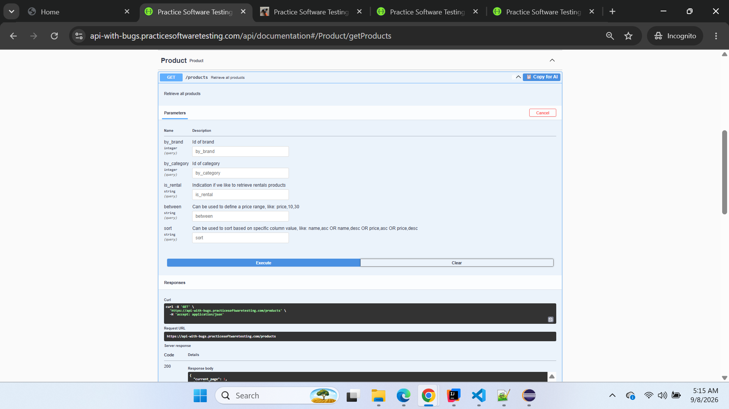

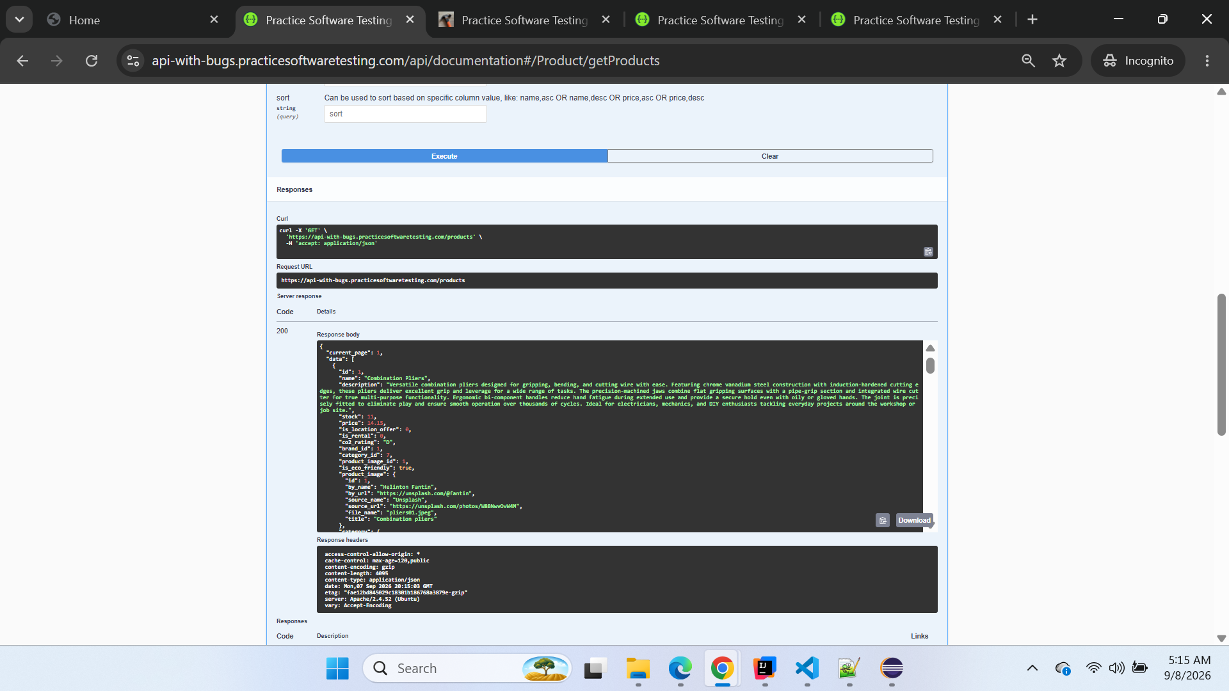

Response body
Download
{
"current_page": 1,
"data": [
{
"id": 1,
"name": "Combination Pliers",
"description": "Versatile combination pliers designed for gripping, bending, and cutting wire with ease. Featuring chrome vanadium steel construction with induction-hardened cutting edges, these pliers deliver excellent grip and leverage for a wide range of tasks. The precision-machined jaws combine flat gripping surfaces with a pipe-grip section and integrated wire cutter for true multi-purpose functionality. Ergonomic bi-component handles reduce hand fatigue during extended use and provide a secure hold even with oily or gloved hands. The joint is precisely fitted to eliminate play and ensure smooth operation over thousands of cycles. Ideal for electricians, mechanics, and DIY enthusiasts tackling everyday projects around the workshop or job site.",
"stock": 11,
"price": 14.15,
"is_location_offer": 0,
"is_rental": 0,
"co2_rating": "D",
"brand_id": 1,
"category_id": 7,
"product_image_id": 1,
"is_eco_friendly": true,
"product_image": {
"id": 1,
"by_name": "Helinton Fantin",
"by_url": "https://unsplash.com/@fantin",
"source_name": "Unsplash",
"source_url": "https://unsplash.com/photos/W8BNwvOvW4M",
"file_name": "pliers01.jpeg",
"title": "Combination pliers"
},
"category": {
"id": 7,
"parent_id": 1,
"name": "Pliers",
"slug": "pliers"
},
"brand": {
"id": 1,
"name": "Brand name 1",
"slug": "brand-name-1"
}
},
{
"id": 2,
"name": "Pliers",
"description": "Reliable general-purpose pliers crafted from drop-forged carbon steel for long-lasting durability in demanding working conditions. The serrated jaws provide a firm grip on a variety of materials including wire, nails, small fasteners, and irregularly shaped objects. Comfortable rubber-coated handles absorb vibration and reduce hand fatigue during extended use, while the non-slip surface ensures confident handling. The precision pivot joint maintains alignment under load, delivering smooth, controlled jaw action with every squeeze. Heat-treated steel construction resists wear and deformation even under heavy use. A must-have foundational tool for any workshop, equally suited for professional tradespeople and home repair projects.",
"stock": 11,
"price": 12.01,
"is_location_offer": 0,
"is_rental": 0,
"co2_rating": "D",
"brand_id": 1,
"category_id": 7,
"product_image_id": 2,
"is_eco_friendly": true,
"product_image": {
"id": 2,
"by_name": "Everyday basics",
"by_url": "https://unsplash.com/@zanardi",
"source_name": "Unsplash",
"source_url": "https://unsplash.com/photos/I8eTuMmxIfo",
"file_name": "pliers02.jpeg",
"title": "Pliers"
},
"category": {
"id": 7,
"parent_id": 1,
"name": "Pliers",
"slug": "pliers"
},
"brand": {
"id": 1,
"name": "Brand name 1",
"slug": "brand-name-1"
}
},
{
"id": 3,
"name": "Bolt Cutters",
"description": "Heavy-duty bolt cutters engineered to slice through hardened bolts, chains, padlocks, and wire fencing with minimal effort. The compound leverage mechanism multiplies your cutting force by a factor of 30, enabling clean cuts through materials up to 10mm in diameter. Hardened alloy steel blades are precisely ground and heat-treated to maintain a sharp edge through years of repeated use on tough materials. Ergonomic rubber grips and the generous 750mm handle length provide excellent control, leverage, and reach during overhead or awkward-angle cuts. An adjustable blade tension screw lets you fine-tune the jaw alignment for optimal cutting performance. Built for demolition crews, locksmiths, fencing contractors, and maintenance professionals who need reliable cutting power day after day.",
"stock": 11,
"price": 48.41,
"is_location_offer": 1,
"is_rental": 0,
"co2_rating": "D",
"brand_id": 2,
"category_id": 7,
"product_image_id": 3,
"is_eco_friendly": true,
"product_image": {
"id": 3,
"by_name": "Michael Dziedzic",
"by_url": "https://unsplash.com/@lazycreekimages",
"source_name": "Unsplash",
"source_url": "https://unsplash.com/photos/pM9pkc9J918",
"file_name": "pliers03.jpeg",
"title": "Bolt cutters"
},
"category": {
"id": 7,
"parent_id": 1,
"name": "Pliers",
"slug": "pliers"
},
"brand": {
"id": 2,
"name": "Brand name 2",
"slug": "brand-name-2"
}
},
{
"id": 4,
"name": "Long Nose Pliers",
"description": "Precision long nose pliers with narrow tapered jaws designed for reaching into tight, confined spaces and bending fine wire with accuracy. Made from chrome vanadium steel with induction-hardened cutting edges that cleanly sever copper, brass, and steel wire without crushing or fraying. The slim jaw profile tapers to a fine point, making these pliers indispensable for electrical terminal work, jewelry making, and intricate mechanical repairs. Bi-component comfort grips minimize hand strain during detailed tasks requiring a steady hand and controlled pressure. The leaf-spring joint returns the handles to the open position automatically, speeding up repetitive tasks. A must-have precision tool trusted by electricians, electronics technicians, and hobbyists worldwide.",
"stock": 0,
"price": 14.24,
"is_location_offer": 0,
"is_rental": 0,
"co2_rating": "D",
"brand_id": 1,
"category_id": 7,
"product_image_id": 4,
"is_eco_friendly": true,
"product_image": {
"id": 4,
"by_name": "Brett Jordan",
"by_url": "https://unsplash.com/@brett_jordan",
"source_name": "Unsplash",
"source_url": "https://unsplash.com/photos/GamuDTVm02g",
"file_name": "pliers04.jpeg",
"title": "Long nose pliers"
},
"category": {
"id": 7,
"parent_id": 1,
"name": "Pliers",
"slug": "pliers"
},
"brand": {
"id": 1,
"name": "Brand name 1",
"slug": "brand-name-1"
}
},
{
"id": 5,
"name": "Slip Joint Pliers",
"description": "Adjustable slip joint pliers that feature a two-position pivot mechanism for switching between regular and wide jaw openings to accommodate different fastener sizes. The PVC-coated handles offer a comfortable, non-slip grip while the precisely machined jaws securely grasp round, flat, and hexagonal objects without slipping. Constructed from durable drop-forged carbon steel that has been heat-treated to withstand heavy daily use in professional environments. The curved jaw section grips pipes and cylindrical objects, while the flat front surface handles nuts, bolts, and sheet materials. A wire cutter integrated near the pivot handles light cutting tasks without reaching for a separate tool. Perfect for plumbing, automotive, HVAC, and general maintenance work where a single versatile gripping tool saves time.",
"stock": 11,
"price": 9.17,
"is_location_offer": 0,
"is_rental": 0,
"co2_rating": "D",
"brand_id": 2,
"category_id": 7,
"product_image_id": 5,
"is_eco_friendly": true,
"product_image": {
"id": 5,
"by_name": "Yasin Hasan",
"by_url": "https://unsplash.com/@yasin",
"source_name": "Unsplash",
"source_url": "https://unsplash.com/photos/dwlxTSpfKXg",
"file_name": "pliers05.jpeg",
"title": "Slip joint pliers"
},
"category": {
"id": 7,
"parent_id": 1,
"name": "Pliers",
"slug": "pliers"
},
"brand": {
"id": 2,
"name": "Brand name 2",
"slug": "brand-name-2"
}
},
{
"id": 6,
"name": "Claw Hammer with Shock Reduction Grip",
"description": "Ergonomic claw hammer featuring an advanced shock reduction grip system that absorbs up to 70% of impact vibrations, protecting your wrist, elbow, and shoulder during prolonged nailing sessions. The 450g carbon steel head is precision-balanced and heat-treated for maximum hardness, ensuring accurate nail driving with minimal effort on every swing. The curved claw design effortlessly removes nails without damaging surrounding wood surfaces, making it equally useful for construction and renovation work. A fiberglass-reinforced handle combines lightweight strength with exceptional durability that far outlasts traditional wooden handles. The overmolded soft-grip zone conforms to your hand shape for a custom-feeling, fatigue-free hold throughout long working days. Recommended for professional framing, carpentry, and renovation projects where operator comfort matters as much as striking performance.",
"stock": 11,
"price": 13.41,
"is_location_offer": 1,
"is_rental": 0,
"co2_rating": "D",
"brand_id": 1,
"category_id": 3,
"product_image_id": 6,
"is_eco_friendly": true,
"product_image": {
"id": 6,
"by_name": "iMattSmart",
"by_url": "https://unsplash.com/@imattsmart",
"source_name": "Unsplash",
"source_url": "https://unsplash.com/photos/jaLaLQdkBOE",
"file_name": "hammer01.jpeg",
"title": "Claw Hammer"
},
"category": {
"id": 3,
"parent_id": 1,
"name": "Hammer",
"slug": "hammer"
},
"brand": {
"id": 1,
"name": "Brand name 1",
"slug": "brand-name-1"
}
},
{
"id": 7,
"name": "Hammer",
"description": "A dependable standard claw hammer suitable for driving and removing nails in everyday construction, carpentry, and home improvement projects. The 350g carbon steel head is drop-forged and heat-treated for maximum hardness, then fitted to a traditional wooden handle that provides natural shock absorption with each strike. Well-balanced weight distribution between the head and handle ensures accurate strikes with minimal wrist effort, reducing fatigue during repetitive nailing tasks. The polished face resists rust and provides a smooth surface that drives nails cleanly without leaving marks on finish materials. A gently curved claw provides reliable nail extraction leverage without excessive force. This versatile hammer belongs in every toolbox, from professional carpentry workshops to home garages and apartment maintenance kits.",
"stock": 11,
"price": 12.58,
"is_location_offer": 0,
"is_rental": 0,
"co2_rating": "D",
"brand_id": 1,
"category_id": 3,
"product_image_id": 7,
"is_eco_friendly": true,
"product_image": {
"id": 7,
"by_name": "Jozsef Hocza",
"by_url": "https://unsplash.com/@hocza",
"source_name": "Unsplash",
"source_url": "https://unsplash.com/photos/D3nouOYbALc",
"file_name": "hammer02.jpeg",
"title": "Hammer"
},
"category": {
"id": 3,
"parent_id": 1,
"name": "Hammer",
"slug": "hammer"
},
"brand": {
"id": 1,
"name": "Brand name 1",
"slug": "brand-name-1"
}
},
{
"id": 8,
"name": "Claw Hammer",
"description": "Traditional claw hammer with a polished carbon steel head engineered for driving and removing nails with precision and confidence. The rubber-wrapped handle provides a secure, comfortable grip even in wet, dusty, or cold conditions where bare metal or wood handles would slip. At 500g, it offers the ideal balance between striking power and maneuverability for general carpentry, framing, and construction tasks. The curved claw design allows for smooth nail extraction without gouging or marring wood surfaces, protecting your finished work. The head-to-handle connection uses an epoxy-bonded wedge system that prevents loosening over time. A reliable, no-nonsense tool that professional carpenters and weekend builders alike reach for every day.",
"stock": 11,
"price": 11.48,
"is_location_offer": 1,
"is_rental": 0,
"co2_rating": "D",
"brand_id": 1,
"category_id": 3,
"product_image_id": 8,
"is_eco_friendly": true,
"product_image": {
"id": 8,
"by_name": "Andrew George",
"by_url": "https://unsplash.com/@andrewjoegeorge",
"source_name": "Unsplash",
"source_url": "https://unsplash.com/photos/YU2mCvXR0wA",
"file_name": "hammer03.jpeg",
"title": "Claw Hammer"
},
"category": {
"id": 3,
"parent_id": 1,
"name": "Hammer",
"slug": "hammer"
},
"brand": {
"id": 1,
"name": "Brand name 1",
"slug": "brand-name-1"
}
},
{
"id": 9,
"name": "Thor Hammer",
"description": "The legendary Thor Hammer combines premium craftsmanship with raw striking power in a tool that is truly built to last generations. Forged from Uru metal with a hand-wrapped leather grip, this extraordinary 5kg masterpiece delivers unmatched impact force for the most demanding demolition, forging, and heavy construction tasks. The perfectly balanced oversized head ensures every swing transfers maximum energy to the target, while the enlarged striking face covers more surface area than any conventional hammer. Despite its impressive mass, the ergonomic handle design and precise weight distribution allow for surprisingly controlled, accurate swings. This is not merely a tool but a statement piece for those who accept nothing less than the absolute best in their workshop. Comes with a lifetime warranty because true legends never fade. Please note: only one Thor Hammer is permitted per customer.",
"stock": 11,
"price": 11.14,
"is_location_offer": 0,
"is_rental": 0,
"co2_rating": "D",
"brand_id": 1,
"category_id": 3,
"product_image_id": 9,
"is_eco_friendly": true,
"product_image": {
"id": 9,
"by_name": "ANIRUDH",
"by_url": "https://unsplash.com/@lanirudhreddy",
"source_name": "Unsplash",
"source_url": "https://unsplash.com/photos/3esjG-nlgyk",
"file_name": "hammer04.jpeg",
"title": "Hammer"
},
"category": {
"id": 3,
"parent_id": 1,
"name": "Hammer",
"slug": "hammer"
},
"brand": {
"id": 1,
"name": "Brand name 1",
"slug": "brand-name-1"
}
}
],
"from": 1,
"last_page": 3,
"per_page": 9,
"to": 9,
"total": 26
}

Response headers
access-control-allow-origin: *
cache-control: max-age=120,public
content-encoding: gzip
content-length: 4095
content-type: application/json
date: Mon,07 Sep 2026 20:15:03 GMT
etag: "fae12bd845029c18301b186768a3879e-gzip"
server: Apache/2.4.52 (Ubuntu)
vary: Accept-Encoding

Conclusion
Confirmed defect.
Multiple Playwright failures caused by missing in_stock should be consolidated under BUG-001.

BUG-002 — Eco-friendly classification is incorrect/inverted
Classification: Confirmed Defect
Severity: High
Priority: High
Area: Product Classification / Financial Rules
Endpoint: GET /products
Environment: BUGGY
Reproducibility: Consistently reproducible

Description
The is_eco_friendly classification returned by the BUGGY Product API does not match the behavior observed in the CLEAN oracle.
Representative comparisons indicate that the classification appears inverted or incorrectly assigned.
For example:
CLEAN — Sledgehammer
CO₂ rating: D
is_eco_friendly: false
BUGGY — Sledgehammer
CO₂ rating: D
is_eco_friendly: true
Another stronger comparison is the Wood Saw:
CLEAN — Wood Saw
CO₂ rating: B
is_eco_friendly: true
BUGGY — Wood Saw
CO₂ rating: B
is_eco_friendly: false
The contrasting behavior across multiple products indicates that this is not simply a random data difference.

Preconditions
- CLEAN Product API is accessible.
- BUGGY Product API is accessible.
- Product page 2 is available.

Steps to Reproduce
- Call GET /products?page=2 against CLEAN.
- Locate Sledgehammer.
- Record its co2_rating and is_eco_friendly values.
- Locate Wood Saw.
- Record its co2_rating and is_eco_friendly values.
- Call GET /products?page=2 against BUGGY.
- Compare the equivalent products.
- Observe that the eco-friendly classifications differ from CLEAN.

Expected Result
BUGGY should preserve the classification behavior established by CLEAN.
Representative expected values:
Sledgehammer
CO₂ rating = D
is_eco_friendly = false
and:
Wood Saw
CO₂ rating = B
is_eco_friendly = true

Actual Result
BUGGY returns contradictory values.
Representative actual behavior:
Sledgehammer
CO₂ rating = D
is_eco_friendly = true
and:
Wood Saw
CO₂ rating = B
is_eco_friendly = false

Impact
This is independent of BUG-001.
Incorrect eco-friendly classification can affect business functionality that depends on product eco status, including:
- eco-friendly discount eligibility,
- product classification,
- discount calculations,
- mixed-cart financial calculations,
- and invoice totals.
Therefore, failures involving eco discount calculations must be carefully triaged to determine whether they are caused by this classification defect or another downstream issue.

Screenshot Evidence
Screenshot 1 — CLEAN Sledgehammer / Wood Saw classification
Attach screenshot showing the CLEAN CO₂ rating and is_eco_friendly values.

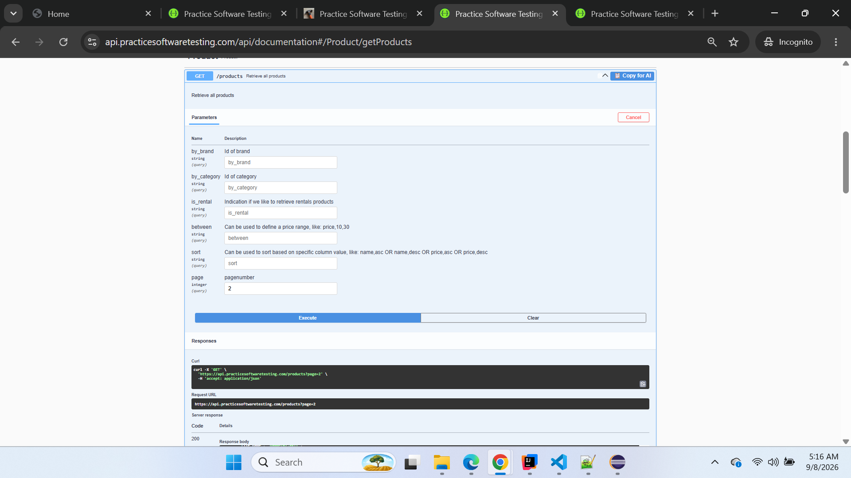

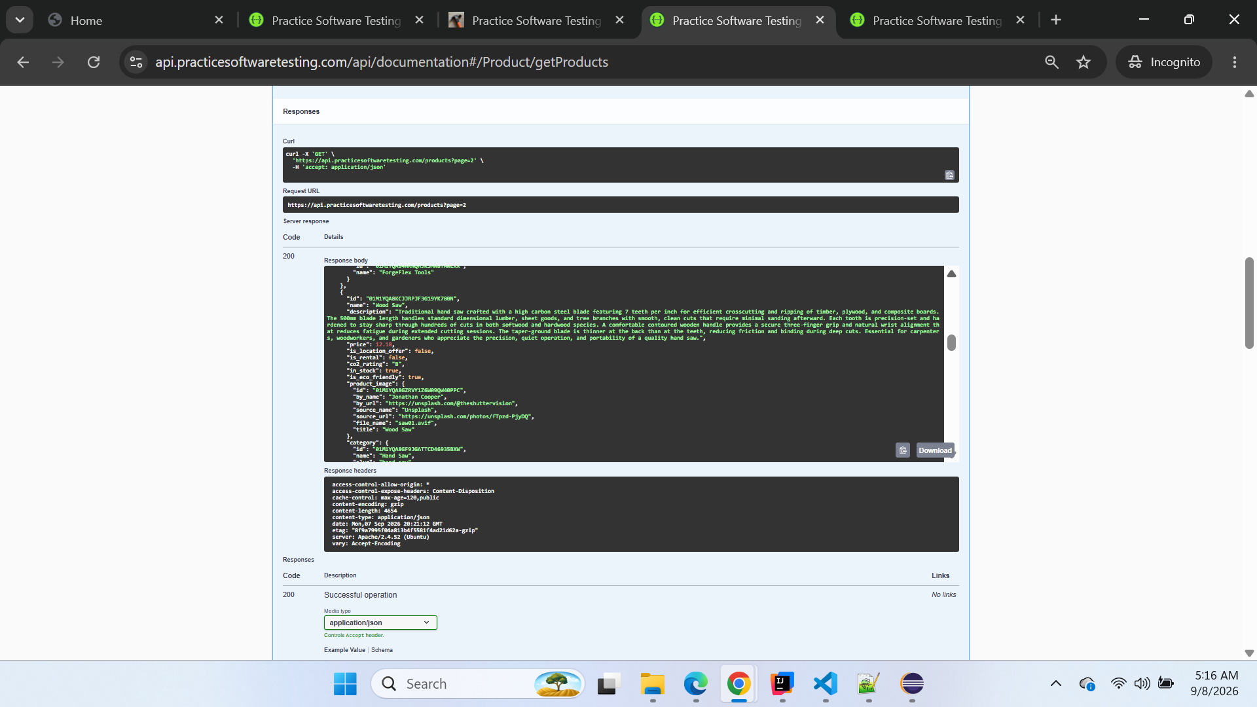

Response body
Download
{
"current_page": 2,
"data": [
{
"id": "01M1YQA8JKKFJMJJX3CREYMG5F",
"name": "Sledgehammer",
"description": "Powerful sledgehammer designed for heavy demolition, driving stakes, breaking concrete, and splitting masonry with devastating efficiency. The 3.6kg forged steel head delivers tremendous impact force concentrated through a hardened striking face that resists chipping and mushrooming. A 900mm fiberglass handle provides excellent shock absorption, superior reach, and the flexibility needed to generate maximum swing velocity. Anti-vibration technology embedded in the handle dampens recoil forces, significantly reducing operator fatigue during extended demolition sessions. The overmolded grip zone prevents the handle from twisting or slipping out of sweaty or gloved hands during overhead swings. Built for construction workers, landscapers, and demolition crews who demand professional-grade striking tools that perform reliably under the most punishing conditions.",
"price": 17.75,
"is_location_offer": false,
"is_rental": false,
"co2_rating": "D",
"in_stock": true,
"is_eco_friendly": false,
"product_image": {
"id": "01M1YQA8GZRVY1Z6W09QW40PP9",
"by_name": "Fausto Marqués",
"by_url": "https://unsplash.com/@faustomarques",
"source_name": "Unsplash",
"source_url": "https://unsplash.com/photos/A9dq-L3zzHA",
"file_name": "hammer05.avif",
"title": "Hammer"
},
"category": {
"id": "01M1YQA8GF9JGATTCD46935BXV",
"name": "Hammer",
"slug": "hammer"
},
"brand": {
"id": "01M1YQA84NKNQHJKSMN8TAWEXX",
"name": "ForgeFlex Tools"
}
},
{
"id": "01M1YQA8JT7Z50KXNV1RCEBGV5",
"name": "Claw Hammer with Fiberglass Handle",
"description": "Modern claw hammer featuring a durable fiberglass handle that outlasts wood, absorbs vibration more effectively, and shrugs off moisture without swelling, cracking, or loosening over time. The 400g carbon steel head is drop-forged and heat-treated to optimal hardness for reliable nail driving in softwood, hardwood, and engineered lumber. The fiberglass core is permanently bonded to the head and encased in a comfortable overmold grip that prevents slipping even when wet or oily. A magnetic nail starter near the head allows one-handed nail placement, freeing your other hand to hold materials in position. The curved claw provides smooth, controlled nail extraction with excellent leverage. Ideal for contractors and DIY builders who want a weather-resistant, maintenance-free hammer that performs reliably on every job site and in any season.",
"price": 20.14,
"is_location_offer": false,
"is_rental": false,
"co2_rating": "D",
"in_stock": true,
"is_eco_friendly": false,
"product_image": {
"id": "01M1YQA8GZRVY1Z6W09QW40PPA",
"by_name": "Jonny Gios",
"by_url": "https://unsplash.com/@supergios",
"source_name": "Unsplash",
"source_url": "https://unsplash.com/photos/ARaYGFeuwpU",
"file_name": "hammer06.avif",
"title": "Claw Hammer"
},
"category": {
"id": "01M1YQA8GF9JGATTCD46935BXV",
"name": "Hammer",
"slug": "hammer"
},
"brand": {
"id": "01M1YQA84NKNQHJKSMN8TAWEXX",
"name": "ForgeFlex Tools"
}
},
{
"id": "01M1YQA8K3ZV4JM331EZVNWZVC",
"name": "Court Hammer",
"description": "Compact precision court hammer with a 300g carbon steel head designed for light-duty nailing, tapping dowels, and delicate assembly tasks where a full-size hammer would be too heavy and unwieldy. The short 280mm wooden handle provides excellent close-quarters control for detailed work in confined spaces such as cabinets, closets, and furniture interiors. The polished flat face drives small nails and brads without bending them, while the cross-peen on the opposite side is useful for starting small fasteners between your fingers. Perfectly weighted to provide enough force for trim carpentry and light framing without damaging delicate surfaces. The lacquered wooden handle resists moisture absorption and provides a warm, comfortable grip. A handy addition to any toolkit when precision and finesse matter more than raw striking power.",
"price": 18.63,
"is_location_offer": true,
"is_rental": false,
"co2_rating": "D",
"in_stock": true,
"is_eco_friendly": false,
"product_image": {
"id": "01M1YQA8GZRVY1Z6W09QW40PPB",
"by_name": "Wesley Tingey",
"by_url": "https://unsplash.com/@wesleyphotography",
"source_name": "Unsplash",
"source_url": "https://unsplash.com/photos/9z9fxr_7Z-k",
"file_name": "hammer07.avif",
"title": "Hammer"
},
"category": {
"id": "01M1YQA8GF9JGATTCD46935BXV",
"name": "Hammer",
"slug": "hammer"
},
"brand": {
"id": "01M1YQA84NKNQHJKSMN8TAWEXX",
"name": "ForgeFlex Tools"
}
},
{
"id": "01M1YQA8KCJJRPJF3G19YK780N",
"name": "Wood Saw",
"description": "Traditional hand saw crafted with a high carbon steel blade featuring 7 teeth per inch for efficient crosscutting and ripping of timber, plywood, and composite boards. The 500mm blade length handles standard dimensional lumber, sheet goods, and tree branches with smooth, clean cuts that require minimal sanding afterward. Each tooth is precision-set and hardened to stay sharp through hundreds of cuts in both softwood and hardwood species. A comfortable contoured wooden handle provides a secure three-finger grip and natural wrist alignment that reduces fatigue during extended cutting sessions. The taper-ground blade is thinner at the back than at the teeth, reducing friction and binding during deep cuts. Essential for carpenters, woodworkers, and gardeners who appreciate the precision, quiet operation, and portability of a quality hand saw.",
"price": 12.18,
"is_location_offer": false,
"is_rental": false,
"co2_rating": "B",
"in_stock": true,
"is_eco_friendly": true,
"product_image": {
"id": "01M1YQA8GZRVY1Z6W09QW40PPC",
"by_name": "Jonathan Cooper",
"by_url": "https://unsplash.com/@theshuttervision",
"source_name": "Unsplash",
"source_url": "https://unsplash.com/photos/fTpzd-PjyDQ",
"file_name": "saw01.avif",
"title": "Wood Saw"
},
"category": {
"id": "01M1YQA8GF9JGATTCD46935BXW",
"name": "Hand Saw",
"slug": "hand-saw"
},
"brand": {
"id": "01M1YQA84NKNQHJKSMN8TAWEXX",
"name": "ForgeFlex Tools"
}
},
{
"id": "01M1YQA8KNZQ809JX6E4AJE2AA",
"name": "Adjustable Wrench",
"description": "Chrome vanadium steel adjustable wrench with a smooth-action worm gear jaw mechanism that opens to a generous 30mm capacity for versatile bolt, nut, and fitting work. The precision-machined worm gear ensures the movable jaw stays firmly locked in position under heavy torque loads, eliminating the slipping and rounding common with lesser tools. Laser-etched metric and imperial scales on the jaw face allow for quick size identification without a separate caliper or ruler. The slim-profile head design fits into recessed areas and tight clearances where a standard box wrench cannot reach. A corrosion-resistant chrome finish protects against rust and makes the wrench easy to wipe clean after greasy jobs. A workshop essential for plumbers, mechanics, and assembly technicians who work with multiple fastener sizes throughout the day.",
"price": 20.33,
"is_location_offer": false,
"is_rental": false,
"co2_rating": "D",
"in_stock": true,
"is_eco_friendly": false,
"product_image": {
"id": "01M1YQA8GZRVY1Z6W09QW40PPD",
"by_name": "Recha Oktaviani",
"by_url": "https://unsplash.com/@rechaoktaviani",
"source_name": "Unsplash",
"source_url": "https://unsplash.com/photos/t__61ap00Mc",
"file_name": "wrench01.avif",
"title": "Adjustable wrench"
},
"category": {
"id": "01M1YQA8GF9JGATTCD46935BXX",
"name": "Wrench",
"slug": "wrench"
},
"brand": {
"id": "01M1YQA84NKNQHJKSMN8TAWEXX",
"name": "ForgeFlex Tools"
}
},
{
"id": "01M1YQA8KXE9J924J3PV5WDWT0",
"name": "Angled Spanner",
"description": "Offset angled spanner specifically designed to reach bolts, nuts, and fittings in recessed, obstructed, or deeply set locations where a straight wrench simply cannot fit or turn. Made from chrome vanadium steel with a satin-chrome finish for excellent corrosion resistance, easy cleaning, and professional appearance. The 15-degree offset angle at both ends provides ample knuckle clearance while maintaining full torque transfer to the fastener without slipping. By flipping the spanner over between turns, you can work in spaces with as little as 30 degrees of swing arc. The slim jaw profile fits into narrow gaps alongside adjacent components without interference. Indispensable for automotive mechanics working in engine bays, appliance repair technicians accessing internal components, and industrial maintenance engineers servicing tightly packed machinery.",
"price": 14.14,
"is_location_offer": true,
"is_rental": false,
"co2_rating": "D",
"in_stock": true,
"is_eco_friendly": false,
"product_image": {
"id": "01M1YQA8GZRVY1Z6W09QW40PPE",
"by_name": "Tekton",
"by_url": "https://unsplash.com/@tekton_tools",
"source_name": "Unsplash",
"source_url": "https://unsplash.com/photos/9z7t48S5C_g",
"file_name": "wrench02.avif",
"title": "Wrench"
},
"category": {
"id": "01M1YQA8GF9JGATTCD46935BXX",
"name": "Wrench",
"slug": "wrench"
},
"brand": {
"id": "01M1YQA84NKNQHJKSMN8TAWEXX",
"name": "ForgeFlex Tools"
}
},
{
"id": "01M1YQA8M0NBXNS9GNSPS9M4JK",
"name": "Open-end Spanners (Set)",
"description": "Complete professional set of 12 open-end spanners covering metric sizes from 6mm to 32mm, crafted from chrome vanadium steel for lasting strength and resistance to flexing under heavy torque. Each spanner features a slim-profile head design angled at 15 degrees for access in tight spaces, and the open-end configuration allows quick lateral placement on fasteners without the need to thread them through from the end. A mirror-polished chrome finish resists corrosion, repels grease and oil, and looks sharp in any professional tool collection. Size markings are deeply laser-etched on both sides of each spanner for instant identification even in low light conditions. The set is supplied in a durable roll-up canvas pouch with individual pockets for organized storage and easy transport to any job site. An essential investment for automotive workshops, industrial maintenance departments, and serious home mechanics.",
"price": 38.51,
"is_location_offer": false,
"is_rental": false,
"co2_rating": "D",
"in_stock": true,
"is_eco_friendly": false,
"product_image": {
"id": "01M1YQA8GZRVY1Z6W09QW40PPF",
"by_name": "Akshat Swaminath",
"by_url": "https://unsplash.com/@akshat_swaminath",
"source_name": "Unsplash",
"source_url": "https://unsplash.com/photos/hg34mNWFRaI",
"file_name": "wrench03.avif",
"title": "Open-end spanners (Set)"
},
"category": {
"id": "01M1YQA8GF9JGATTCD46935BXX",
"name": "Wrench",
"slug": "wrench"
},
"brand": {
"id": "01M1YQA84NKNQHJKSMN8TAWEXX",
"name": "ForgeFlex Tools"
}
},
{
"id": "01M1YQA8M2BTVQ1XVB3F08KY9X",
"name": "Phillips Screwdriver",
"description": "Professional-quality Phillips screwdriver with a PH2 tip precision-machined from chrome vanadium steel and vapor-blasted for maximum grip inside cross-head screw recesses. The bi-component handle features a soft-grip comfort zone that absorbs torque reaction and vibration, combined with a hard polypropylene core that transmits maximum turning force to the blade. A hex bolster machined into the shaft just above the handle allows a wrench to be applied for additional turning leverage on stubborn or over-tightened screws. The round blade shaft is chrome-plated for corrosion resistance and easy cleaning after use in greasy or painted environments. A hanging hole in the handle allows convenient pegboard or hook storage for quick identification and access. Suitable for electricians, cabinet makers, assembly technicians, and anyone who needs a reliable, comfortable everyday screwdriver.",
"price": 4.92,
"is_location_offer": true,
"is_rental": false,
"co2_rating": "C",
"in_stock": true,
"is_eco_friendly": false,
"product_image": {
"id": "01M1YQA8GZRVY1Z6W09QW40PPG",
"by_name": "Tekton",
"by_url": "https://unsplash.com/@tekton_tools",
"source_name": "Unsplash",
"source_url": "https://unsplash.com/photos/jlY6nV_STIw",
"file_name": "screwdriver01.avif",
"title": "Phillips Screwdriver"
},
"category": {
"id": "01M1YQA8GF9JGATTCD46935BXY",
"name": "Screwdriver",
"slug": "screwdriver"
},
"brand": {
"id": "01M1YQA84NKNQHJKSMN8TAWEXX",
"name": "ForgeFlex Tools"
}
},
{
"id": "01M1YQA8M5294P2FNM6DNGNFBG",
"name": "Mini Screwdriver",
"description": "Precision mini screwdriver with a PH0 tip designed specifically for working with small screws found in electronics, eyeglasses, watches, camera equipment, and detailed hobby projects. The carbon steel blade is hardened and tempered to maintain an accurate tip profile through thousands of insertions in delicate threaded fasteners. A freely rotating end cap allows single-handed operation by applying downward pressure with your index finger while your thumb and middle finger turn the barrel. The knurled aluminum barrel provides a secure, non-slip grip for fine adjustments requiring minimal torque. At just 150mm overall length, this screwdriver fits easily in a shirt pocket, precision tool roll, or electronics repair kit. An essential tool for IT technicians, jewelers, model builders, and anyone who works with miniature components.",
"price": 13.96,
"is_location_offer": false,
"is_rental": false,
"co2_rating": "C",
"in_stock": true,
"is_eco_friendly": false,
"product_image": {
"id": "01M1YQA8GZRVY1Z6W09QW40PPH",
"by_name": "Everyday basics",
"by_url": "https://unsplash.com/@zanardi",
"source_name": "Unsplash",
"source_url": "https://unsplash.com/photos/a6LO3iO5AIk",
"file_name": "screwdriver02.avif",
"title": "Screwdriver"
},
"category": {
"id": "01M1YQA8GF9JGATTCD46935BXY",
"name": "Screwdriver",
"slug": "screwdriver"
},
"brand": {
"id": "01M1YQA84NKNQHJKSMN8TAWEXX",
"name": "ForgeFlex Tools"
}
}
],
"from": 10,
"last_page": 6,
"per_page": 9,
"to": 18,
"total": 50
}

Response headers
access-control-allow-origin: *
access-control-expose-headers: Content-Disposition
cache-control: max-age=120,public
content-encoding: gzip
content-length: 4654
content-type: application/json
date: Mon,07 Sep 2026 20:21:12 GMT
etag: "8f9a7995f04a813b4f5581f4ad21d62a-gzip"
server: Apache/2.4.52 (Ubuntu)
vary: Accept-Encoding

Screenshot 2 — BUGGY Sledgehammer / Wood Saw classification
Attach screenshot showing the contradictory BUGGY values.

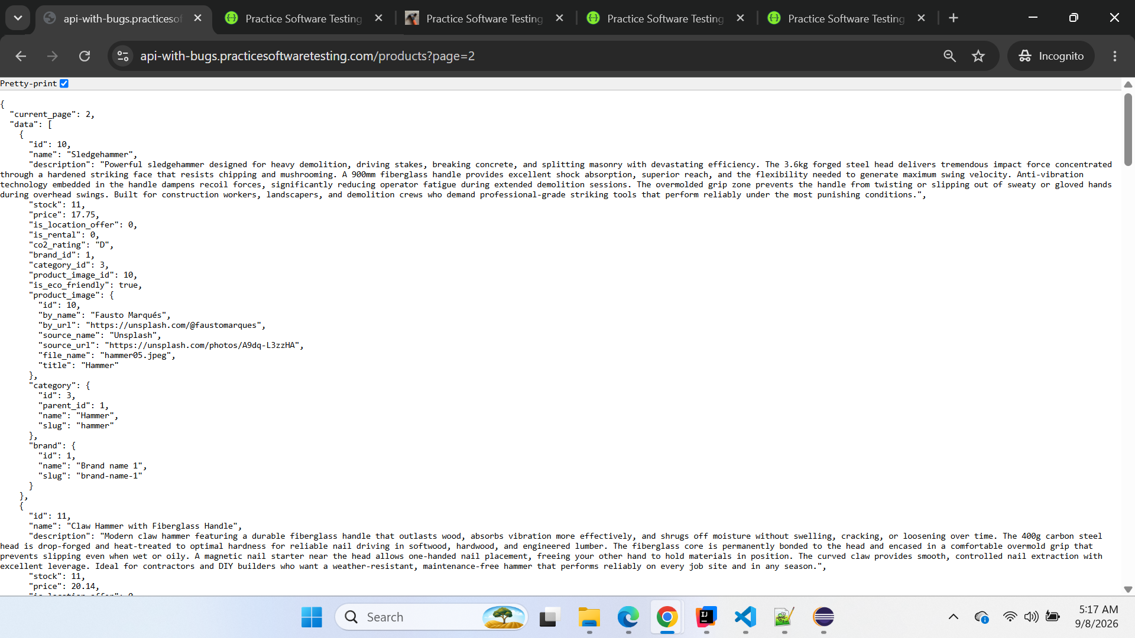

{
"current_page": 2,
"data": [
{
"id": 10,
"name": "Sledgehammer",
"description": "Powerful sledgehammer designed for heavy demolition, driving stakes, breaking concrete, and splitting masonry with devastating efficiency. The 3.6kg forged steel head delivers tremendous impact force concentrated through a hardened striking face that resists chipping and mushrooming. A 900mm fiberglass handle provides excellent shock absorption, superior reach, and the flexibility needed to generate maximum swing velocity. Anti-vibration technology embedded in the handle dampens recoil forces, significantly reducing operator fatigue during extended demolition sessions. The overmolded grip zone prevents the handle from twisting or slipping out of sweaty or gloved hands during overhead swings. Built for construction workers, landscapers, and demolition crews who demand professional-grade striking tools that perform reliably under the most punishing conditions.",
"stock": 11,
"price": 17.75,
"is_location_offer": 0,
"is_rental": 0,
"co2_rating": "D",
"brand_id": 1,
"category_id": 3,
"product_image_id": 10,
"is_eco_friendly": true,
"product_image": {
"id": 10,
"by_name": "Fausto Marqués",
"by_url": "https://unsplash.com/@faustomarques",
"source_name": "Unsplash",
"source_url": "https://unsplash.com/photos/A9dq-L3zzHA",
"file_name": "hammer05.jpeg",
"title": "Hammer"
},
"category": {
"id": 3,
"parent_id": 1,
"name": "Hammer",
"slug": "hammer"
},
"brand": {
"id": 1,
"name": "Brand name 1",
"slug": "brand-name-1"
}
},
{
"id": 11,
"name": "Claw Hammer with Fiberglass Handle",
"description": "Modern claw hammer featuring a durable fiberglass handle that outlasts wood, absorbs vibration more effectively, and shrugs off moisture without swelling, cracking, or loosening over time. The 400g carbon steel head is drop-forged and heat-treated to optimal hardness for reliable nail driving in softwood, hardwood, and engineered lumber. The fiberglass core is permanently bonded to the head and encased in a comfortable overmold grip that prevents slipping even when wet or oily. A magnetic nail starter near the head allows one-handed nail placement, freeing your other hand to hold materials in position. The curved claw provides smooth, controlled nail extraction with excellent leverage. Ideal for contractors and DIY builders who want a weather-resistant, maintenance-free hammer that performs reliably on every job site and in any season.",
"stock": 11,
"price": 20.14,
"is_location_offer": 0,
"is_rental": 0,
"co2_rating": "D",
"brand_id": 1,
"category_id": 3,
"product_image_id": 11,
"is_eco_friendly": true,
"product_image": {
"id": 11,
"by_name": "Jonny Gios",
"by_url": "https://unsplash.com/@supergios",
"source_name": "Unsplash",
"source_url": "https://unsplash.com/photos/ARaYGFeuwpU",
"file_name": "hammer06.jpeg",
"title": "Claw Hammer"
},
"category": {
"id": 3,
"parent_id": 1,
"name": "Hammer",
"slug": "hammer"
},
"brand": {
"id": 1,
"name": "Brand name 1",
"slug": "brand-name-1"
}
},
{
"id": 12,
"name": "Court Hammer",
"description": "Compact precision court hammer with a 300g carbon steel head designed for light-duty nailing, tapping dowels, and delicate assembly tasks where a full-size hammer would be too heavy and unwieldy. The short 280mm wooden handle provides excellent close-quarters control for detailed work in confined spaces such as cabinets, closets, and furniture interiors. The polished flat face drives small nails and brads without bending them, while the cross-peen on the opposite side is useful for starting small fasteners between your fingers. Perfectly weighted to provide enough force for trim carpentry and light framing without damaging delicate surfaces. The lacquered wooden handle resists moisture absorption and provides a warm, comfortable grip. A handy addition to any toolkit when precision and finesse matter more than raw striking power.",
"stock": 11,
"price": 18.63,
"is_location_offer": 1,
"is_rental": 0,
"co2_rating": "D",
"brand_id": 1,
"category_id": 3,
"product_image_id": 12,
"is_eco_friendly": true,
"product_image": {
"id": 12,
"by_name": "Wesley Tingey",
"by_url": "https://unsplash.com/@wesleyphotography",
"source_name": "Unsplash",
"source_url": "https://unsplash.com/photos/9z9fxr_7Z-k",
"file_name": "hammer07.jpeg",
"title": "Hammer"
},
"category": {
"id": 3,
"parent_id": 1,
"name": "Hammer",
"slug": "hammer"
},
"brand": {
"id": 1,
"name": "Brand name 1",
"slug": "brand-name-1"
}
},
{
"id": 13,
"name": "Wood Saw",
"description": "Traditional hand saw crafted with a high carbon steel blade featuring 7 teeth per inch for efficient crosscutting and ripping of timber, plywood, and composite boards. The 500mm blade length handles standard dimensional lumber, sheet goods, and tree branches with smooth, clean cuts that require minimal sanding afterward. Each tooth is precision-set and hardened to stay sharp through hundreds of cuts in both softwood and hardwood species. A comfortable contoured wooden handle provides a secure three-finger grip and natural wrist alignment that reduces fatigue during extended cutting sessions. The taper-ground blade is thinner at the back than at the teeth, reducing friction and binding during deep cuts. Essential for carpenters, woodworkers, and gardeners who appreciate the precision, quiet operation, and portability of a quality hand saw.",
"stock": 11,
"price": 12.18,
"is_location_offer": 0,
"is_rental": 0,
"co2_rating": "B",
"brand_id": 1,
"category_id": 4,
"product_image_id": 13,
"is_eco_friendly": false,
"product_image": {
"id": 13,
"by_name": "Jonathan Cooper",
"by_url": "https://unsplash.com/@theshuttervision",
"source_name": "Unsplash",
"source_url": "https://unsplash.com/photos/fTpzd-PjyDQ",
"file_name": "saw01.jpeg",
"title": "Wood Saw"
},
"category": {
"id": 4,
"parent_id": 1,
"name": "Hand Saw",
"slug": "hand-saw"
},
"brand": {
"id": 1,
"name": "Brand name 1",
"slug": "brand-name-1"
}
},
{
"id": 14,
"name": "Adjustable Wrench",
"description": "Chrome vanadium steel adjustable wrench with a smooth-action worm gear jaw mechanism that opens to a generous 30mm capacity for versatile bolt, nut, and fitting work. The precision-machined worm gear ensures the movable jaw stays firmly locked in position under heavy torque loads, eliminating the slipping and rounding common with lesser tools. Laser-etched metric and imperial scales on the jaw face allow for quick size identification without a separate caliper or ruler. The slim-profile head design fits into recessed areas and tight clearances where a standard box wrench cannot reach. A corrosion-resistant chrome finish protects against rust and makes the wrench easy to wipe clean after greasy jobs. A workshop essential for plumbers, mechanics, and assembly technicians who work with multiple fastener sizes throughout the day.",
"stock": 11,
"price": 20.33,
"is_location_offer": 0,
"is_rental": 0,
"co2_rating": "D",
"brand_id": 1,
"category_id": 5,
"product_image_id": 14,
"is_eco_friendly": true,
"product_image": {
"id": 14,
"by_name": "Recha Oktaviani",
"by_url": "https://unsplash.com/@rechaoktaviani",
"source_name": "Unsplash",
"source_url": "https://unsplash.com/photos/t__61ap00Mc",
"file_name": "wrench01.jpeg",
"title": "Adjustable wrench"
},
"category": {
"id": 5,
"parent_id": 1,
"name": "Wrench",
"slug": "wrench"
},
"brand": {
"id": 1,
"name": "Brand name 1",
"slug": "brand-name-1"
}
},
{
"id": 15,
"name": "Angled Spanner",
"description": "Offset angled spanner specifically designed to reach bolts, nuts, and fittings in recessed, obstructed, or deeply set locations where a straight wrench simply cannot fit or turn. Made from chrome vanadium steel with a satin-chrome finish for excellent corrosion resistance, easy cleaning, and professional appearance. The 15-degree offset angle at both ends provides ample knuckle clearance while maintaining full torque transfer to the fastener without slipping. By flipping the spanner over between turns, you can work in spaces with as little as 30 degrees of swing arc. The slim jaw profile fits into narrow gaps alongside adjacent components without interference. Indispensable for automotive mechanics working in engine bays, appliance repair technicians accessing internal components, and industrial maintenance engineers servicing tightly packed machinery.",
"stock": 11,
"price": 14.14,
"is_location_offer": 1,
"is_rental": 0,
"co2_rating": "D",
"brand_id": 1,
"category_id": 5,
"product_image_id": 15,
"is_eco_friendly": true,
"product_image": {
"id": 15,
"by_name": "Tekton",
"by_url": "https://unsplash.com/@tekton_tools",
"source_name": "Unsplash",
"source_url": "https://unsplash.com/photos/9z7t48S5C_g",
"file_name": "wrench02.jpeg",
"title": "Wrench"
},
"category": {
"id": 5,
"parent_id": 1,
"name": "Wrench",
"slug": "wrench"
},
"brand": {
"id": 1,
"name": "Brand name 1",
"slug": "brand-name-1"
}
},
{
"id": 16,
"name": "Open-end Spanners (Set)",
"description": "Complete professional set of 12 open-end spanners covering metric sizes from 6mm to 32mm, crafted from chrome vanadium steel for lasting strength and resistance to flexing under heavy torque. Each spanner features a slim-profile head design angled at 15 degrees for access in tight spaces, and the open-end configuration allows quick lateral placement on fasteners without the need to thread them through from the end. A mirror-polished chrome finish resists corrosion, repels grease and oil, and looks sharp in any professional tool collection. Size markings are deeply laser-etched on both sides of each spanner for instant identification even in low light conditions. The set is supplied in a durable roll-up canvas pouch with individual pockets for organized storage and easy transport to any job site. An essential investment for automotive workshops, industrial maintenance departments, and serious home mechanics.",
"stock": 11,
"price": 38.51,
"is_location_offer": 0,
"is_rental": 0,
"co2_rating": "D",
"brand_id": 1,
"category_id": 5,
"product_image_id": 16,
"is_eco_friendly": true,
"product_image": {
"id": 16,
"by_name": "Akshat Swaminath",
"by_url": "https://unsplash.com/@akshat_swaminath",
"source_name": "Unsplash",
"source_url": "https://unsplash.com/photos/hg34mNWFRaI",
"file_name": "wrench03.jpeg",
"title": "Open-end spanners (Set)"
},
"category": {
"id": 5,
"parent_id": 1,
"name": "Wrench",
"slug": "wrench"
},
"brand": {
"id": 1,
"name": "Brand name 1",
"slug": "brand-name-1"
}
},
{
"id": 17,
"name": "Phillips Screwdriver",
"description": "Professional-quality Phillips screwdriver with a PH2 tip precision-machined from chrome vanadium steel and vapor-blasted for maximum grip inside cross-head screw recesses. The bi-component handle features a soft-grip comfort zone that absorbs torque reaction and vibration, combined with a hard polypropylene core that transmits maximum turning force to the blade. A hex bolster machined into the shaft just above the handle allows a wrench to be applied for additional turning leverage on stubborn or over-tightened screws. The round blade shaft is chrome-plated for corrosion resistance and easy cleaning after use in greasy or painted environments. A hanging hole in the handle allows convenient pegboard or hook storage for quick identification and access. Suitable for electricians, cabinet makers, assembly technicians, and anyone who needs a reliable, comfortable everyday screwdriver.",
"stock": 11,
"price": 4.92,
"is_location_offer": 1,
"is_rental": 0,
"co2_rating": "C",
"brand_id": 1,
"category_id": 6,
"product_image_id": 17,
"is_eco_friendly": false,
"product_image": {
"id": 17,
"by_name": "Tekton",
"by_url": "https://unsplash.com/@tekton_tools",
"source_name": "Unsplash",
"source_url": "https://unsplash.com/photos/jlY6nV_STIw",
"file_name": "screwdriver01.jpeg",
"title": "Phillips Screwdriver"
},
"category": {
"id": 6,
"parent_id": 1,
"name": "Screwdriver",
"slug": "screwdriver"
},
"brand": {
"id": 1,
"name": "Brand name 1",
"slug": "brand-name-1"
}
},
{
"id": 18,
"name": "Mini Screwdriver",
"description": "Precision mini screwdriver with a PH0 tip designed specifically for working with small screws found in electronics, eyeglasses, watches, camera equipment, and detailed hobby projects. The carbon steel blade is hardened and tempered to maintain an accurate tip profile through thousands of insertions in delicate threaded fasteners. A freely rotating end cap allows single-handed operation by applying downward pressure with your index finger while your thumb and middle finger turn the barrel. The knurled aluminum barrel provides a secure, non-slip grip for fine adjustments requiring minimal torque. At just 150mm overall length, this screwdriver fits easily in a shirt pocket, precision tool roll, or electronics repair kit. An essential tool for IT technicians, jewelers, model builders, and anyone who works with miniature components.",
"stock": 11,
"price": 13.96,
"is_location_offer": 0,
"is_rental": 0,
"co2_rating": "C",
"brand_id": 1,
"category_id": 6,
"product_image_id": 18,
"is_eco_friendly": false,
"product_image": {
"id": 18,
"by_name": "Everyday basics",
"by_url": "https://unsplash.com/@zanardi",
"source_name": "Unsplash",
"source_url": "https://unsplash.com/photos/a6LO3iO5AIk",
"file_name": "screwdriver02.jpeg",
"title": "Screwdriver"
},
"category": {
"id": 6,
"parent_id": 1,
"name": "Screwdriver",
"slug": "screwdriver"
},
"brand": {
"id": 1,
"name": "Brand name 1",
"slug": "brand-name-1"
}
}
],
"from": 10,
"last_page": 3,
"per_page": 9,
"to": 18,
"total": 26
}

Conclusion
Confirmed defect based on repeated CLEAN-vs-BUGGY comparison.
This should be tracked separately from BUG-001 because it affects a different field and business rule.

OBS-001 — BUGGY Swagger does not document the page parameter
Classification: Documentation Observation
Severity: Low / Informational
Priority: Low
Area: Swagger / API Documentation
Endpoint: GET /products

Description
The BUGGY Swagger documentation for GET /products does not display a page query parameter.
However, direct testing confirms that the API still supports pagination.
For example:
GET /products?page=2
successfully returns page 2 and reports:
"current_page": 2
Therefore, this is not a functional pagination defect.
It is a discrepancy between the API's actual capability and its Swagger documentation.

Steps to Reproduce
- Open BUGGY Swagger.
- Navigate to GET /products.
- Review the documented query parameters.
- Observe that page is not listed.
- Manually call:
/products?page=2
- Observe that the request succeeds.
- Verify that the response indicates:
"current_page": 2

Expected Result
Swagger should document supported API query parameters, including page if pagination is available.

Actual Result
The page parameter is not exposed in BUGGY Swagger, although pagination works functionally.

Impact
Low functional impact.
This may confuse API consumers or testers because Swagger suggests that pagination is unavailable even though the endpoint supports it.

Screenshot Evidence
Screenshot 1 — BUGGY Swagger GET /products parameters
Attach screenshot showing that page is not listed.

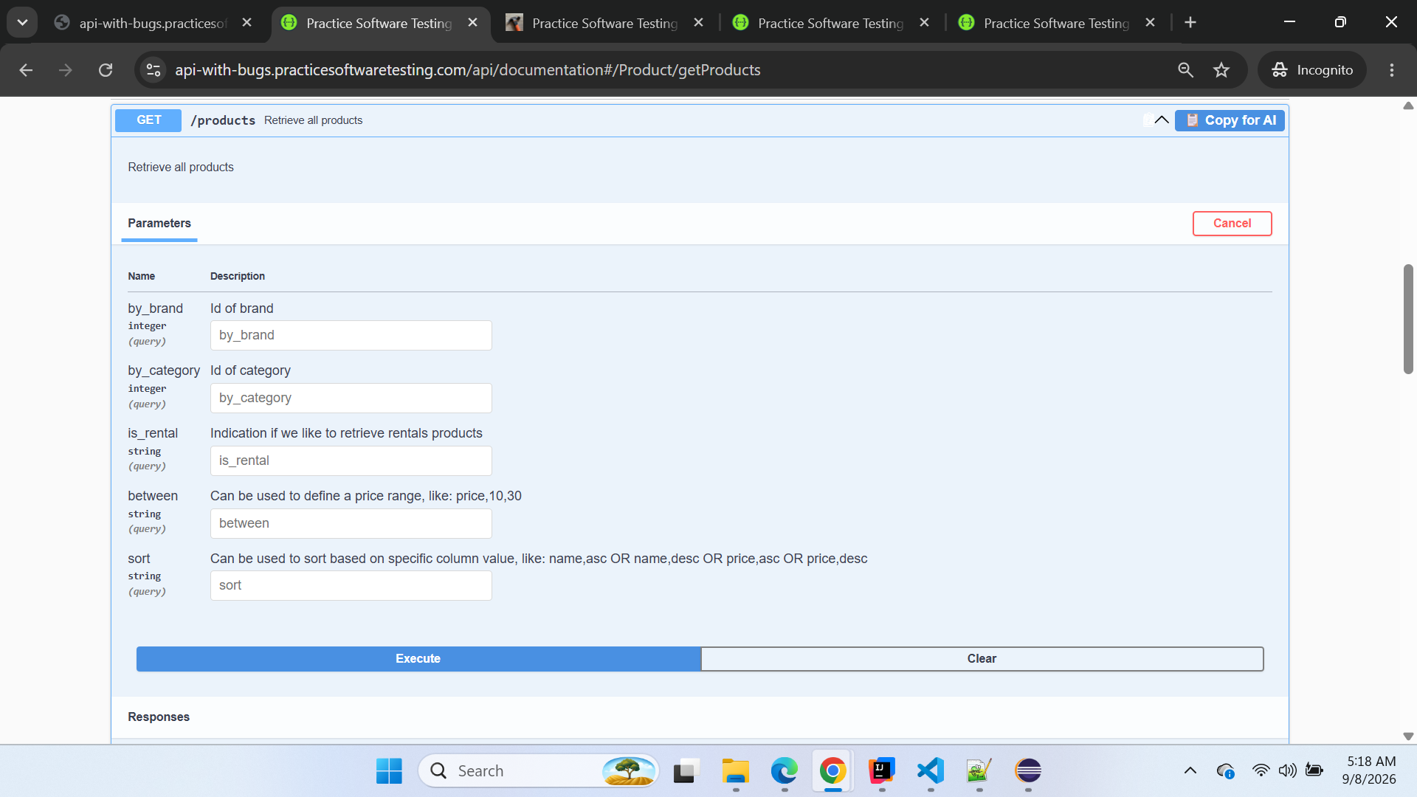
Screenshot 2 — Direct BUGGY /products?page=2 response
Attach screenshot showing current_page: 2.

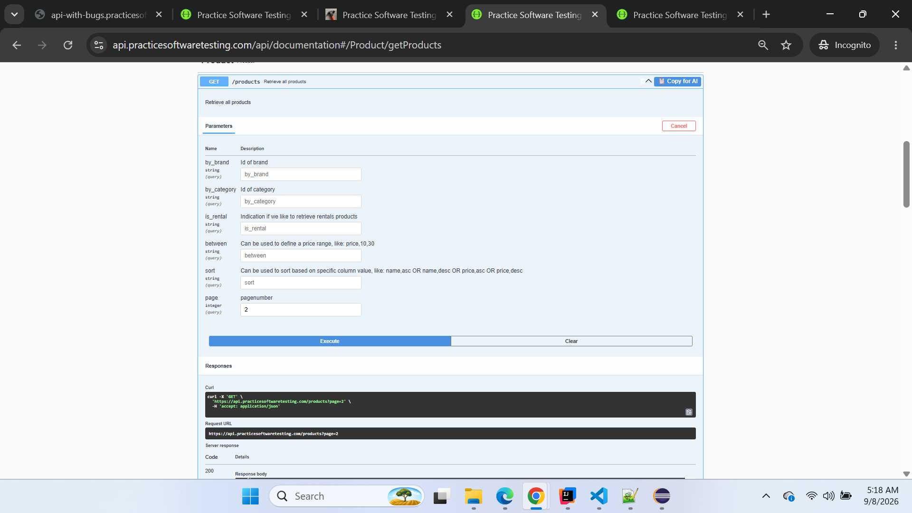

Conclusion
Documentation observation only.
Do not report this as a functional pagination failure.

OBS-002 — Catalog size differs between CLEAN and BUGGY
Classification: Observation
Severity: Informational
Priority: Informational
Area: Product Catalog / Test Data
Endpoint: GET /products

Description
The total product population returned by CLEAN differs significantly from BUGGY.
Observed values:
Environment | Total Products | Last Page | Products per Page
CLEAN | 50 | 6 | 9
BUGGY | 26 | 3 | 9
The difference is clearly observable, but there is currently no explicit requirement proving that CLEAN and BUGGY must contain an identical product population.
Therefore, this should not currently be counted as a confirmed defect.

Steps to Reproduce
- Call GET /products against CLEAN.
- Inspect pagination metadata.
- Record:
  - total
  - last_page
  - per_page
- Call GET /products against BUGGY.
- Inspect the same metadata.
- Compare the values.

Expected Result
No defect expectation is currently asserted because no requirement has yet been identified stating that the catalog population must be identical across both environments.

Actual Result
CLEAN reports:
total = 50
last_page = 6
BUGGY reports:
total = 26
last_page = 3

Impact
The smaller BUGGY catalog may influence:
- dynamic test-data discovery,
- availability of product categories,
- product-selection scenarios,
- rental/eco combinations,
- and financial test setup.
However, catalog-size difference alone is insufficient evidence of a defect.

Screenshot Evidence
Screenshot 1 — CLEAN pagination metadata
Attach screenshot showing total: 50 and last_page: 6.
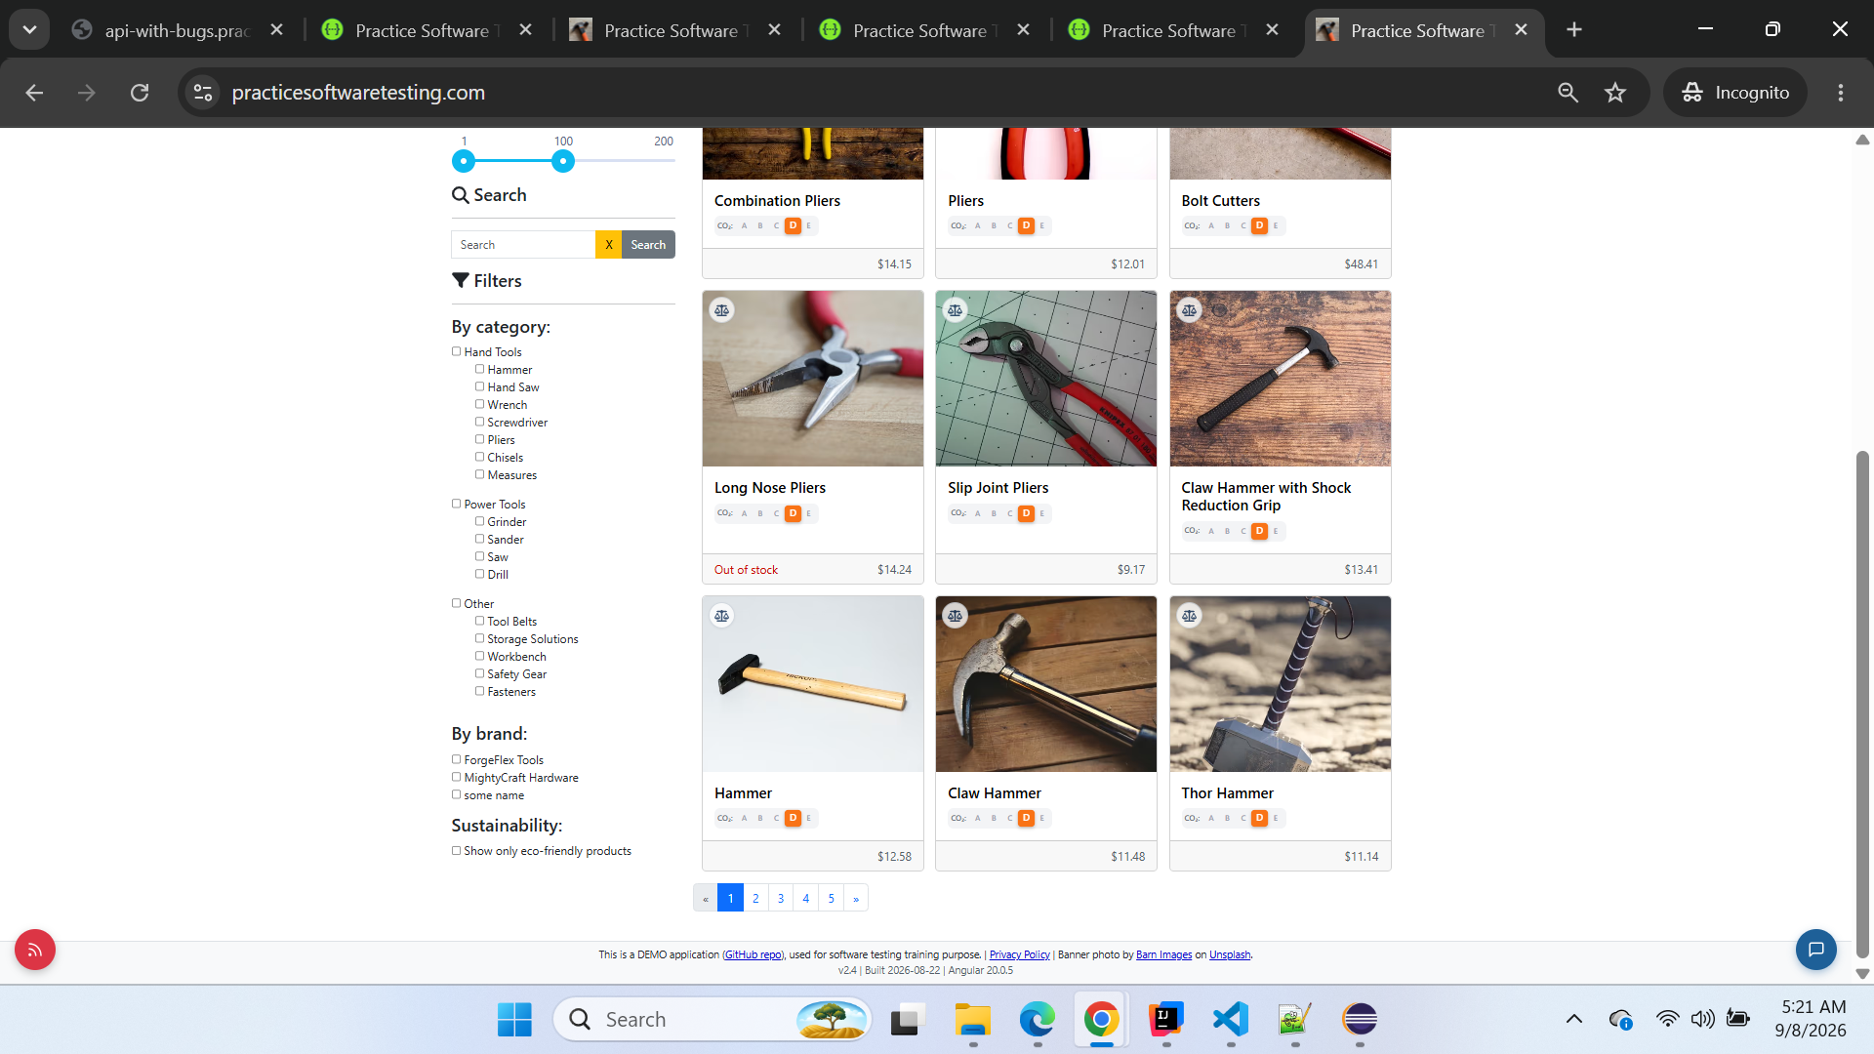

Screenshot 2 — BUGGY pagination metadata
Attach screenshot showing total: 26 and last_page: 3.
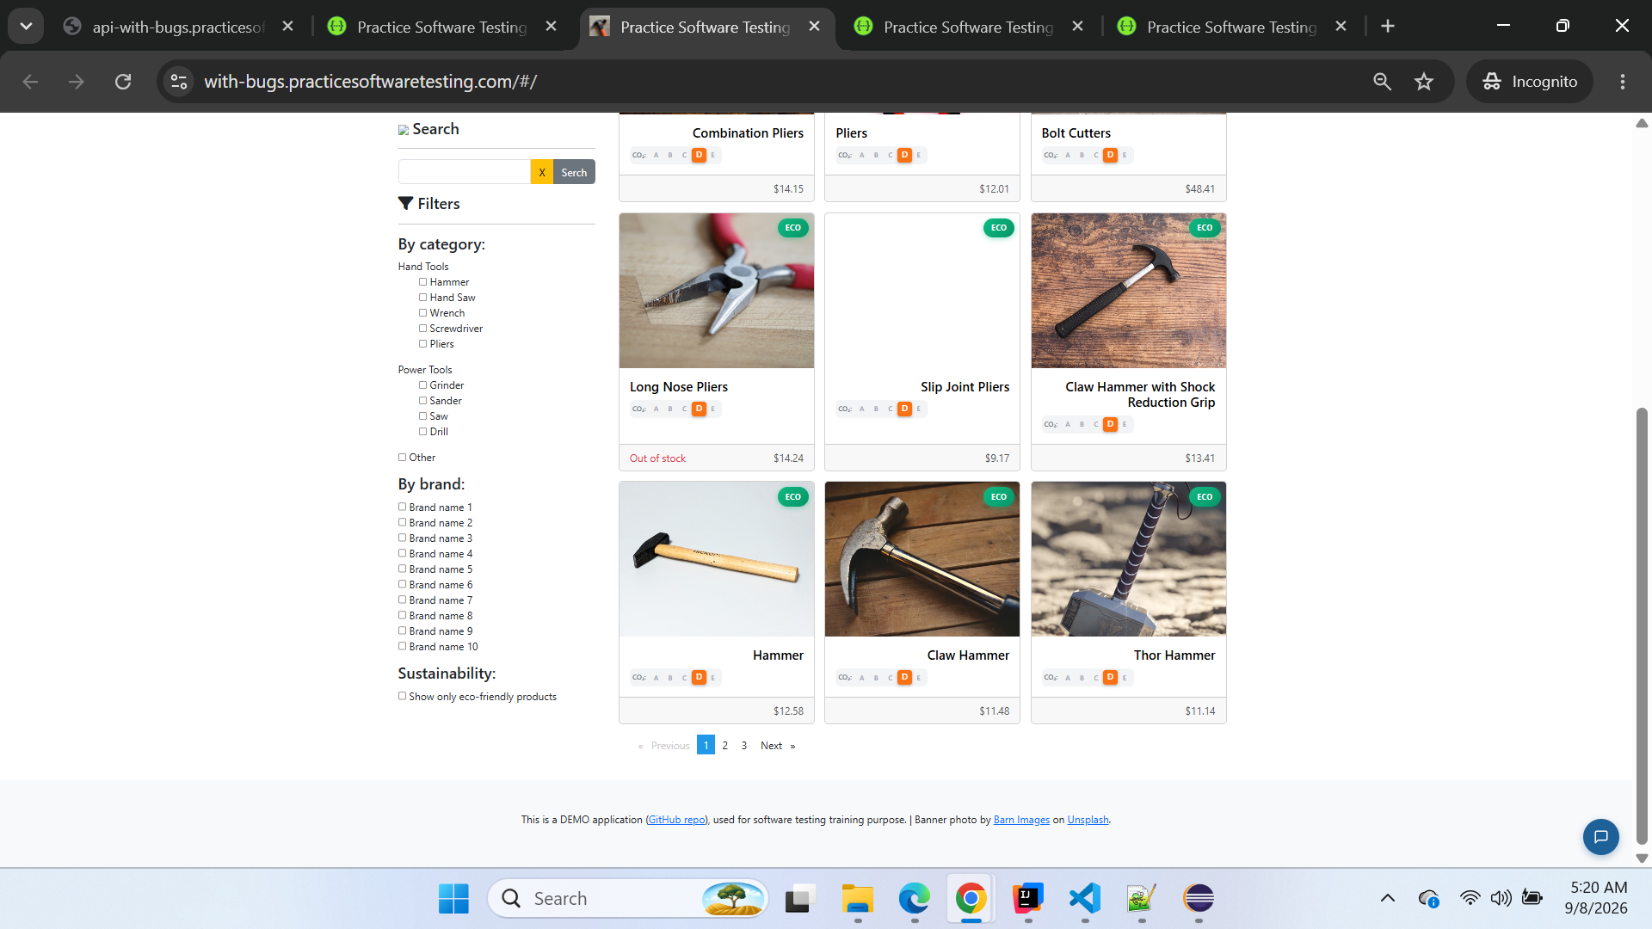

Conclusion
Observation only — not currently a defect.
This should remain in the investigation log unless a requirement confirms that BUGGY must contain the same catalog dataset as CLEAN.

Triage Summary
ID | Finding | Classification | Severity | Current Status
BUG-001 | Product API omits in_stock | Confirmed Defect | High | Confirmed
BUG-002 | Eco-friendly classification incorrect/inverted | Confirmed Defect | High | Confirmed
OBS-001 | Swagger missing page parameter | Documentation Observation | Low | Recorded
OBS-002 | Catalog size 50 vs 26 | Observation | Informational | Needs requirement evidence
A key triage principle used during this investigation is:
One root cause may create many automated test failures, but those failures should not be reported as many separate defects.
For example, several cart, checkout, financial, invoice-setup, and UI tests currently fail because product discovery cannot find an in-stock product. Those failures should be mapped back to BUG-001 when the direct cause is the missing in_stock field.
This keeps the defect report truthful and avoids artificially inflating the number of defects from cascading automation failures.

========================================================================

BUG-003 — Payment API accepts expired credit-card expiration date
Classification: Confirmed Defect
Severity: High
Priority: High
Area: Payment API / Credit Card Validation
Endpoint: POST /payment/check
Environment: BUGGY
Reproducibility: Consistently reproducible

Description
The BUGGY Payment API accepts a credit card with an already expired expiration date.
The CLEAN environment establishes that an expired credit-card expiration date must be rejected with HTTP 422.
The same validation is also covered by automated scenario:
CKO-017 — Credit card with an expired date is rejected (422, confirmed error text)
When the same request is executed against BUGGY with:
{
"method": "Credit Card",
"payment_details": {
"credit_card_number": "4111111111111111",
"expiration_date": "12/2020",
"cvv": "123",
"card_holder_name": "Test User"
}
}
BUGGY incorrectly returns:
HTTP 200
with:
{
"message": "Payment was successful"
}
Therefore, an expired credit card is treated as valid instead of being rejected.

Preconditions
- CLEAN Payment API is accessible.
- BUGGY Payment API is accessible.
- POST /payment/check is available.
- Credit Card is selected as the payment method.
- All payment fields except the expiration-date condition contain valid test data.

Steps to Reproduce
- Open BUGGY Swagger.
- Navigate to POST /payment/check.
- Click Try it out.
- Submit the following request:
{
"method": "Credit Card",
"payment_details": {
"credit_card_number": "4111111111111111",
"expiration_date": "12/2020",
"cvv": "123",
"card_holder_name": "Test User"
}
}
- Execute the request.
- Observe the HTTP status and response body.

Expected Result
The payment request should be rejected because:
expiration_date = 12/2020
is already expired.
Expected response:
HTTP 422
The response should contain the expiration-date validation error established by the CLEAN environment.
The payment must not be accepted as successful.

Actual Result
BUGGY returns:
HTTP 200
Response:
{
"message": "Payment was successful"
}
The expired credit card is therefore incorrectly accepted.

Impact
This is a high-impact payment-validation defect because an invalid and already expired payment instrument passes validation.
Potential impact includes:
- expired credit cards being accepted by the payment-validation service,
- invalid payment information progressing further into checkout,
- incorrect validation feedback to users,
- downstream payment failures occurring later instead of being prevented at validation,
- and violation of the credit-card expiration-date validation rule.
Unlike failures caused by BUG-001, this is not a cascading setup failure.
The actual payment-validation endpoint is reached and the business rule itself fails.

Automation Evidence
Playwright scenario:
F-API-06 — Checkout Validation
CKO-017 — Credit card with an expired date is rejected (422, confirmed error text)
Automation expected:
422
Automation received:
200
Failure:
Expected: 422
Received: 200
The expected assertion must not be changed from 422 to 200, because that would hide the BUGGY regression.

Manual Reproduction Evidence
The issue was manually reproduced through BUGGY Swagger using:
POST /payment/check
Expired expiration date:
12/2020
Actual manual response:
HTTP 200
{
"message": "Payment was successful"
}
This independently confirms the Playwright automation failure.

Screenshot Evidence
Screenshot 1 — BUGGY POST /payment/check request
Attach the screenshot showing:
- Method = Credit Card
- credit_card_number = 4111111111111111
- expiration_date = 12/2020
- cvv = 123
- card_holder_name = Test User
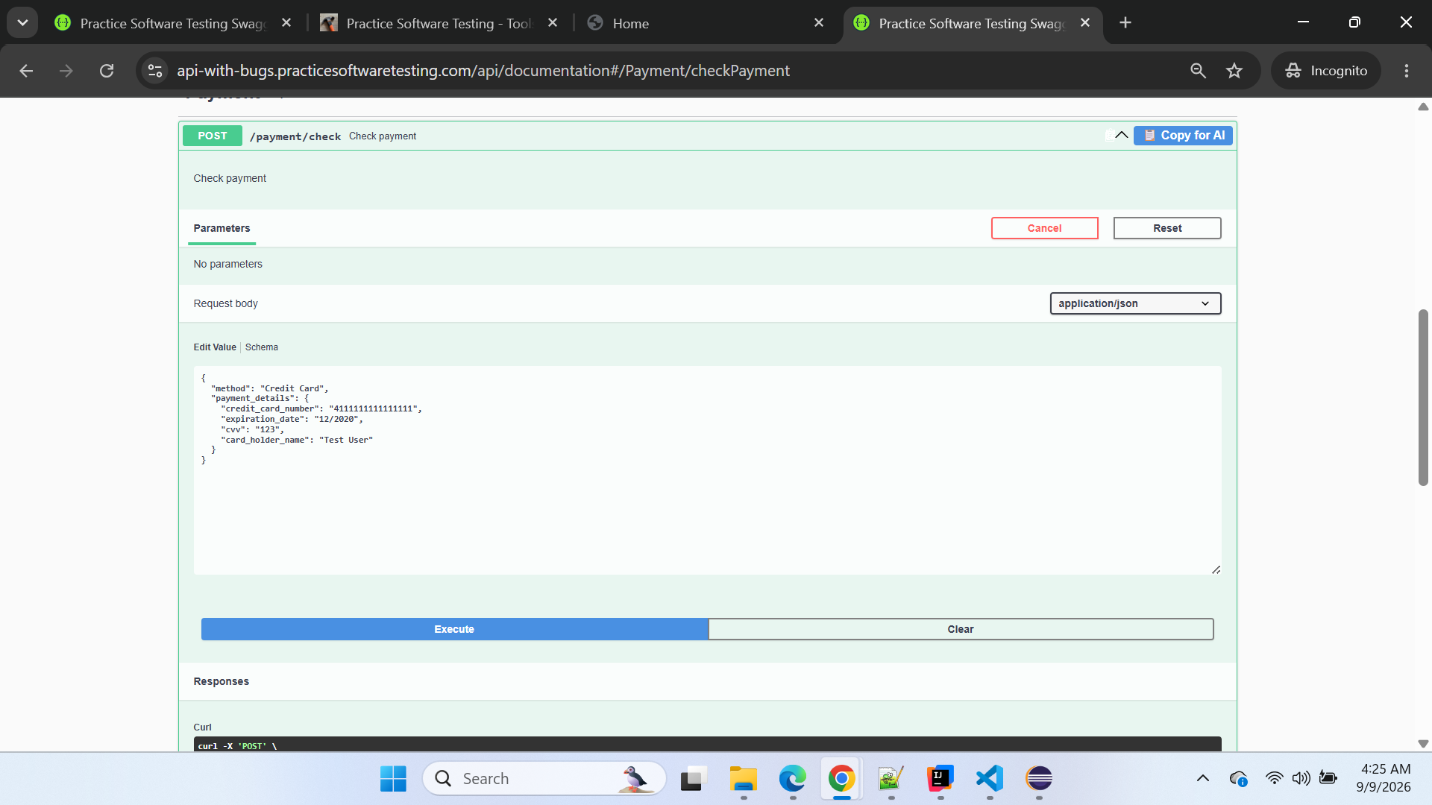
Screenshot 2 — BUGGY response
Attach the screenshot showing:
Code: 200
and:
{
"message": "Payment was successful"
}

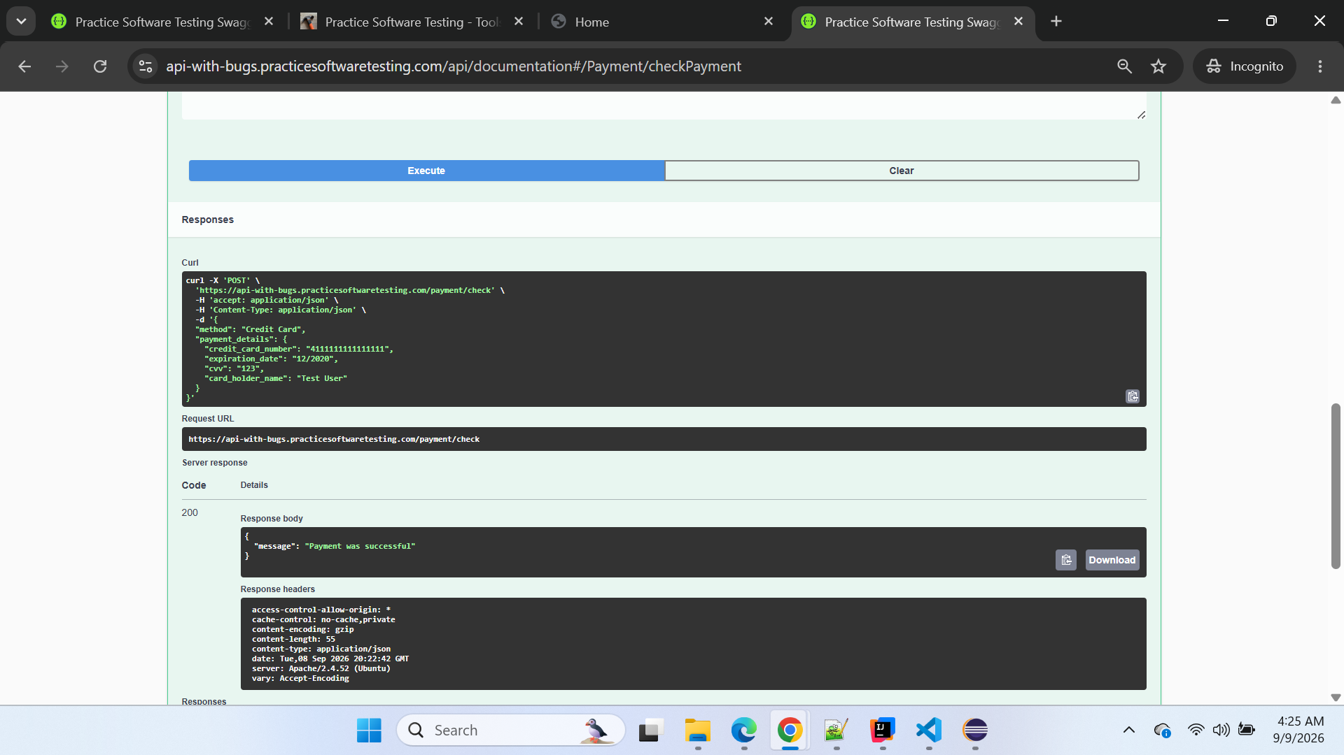

Conclusion
Confirmed defect.
BUGGY POST /payment/check incorrectly accepts an expired credit card and returns HTTP 200 instead of rejecting the request with HTTP 422.
Final defect mapping:
BUG-003 — Payment API accepts expired credit-card expiration date

BUG-004 — Payment API accepts malformed credit-card number
Classification: Confirmed Defect
Severity: High
Priority: High
Area: Payment API / Credit Card Validation
Endpoint: POST /payment/check
Environment: BUGGY
Reproducibility: Consistently reproducible

Description
The BUGGY Payment API incorrectly accepts a malformed credit-card number instead of rejecting the payment details.
The CLEAN environment establishes that an invalid/malformed credit-card number must be rejected with HTTP 422.
The same validation is covered by automated scenario:
CKO-018 — Malformed credit-card number is rejected (422, confirmed error text)
The test isolates the credit-card-number validation by keeping the remaining payment details valid:
{
"method": "Credit Card",
"payment_details": {
"credit_card_number": "4111111111111111",
"expiration_date": "12/2030",
"cvv": "123",
"card_holder_name": "Test User"
}
}
When this request is submitted to the BUGGY environment, the API incorrectly returns HTTP 200 and reports the payment as successful.

Preconditions
- BUGGY Payment API is accessible.
- POST /payment/check endpoint is available.
- Payment method is set to Credit Card.
- Expiration date is valid/future dated.
- CVV is valid.
- Card-holder name is valid.
- Only the credit-card-number validation condition is being tested.

Steps to Reproduce
- Open the BUGGY Swagger documentation.
- Navigate to Payment → POST /payment/check.
- Click Try it out.
- Enter the following request:
{
"method": "Credit Card",
"payment_details": {
"credit_card_number": "4111111111111111",
"expiration_date": "12/2030",
"cvv": "123",
"card_holder_name": "Test User"
}
}
- Click Execute.
- Observe the HTTP status code and response body.

Expected Result
The malformed credit-card number should fail payment validation.
Expected HTTP response:
422
The response should contain the credit-card-number validation error established by the CLEAN environment.
The API must not report the payment as successful.

Actual Result
BUGGY returns:
HTTP 200
with:
{
"message": "Payment was successful"
}
Therefore, the malformed credit-card number is incorrectly accepted.

Impact
This is a High-severity payment-validation defect because invalid credit-card information is allowed to pass the payment-validation layer.
Potential impact includes:
- malformed/invalid credit-card numbers being accepted;
- invalid payment information progressing further through checkout;
- users receiving an incorrect "Payment was successful" response;
- downstream payment failures occurring after validation should already have prevented the transaction;
- incorrect enforcement of credit-card validation rules.
This is not a cascading automation failure.
The test successfully reaches the Payment API and directly exercises the credit-card-number validation business rule.

Automation Evidence
Main Automation Case:
F-API-06 — Checkout Validation
Automated Scenario:
CKO-018 — Malformed credit-card number is rejected (422, confirmed error text)
Playwright expected:
422
Playwright received:
200
Failure:
Expected: 422
Received: 200
The assertion:
expect(status).toBe(
malformedCreditCardCase.expectedStatus
);
is behaving correctly.
The expected status must not be changed from 422 to 200 merely to make the BUGGY test pass, because doing so would mask the regression.

Manual Reproduction Evidence
The defect was independently reproduced through BUGGY Swagger against:
POST /payment/check
The request used:
credit_card_number = 4111111111111111
expiration_date = 12/2030
cvv = 123
card_holder_name = Test User
Actual BUGGY response:
HTTP 200
{
"message": "Payment was successful"
}
The manual Swagger execution therefore confirms the same behavior detected by Playwright.

Screenshot Evidence

Screenshot 1 — BUGGY Payment API request
Attach your first screenshot showing:
- BUGGY Swagger environment
- POST /payment/check
- Method = Credit Card
- Credit-card number = 4111111111111111
- Expiration date = 12/2030
- CVV = 123
- Card-holder name = Test User
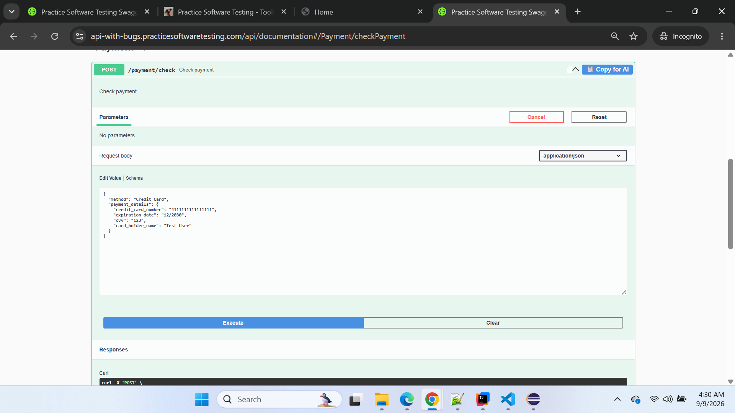

Screenshot 2 — BUGGY Payment API response
Attach your second screenshot showing:
Code: 200
and:
{
"message": "Payment was successful"
}

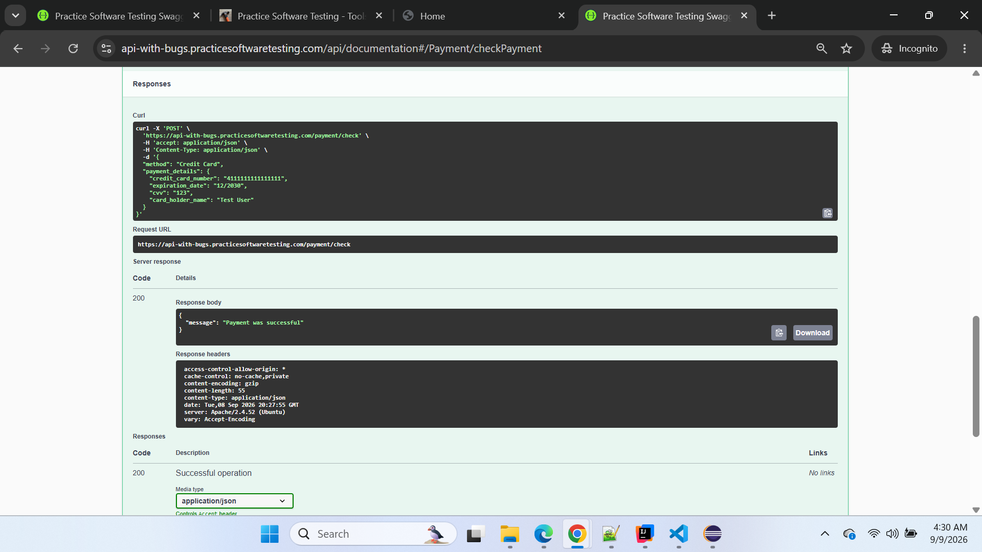

Conclusion
Confirmed defect.
BUGGY Payment API POST /payment/check incorrectly accepts the malformed credit-card number and returns:
HTTP 200 — Payment was successful
instead of rejecting the invalid payment details with:
HTTP 422
The defect is reproduced through both Playwright automation and manual BUGGY Swagger execution.
Final Defect ID: BUG-004 — Payment API accepts malformed credit-card number.

====================================================================

BUG-005 — Cart creation API POST /carts is unavailable and Cart section is missing from BUGGY Swagger documentation
Classification: Confirmed Defect
Severity: Critical
Priority: High
Area: Cart API / Cart Creation / API Documentation
Endpoint: POST /carts
Environment: BUGGY
Reproducibility: Consistently reproducible

Description
The BUGGY environment does not provide a functioning Cart creation API.
The CLEAN environment exposes the Cart API and supports:
POST /carts
for creating a new shopping cart.
In the BUGGY environment, Playwright attempts the same POST /carts request, but the API returns:
HTTP 404
{
"message": "Resource not found"
}
The issue was independently reproduced by sending the request directly to the BUGGY API through PowerShell.
Additionally, comparison of the CLEAN and BUGGY Swagger documentation shows that the entire Cart section is present in CLEAN Swagger but missing from BUGGY Swagger.
This indicates both a functional API availability regression and a corresponding API-documentation discrepancy in the BUGGY environment.

Preconditions
- BUGGY API environment is accessible.
- No authentication is required for the standard cart-creation operation, consistent with the CLEAN behavior.
- Request uses the same cart-creation endpoint and payload used successfully against CLEAN.

Steps to Reproduce

Method 1 — Playwright Automation
- Configure the Playwright API base URL to:
https://api-with-bugs.practicesoftwaretesting.com
- Execute a test requiring creation of a new cart.
- Framework calls:
POST /carts
with:
{}
- Observe the API response.

Method 2 — Direct API Reproduction
- Open Windows PowerShell.
- Execute:
curl.exe -X POST "https://api-with-bugs.practicesoftwaretesting.com/carts" -H "Content-Type: application/json" -H "Accept: application/json" -d "{}"
- Observe the response.

Method 3 — Swagger Documentation Comparison
- Open CLEAN Swagger documentation.
- Observe that a Cart API section is available.
- Open BUGGY Swagger documentation.
- Compare the available API sections.
- Observe that the Cart section is completely missing from BUGGY Swagger.

Expected Result

Functional API
POST /carts should be available and create a new shopping cart, consistent with the CLEAN environment.
Expected successful response:
HTTP 201
(or the framework-supported successful response where applicable).
A valid server-generated cart ID should be returned for subsequent cart operations.
Example expected structure:
{
"id": "<generated-cart-id>"
}

Swagger Documentation
BUGGY Swagger should expose the Cart API section and document the available cart operations, consistent with the expected application API contract.

Actual Result

Functional API
BUGGY returns:
HTTP 404
with:
{
"message": "Resource not found"
}
No cart ID is generated.

Swagger Documentation
The Cart section is completely absent from BUGGY Swagger documentation.
CLEAN Swagger visibly contains:
Brand
Cart
Category
Contact
...
whereas BUGGY Swagger contains:
Brand
Category
Contact
Favorite
...
with Cart missing.

Impact
This is a Critical cart/API regression because cart creation is a prerequisite for major portions of the shopping and checkout journey.
The defect can block:
- creation of new shopping carts;
- adding products to a newly created cart;
- cart quantity updates;
- cart item removal;
- cart lifecycle validation;
- cart discount validation;
- financial line-total calculations;
- combination and eco-discount calculations;
- checkout scenarios that require a cart;
- end-to-end purchase flows dependent on cart creation.
As a result, multiple automated tests can fail as cascading failures from this single root cause.
Those downstream failures must not be reported as separate defects unless their individual business rules can be independently reached and shown to fail.

Automation Evidence
The issue was detected while executing:
Main Automation Case:
F-API-09 — Financial Line Totals + Quantity-Boundary Integrity
Scenario:
FIN-002 — Line total uses the discounted unit price when a per-item location discount applies
Playwright called:
POST /carts
and received:
createCart failed: 404 {"message":"Resource not found"}
Failure location:
utils/apiHelpers.js
The createCart() helper correctly treats this response as a failure:
if (
response.status() !== 201 &&
response.status() !== 200
) {
throw new Error(
`createCart failed: ` +
`${response.status()} ` +
`${JSON.stringify(body)}`
);
}
The automation should not be changed to accept HTTP 404, because that would mask the application defect.

Manual Reproduction Evidence
The same endpoint was independently executed directly through Windows PowerShell:
curl.exe -X POST "https://api-with-bugs.practicesoftwaretesting.com/carts" -H "Content-Type: application/json" -H "Accept: application/json" -d "{}"
Actual response:
{
"message": "Resource not found"
}
This confirms that the Playwright failure is not caused by the automation framework.
The BUGGY API itself cannot resolve the POST /carts resource.

Swagger Documentation Evidence
A manual CLEAN-vs-BUGGY Swagger comparison was also performed.

CLEAN Swagger
The CLEAN API documentation contains a dedicated:
Cart
section.

BUGGY Swagger
The BUGGY API documentation does not contain a Cart section.
This provides additional evidence that the Cart API capability exposed by CLEAN is absent from the BUGGY API/documentation.

Screenshot Evidence

Screenshot 1 — CLEAN Swagger
Attach the CLEAN Swagger screenshot showing:
Brand
Cart
Category
...
This demonstrates that the Cart section exists in CLEAN.
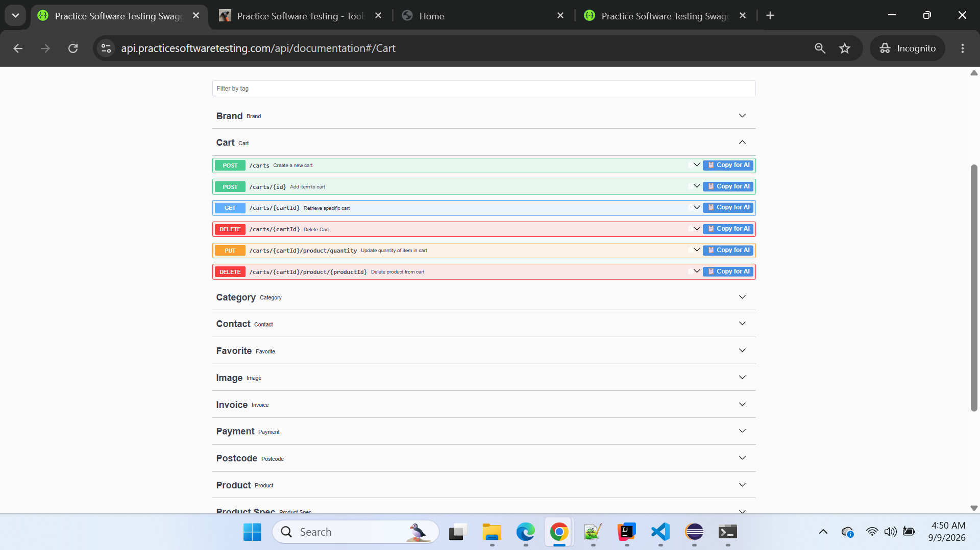

Screenshot 2 — BUGGY Swagger
Attach the BUGGY Swagger screenshot showing:
Brand
Category
Contact
...
with the Cart section absent.
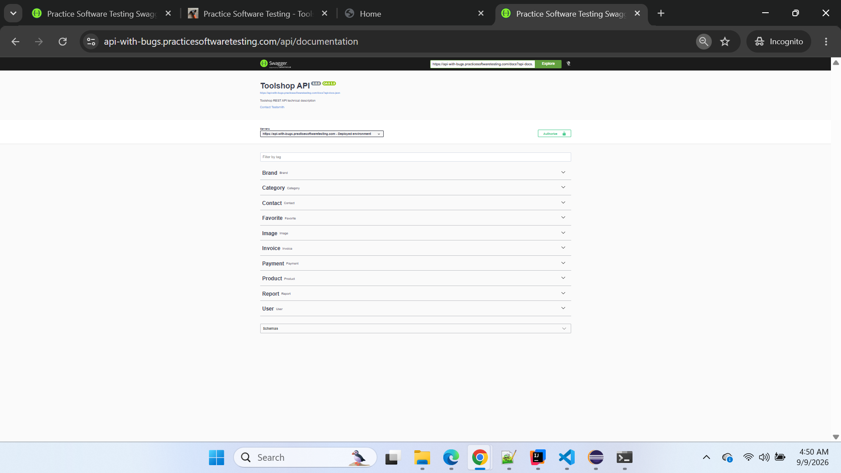

Screenshot 3 — Direct API execution
Attach PowerShell evidence showing:
POST https://api-with-bugs.practicesoftwaretesting.com/carts
returning:
{"message":"Resource not found"}
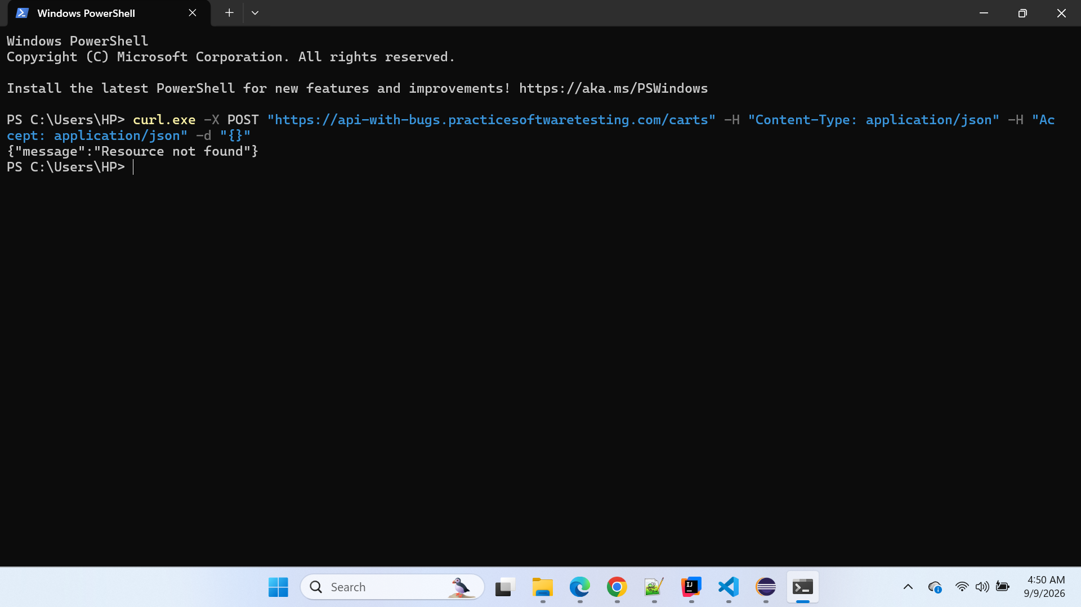

Screenshot 4 — Playwright failure
Where useful, attach the Playwright report showing:
Error: createCart failed: 404 {"message":"Resource not found"}

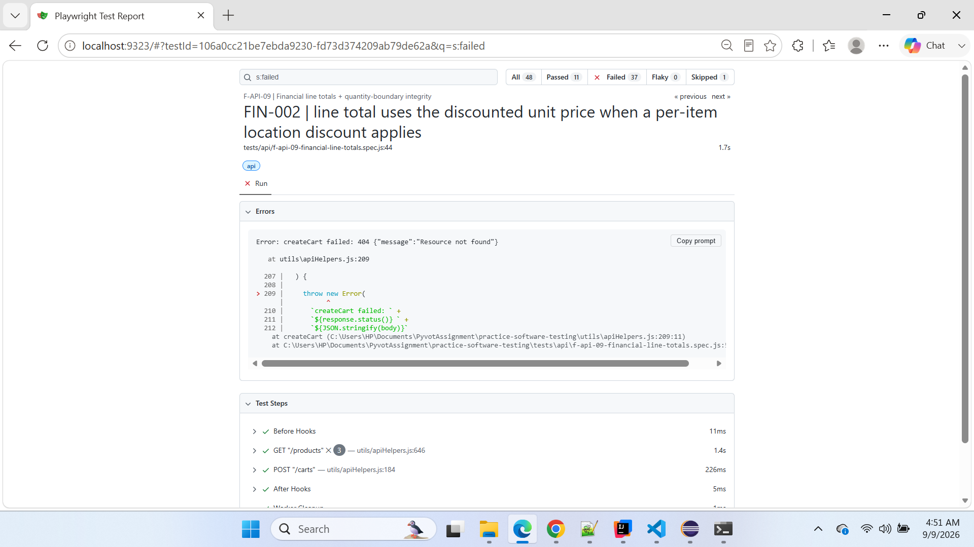
Playwright Test Report

Related / Cascading Automation Failures
Any scenario that fails solely because it cannot create a prerequisite cart should be mapped back to BUG-005, rather than logged as another unique defect.
For example:
FIN-002 — Line total uses the discounted unit price when a per-item location discount applies
is currently a cascading failure from BUG-005.
The intended location-discount financial calculation was not reached, because cart creation failed first.

Conclusion
Confirmed independent defect.
The BUGGY environment does not provide the expected Cart creation capability:
POST /carts
returns:
HTTP 404
{"message":"Resource not found"}
The behavior is reproduced through both Playwright automation and a direct PowerShell API request.
Additionally, the entire Cart section is missing from BUGGY Swagger documentation, while it is present in CLEAN Swagger.
Therefore, this should be logged as:
BUG-005 — Cart creation API POST /carts is unavailable and Cart section is missing from BUGGY Swagger documentation.

==============================================================

BUG-006 — Registration API rejects valid nested address payload accepted by CLEAN
Classification: Confirmed Defect — CLEAN vs BUGGY behavioral/contract regression
Severity: High
Priority: High
Area: Authentication / Customer Registration API
Feature: Customer Registration
Endpoint: POST /users/register
HTTP Method: POST
Automation Test Group ID: F-API-02 — Registration — success and boundaries
Automated Sub-case ID: AUTH-011 — Valid registration succeeds (201)
Technique: Equivalence Partitioning — Valid Registration Partition
Environment: BUGGY
Reproducibility: Consistently reproducible during automation execution
Business Rule Reached: Yes
Cascading Failure: No — Independent defect
New Defect: Yes — Confirmed

Description
The BUGGY Registration API rejects a valid customer registration request containing the nested address object structure that is successfully accepted by the CLEAN application.
The automated scenario F-API-02 / AUTH-011 submits a dynamically generated valid customer registration payload and expects:
HTTP 201 Created
The same payload structure succeeds against the CLEAN API with HTTP 201, confirming that the automation request structure and test data are valid.
However, when the same test is executed against the BUGGY API, registration fails with:
HTTP 422 Unprocessable Entity
The BUGGY API reports:
{
"address": [
"The address field must be a string."
],
"city": [
"The city field is required."
],
"country": [
"The country field is required."
]
}
This demonstrates that the BUGGY API is validating the registration address contract differently from the CLEAN behavioral oracle.

Automation Traceability
Field | Details
Automation Group | F-API-02 — Registration — success and boundaries
Sub-case | AUTH-011
Scenario | Valid registration succeeds
Technique | Equivalence Partitioning
Expected Status | 201 Created
BUGGY Actual Status | 422 Unprocessable Entity
CLEAN Status | 201 Created
Business Rule Reached | Yes
Root Cause Category | Registration request-contract regression
Defect | BUG-006

Preconditions
- Registration API is accessible.
- Customer email is unique.
- Customer registration data satisfies the valid registration requirements.
- Date of birth represents a valid adult customer.
- Password satisfies the valid-password requirements.
- Valid address information is supplied using the nested address structure accepted by CLEAN.

Automation Test
The automated scenario is:
test('AUTH-011 | valid registration succeeds (201)', async ({ request }) => {
const payload = buildRegistrationPayload();

const { status, body } = await register(
request,
payload
);

expect(status).toBe(201);
expect(body.email).toBe(payload.email);
expect(body.id).toBeTruthy();
});
The expected 201 assertion must remain unchanged because CLEAN confirms that this is a valid registration request.

Request Structure
The test dynamically generates customer data. The address is supplied as a nested object:
{
"first_name": "<generated first name>",
"last_name": "<generated last name>",
"dob": "1995-06-15",
"address": {
"street": "<generated street>",
"city": "<generated city>",
"state": "<generated state>",
"country": "Netherlands",
"postal_code": "1234AB"
},
"phone": "0612345678",
"email": "<unique generated email>",
"password": "<valid generated password>"
}
Dynamic names and emails differ between executions, but the registration contract and nested address structure remain the same.

CLEAN Application Comparison

CLEAN API
https://api.practicesoftwaretesting.com

Automated scenario
F-API-02 / AUTH-011

CLEAN result
Expected: 201
Actual: 201
Result: PASS
During the comparison execution, CLEAN accepted the generated registration request:
AUTH-011 status: 201
The response contained the newly created customer ID, email, and address information.
Example CLEAN response from the comparison run:
{
"first_name": "Lola",
"last_name": "Franey",
"dob": "1995-06-15",
"phone": "0612345678",
"email": "qa.1788901398276.JH2IRqlv@example.com",
"id": "01m21da75ds4nnchhdy3xjjse6",
"created_at": "2026-09-08 21:03:19",
"address": {
"street": "646 N Jefferson Street",
"house_number": null,
"city": "Missoula",
"state": "Montana",
"country": "Netherlands",
"postal_code": "1234AB"
}
}
This confirms that CLEAN accepts the nested address contract.

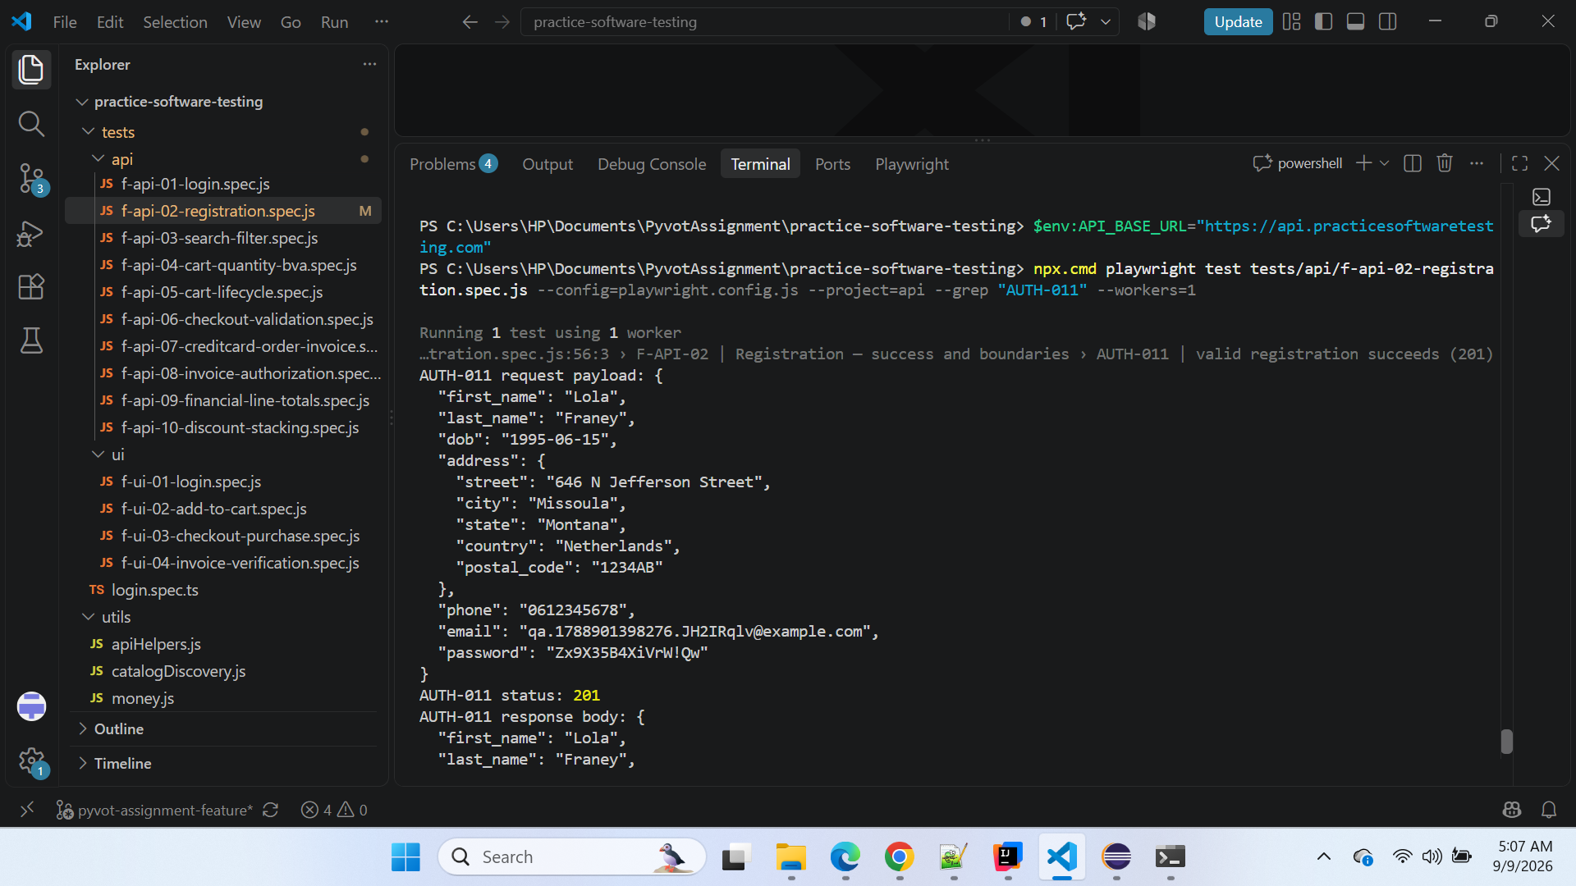

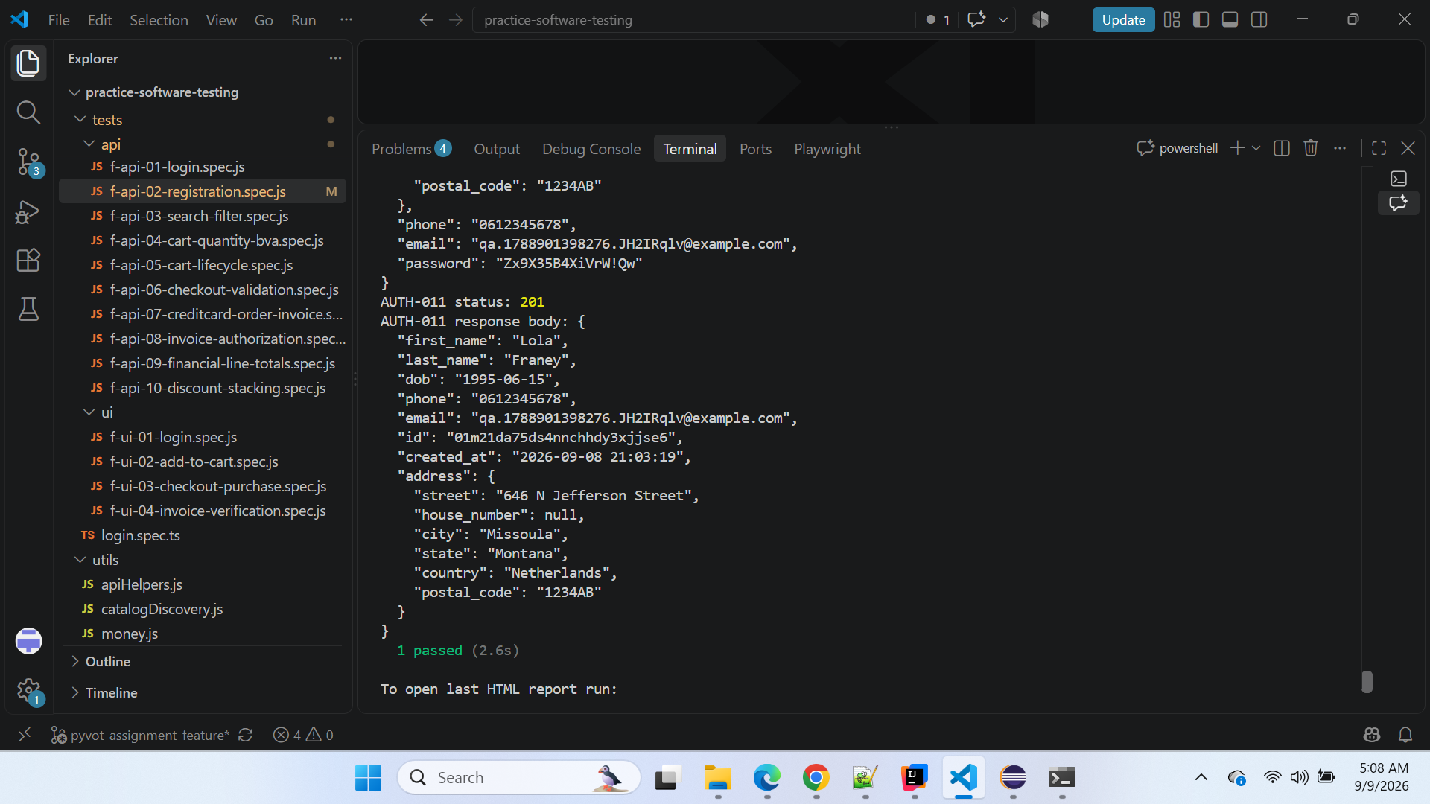

BUGGY Application Comparison

BUGGY API
https://api-with-bugs.practicesoftwaretesting.com

BUGGY Web Application
https://with-bugs.practicesoftwaretesting.com

BUGGY Swagger
https://api-with-bugs.practicesoftwaretesting.com/api/documentation

BUGGY result
Expected: 201
Actual: 422
Result: FAIL
During the BUGGY execution, the request contained:
{
"first_name": "Zane",
"last_name": "Kreiger",
"dob": "1995-06-15",
"address": {
"street": "4927 Dion Harbor",
"city": "North Mildredfort",
"state": "New Hampshire",
"country": "Netherlands",
"postal_code": "1234AB"
},
"phone": "0612345678",
"email": "qa.1788901285076.2R1kugj9@example.com",
"password": "Zx96gAWxUCDUH!Qw"
}
BUGGY returned:
HTTP 422
with:
{
"address": [
"The address field must be a string."
],
"city": [
"The city field is required."
],
"country": [
"The country field is required."
]
}

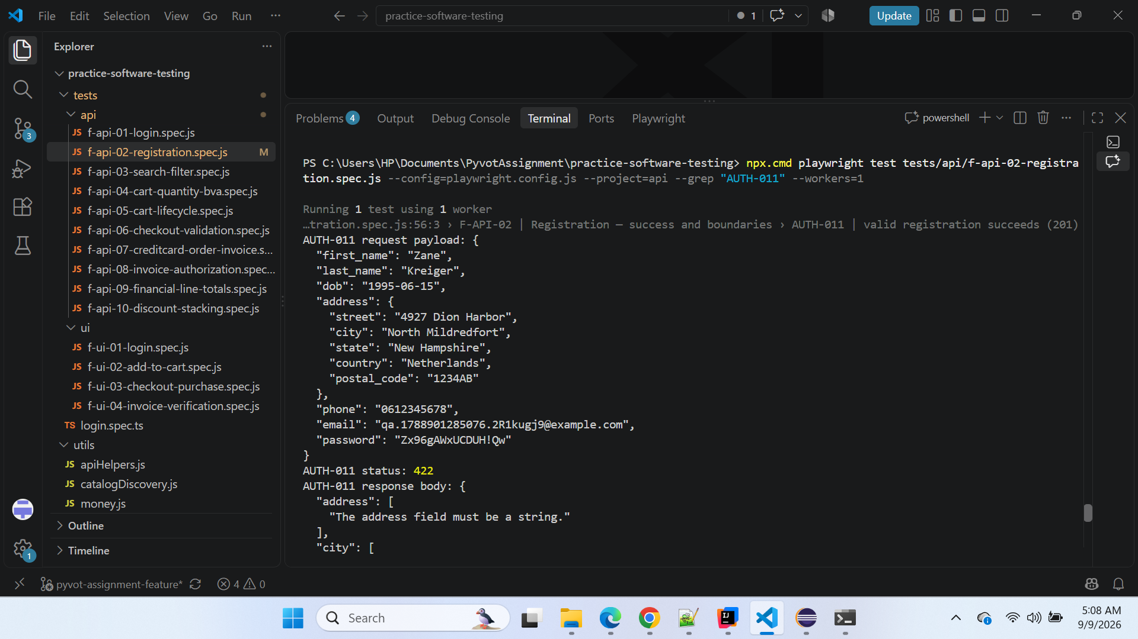

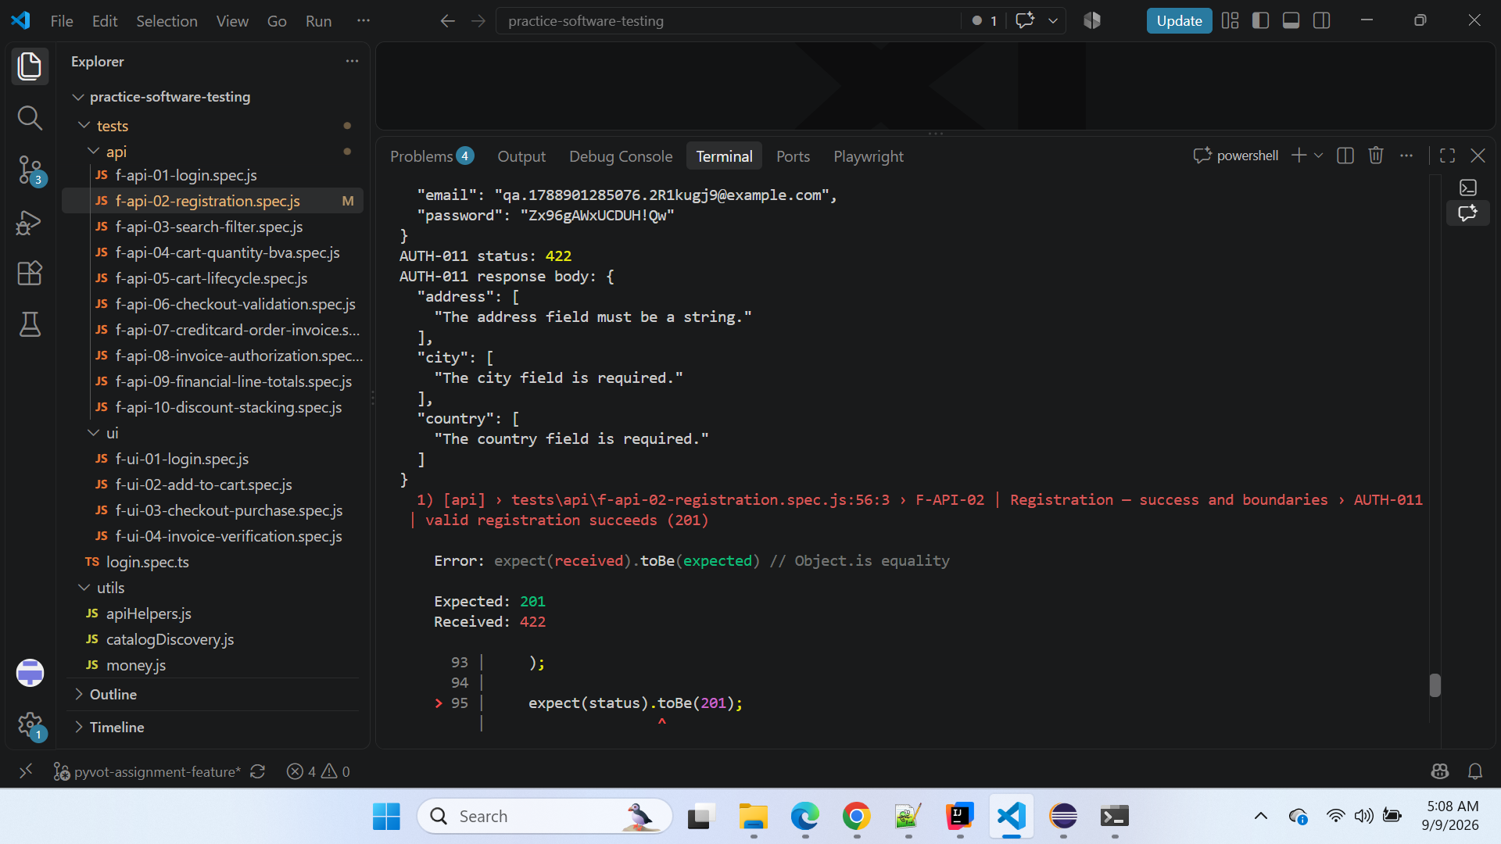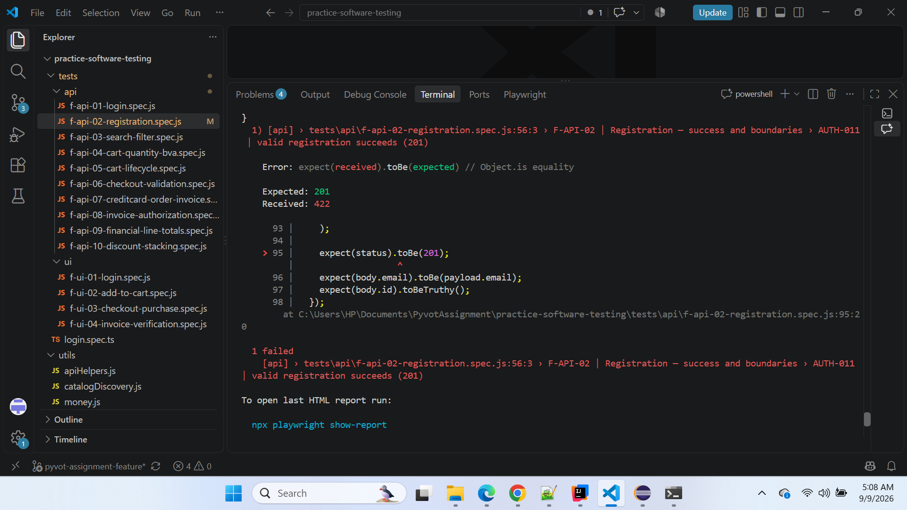

CLEAN vs BUGGY Comparison
Validation Point | CLEAN | BUGGY
Endpoint | POST /users/register | POST /users/register
Scenario | AUTH-011 valid registration | AUTH-011 valid registration
Address structure | Nested object | Same nested object
Request reaches registration validation | Yes | Yes
Address accepted | Yes | No
address treated as nested object | Yes | No — expects string
Nested city accepted | Yes | No — reports city required
Nested country accepted | Yes | No — reports country required
Expected HTTP status | 201 | 201
Actual HTTP status | 201 | 422
Customer created | Yes | No
Automation result | PASS | FAIL
The comparison isolates the regression to the BUGGY registration contract rather than the Playwright test implementation.

Steps to Reproduce
- Prepare a valid customer-registration request.
- Supply a unique valid email.
- Supply a valid password.
- Supply a valid DOB.
- Supply address information as a nested object containing:
  - street
  - city
  - state
  - country
  - postal_code
- Send the request to:
POST /users/register
- Execute against CLEAN.
- Observe HTTP 201 Created and a newly created customer.
- Execute the equivalent valid registration structure against BUGGY.
- Observe HTTP 422 Unprocessable Entity.
- Inspect the BUGGY validation response.

Expected Result
BUGGY should behave consistently with the CLEAN behavioral oracle.
For a valid registration request containing the accepted nested address structure:
HTTP 201 Created
should be returned.
The response should contain the created customer information, including a customer ID and the submitted email/address information.

Actual Result
BUGGY rejects the valid registration request with:
HTTP 422 Unprocessable Entity
and returns:
{
"address": [
"The address field must be a string."
],
"city": [
"The city field is required."
],
"country": [
"The country field is required."
]
}
No customer is created.

Impact
This is a high-impact registration defect because a customer using the registration request contract accepted by CLEAN cannot successfully register against BUGGY.
Potential impact includes:
- valid customer registration being blocked;
- account creation failing before authentication or checkout;
- registration-dependent shopping journeys being blocked;
- downstream authenticated checkout scenarios potentially becoming unavailable;
- API consumers using the CLEAN-compatible registration contract receiving unexpected validation failures.
Because registration is an entry point into authenticated customer journeys, the defect can affect several downstream workflows.
However, downstream failures caused by an inability to create a customer should be mapped back to BUG-006 rather than reported as separate defects, unless an independent root cause is demonstrated.

Automation Evidence
BUGGY automated execution:
F-API-02 | Registration — success and boundaries
AUTH-011 | valid registration succeeds (201)

Expected: 201
Received: 422

1 failed
Diagnostic response:
AUTH-011 status: 422
{
"address": [
"The address field must be a string."
],
"city": [
"The city field is required."
],
"country": [
"The country field is required."
]
}

CLEAN Verification Evidence
The same automated scenario was switched to the CLEAN API without changing the business expectation.
Result:
AUTH-011 status: 201

1 passed
The returned CLEAN customer object contained:
"address": {
"street": "646 N Jefferson Street",
"house_number": null,
"city": "Missoula",
"state": "Montana",
"country": "Netherlands",
"postal_code": "1234AB"
}
This provides direct oracle evidence that the nested address representation is accepted by CLEAN.

Test Automation Handling
Do not change:
expect(status).toBe(201);
to:
expect(status).toBe(422);
The failing assertion is intentionally valuable because it pins the confirmed BUGGY regression.
The correct expected result remains:
HTTP 201 Created

Conclusion
BUG-006 is confirmed.
The F-API-02 / AUTH-011 valid-registration scenario passes against CLEAN with HTTP 201 but fails against BUGGY with HTTP 422.
The BUGGY API rejects the nested address representation accepted by CLEAN and reports that address must be a string while separately requiring city and country.
This is an independent Registration API contract/validation regression, not a cascading failure from BUG-001 through BUG-005 and not an automation-data problem.
Final disposition: Confirmed BUGGY defect — preserve AUTH-011 expected HTTP 201 and keep the BUGGY regression visible in the automated suite.

======================================================================

CLEAN-BUG-001 — Registration API accepts customer older than maximum allowed age
Classification: Confirmed CLEAN Application Defect
Severity: Medium
Priority: Medium
Area: Authentication / Customer Registration API
Feature: Customer Registration / Age Validation
Endpoint: POST /users/register
HTTP Method: POST
Automation Test Group ID: F-API-02 — Registration — success and boundaries
Automated Sub-case ID: AUTH-015 — Over maximum-age boundary
Technique: Boundary Value Analysis (BVA)
Environment: CLEAN
Reproducibility: Manually reproduced and confirmed
Business Rule Reached: Yes
Cascading Failure: No — Independent CLEAN defect
Automation Handling: Known CLEAN defect — intentionally skipped while preserving expected result

Description
The CLEAN Registration API accepts a customer whose age exceeds the intended maximum registration age.
The registration requirement defines the valid age range with an upper boundary of 75 years. Therefore, a customer who is 76 years old belongs to the invalid partition immediately beyond the maximum boundary and should be rejected.
For AUTH-015, the expected response is:
HTTP 422 Unprocessable Entity
However, the deployed CLEAN API accepts the registration and returns:
HTTP 201 Created
The customer is therefore created even though the supplied DOB is outside the intended valid age range.

Automation Traceability
Field | Details
Automation Group | F-API-02 — Registration — success and boundaries
Scenario | AUTH-015
Boundary | 76 years old — maximum + 1
Technique | Boundary Value Analysis
Expected | 422 — Registration rejected
CLEAN Actual | 201 — Customer created
Business Rule Reached | Yes
Classification | Independent CLEAN defect
Defect ID | CLEAN-BUG-001
Automation Status | Skipped as known CLEAN defect

Preconditions
- CLEAN Registration API is available.
- A unique email address is used.
- All registration fields other than DOB contain valid data.
- Password satisfies the registration requirements.
- DOB represents a customer 76 years old, immediately outside the intended maximum-age boundary.

Steps to Reproduce
- Open the CLEAN Registration API/Swagger.
- Prepare an otherwise valid customer registration request.
- Use a unique valid email.
- Supply valid name, address, phone and password information.
- Set DOB so the customer is 76 years old.
- Submit:
POST /users/register
- Observe the response.

Expected Result
Because the customer exceeds the maximum permitted age of 75:
HTTP 422 Unprocessable Entity
should be returned.
The registration should be rejected and no customer should be created.

Actual Result
The CLEAN API returns:
HTTP 201 Created
and creates the customer.
Therefore, the maximum-age validation is not enforced as expected for this boundary case.

Boundary Analysis
The relevant BVA scenarios are:
Boundary | Scenario | Expected
Valid minimum boundary | AUTH-012 refined — 18 years + 1 day | 201
Valid maximum boundary | AUTH-013 — exactly 75 years | 201
Maximum + 1 | AUTH-015 — 76 years | 422
AUTH-015 specifically tests the first invalid value beyond the intended upper boundary.

Automation Evidence
The original business expectation remains:
expect(status).toBe(
boundaryCase.expectedStatus
);
For AUTH-015:
Expected status: 422
CLEAN actual: 201
The scenario is marked as a known CLEAN defect:
if (boundaryCase.knownCleanDefect) {
test.skip(
true,
boundaryCase.defectReason
);
}
This prevents the known CLEAN issue from making the normal CLEAN regression baseline red while preserving the correct expected business result in test data.

Manual Reproduction Evidence
The issue was independently verified against the deployed CLEAN Registration API.
A registration request representing a 76-year-old customer was submitted.
Expected:
422 — Registration rejected
Actual:
201 — Customer created
This confirms that the behavior is not caused by Playwright automation.

Source/Requirement Evidence
The CLEAN Sprint 5 registration validation was reviewed as the source of truth for the intended age constraint.
The registration validation indicates an intended age range with an upper boundary of 75 years.
We also identified a likely implementation explanation involving mutable Carbon date calculations in the CLEAN validation code. That should be described only as a likely root cause, not as proven root cause, because our defect conclusion is based primarily on observable behavior and manual reproduction.

Impact
The defect allows customers outside the intended registration age range to create accounts.
It also creates inconsistency between:
- the intended registration validation;
- boundary-value expectations;
- API behavior; and
- automated regression expectations.
The defect is isolated to the CLEAN baseline and should not be counted as one of the intentionally seeded BUGGY-environment defects.

Automation Handling / Important Note
We should not change:
Expected 422
to:
Expected 201
just to make the CLEAN suite green.
Instead:
AUTH-015 → CLEAN-BUG-001 → known defect → expected 422 preserved → scenario intentionally skipped.
This is why the CLEAN baseline remains:
49 total → 48 passed + 1 skipped (CLEAN-BUG-001 / AUTH-015) + 0 failed.

Conclusion
CLEAN-BUG-001 is a confirmed defect in the CLEAN application.
The F-API-02 / AUTH-015 BVA scenario verifies the first invalid value beyond the intended maximum registration age. A 76-year-old customer should be rejected with HTTP 422, but CLEAN returns HTTP 201 and creates the customer.
The defect was manually reproduced, the original business expectation remains preserved, and the automated scenario is intentionally marked as a known CLEAN defect rather than modifying the assertion to match incorrect runtime behavior.
Final classification: Confirmed independent CLEAN defect — not part of BUG-001 through BUG-006 in the BUGGY environment.
========================================================================

BUG-007 — Invoice API returns an existing invoice for a non-existent invoice ID
Classification: Confirmed Defect — CLEAN vs BUGGY Behavioral Regression
Severity: High
Priority: High
Area: Invoice API / Authorization / Resource Lookup
Feature: Invoice Retrieval / IDOR Protection
HTTP Method: GET
Automation Test Group ID: F-API-08 — Invoice authorization / IDOR protection
Automated Sub-case ID: INV-007 — A non-existent invoice ID is not returned (404)
Technique: Decision Table
Environment: BUGGY
Reproducibility: Consistently reproducible
Business Rule Reached: Yes
Cascading Failure: No — Independent defect
New Defect: Yes — Confirmed

Description
The BUGGY Invoice API incorrectly returns HTTP 200 OK and an existing invoice when an authenticated customer requests an invoice using a deliberately non-existent invoice ID.
The automated scenario F-API-08 / INV-007 requests the following non-existent invoice identifier:
01NONEXISTENTINVOICEID0000
The expected behavior is:
HTTP 404 Not Found
The CLEAN application behaves correctly and returns HTTP 404 with:
{
"message": "Requested item not found"
}
However, the BUGGY application returns HTTP 200 OK and an unrelated existing invoice:
Invoice Number: INV-2019000001
Invoice ID: 1
User ID: 2
Status: SHIPPED
The returned response also contains billing information, payment information, invoice lines, and product details.
This confirms an independent regression in the BUGGY Invoice API's resource lookup behavior.

Automation Traceability
Field | Details
Automation Group | F-API-08 — Invoice authorization / IDOR protection
Automated Sub-case | INV-007
Scenario | A non-existent invoice ID must not return an invoice
Technique | Decision Table
Requested Invoice ID | 01NONEXISTENTINVOICEID0000
Expected Status | 404 Not Found
CLEAN Actual Status | 404 Not Found
BUGGY Actual Status | 200 OK
CLEAN Result | PASS
BUGGY Result | FAIL
Business Rule Reached | Yes
Cascading Failure | No
Defect ID | BUG-007

Preconditions
- Invoice API is available.
- A valid customer account exists.
- Customer authentication succeeds.
- A valid access token is available.
- The requested invoice ID does not exist.
The automated test deliberately uses:
01NONEXISTENTINVOICEID0000
as the non-existent invoice identifier.

Steps to Reproduce
- Authenticate using a valid customer account.
- Obtain the customer's valid access token.
- Send a GET request for an invoice using the following deliberately non-existent invoice ID:
01NONEXISTENTINVOICEID0000
- Execute the scenario against the CLEAN API.
- Observe that CLEAN returns HTTP 404 Not Found.
- Execute the same automated scenario against the BUGGY API.
- Observe that BUGGY returns HTTP 200 OK.
- Inspect the BUGGY response body.
- Observe that an existing invoice, INV-2019000001, is returned even though that invoice was not requested.

Expected Result
A request for a non-existent invoice ID should return:
HTTP 404 Not Found
No invoice information should be returned.
The expected response is consistent with CLEAN behavior:
{
"message": "Requested item not found"
}

Actual Result
The BUGGY API returns:
HTTP 200 OK
and returns an existing invoice unrelated to the requested identifier.
The returned invoice includes:
Invoice ID: 1
Invoice Number: INV-2019000001
User ID: 2
Invoice Date: 2019-04-05 22:04:47
Total: 34.04
Payment Method: Cash on Delivery
Status: SHIPPED
The response additionally contains billing information, payment-account information, invoice lines, and product information.

CLEAN vs BUGGY Comparison
Validation Point | CLEAN | BUGGY
Automation Group | F-API-08 | F-API-08
Scenario | INV-007 | INV-007
Requested Invoice ID | 01NONEXISTENTINVOICEID0000 | 01NONEXISTENTINVOICEID0000
Authentication | Valid authenticated customer | Valid authenticated customer
Expected HTTP Status | 404 | 404
Actual HTTP Status | 404 | 200
Resource Returned | No | Yes
Response | "Requested item not found" | Existing invoice object
Existing Invoice Exposed | No | Yes — INV-2019000001
Test Result | PASS | FAIL
The same automated scenario therefore behaves correctly against CLEAN and incorrectly against BUGGY, isolating the regression to the BUGGY environment.

BUGGY Automation Evidence
The automated scenario was first executed against:
https://api-with-bugs.practicesoftwaretesting.com
Test:
F-API-08 | Invoice authorization / IDOR protection
INV-007 | a non-existent invoice id is not returned (404)

BUGGY execution result
Expected: 404
Received: 200

INV-007 status: 200

Test Result: FAILED
The response contained an existing invoice:
{
"id": 1,
"user_id": 2,
"invoice_date": "2019-04-05 22:04:47",
"invoice_number": "INV-2019000001",
"billing_address": "Test street 123",
"billing_city": "Utrecht",
"billing_state": "Utrecht",
"billing_country": "The Netherlands",
"billing_postcode": "1122AB",
"total": 34.04,
"payment_method": "Cash on Delivery",
"payment_account_name": "Tester",
"payment_account_number": "09876543ABC",
"status": "SHIPPED"
}
The full response additionally contained invoice lines and product information.

Screenshot Evidence — BUGGY
Attached BUGGY VS Code terminal screenshot here.
Suggested caption:
Screenshot 1 — BUGGY automation execution: F-API-08 / INV-007 failed because the Invoice API returned HTTP 200 and an existing invoice (INV-2019000001) for the deliberately non-existent invoice ID 01NONEXISTENTINVOICEID0000.

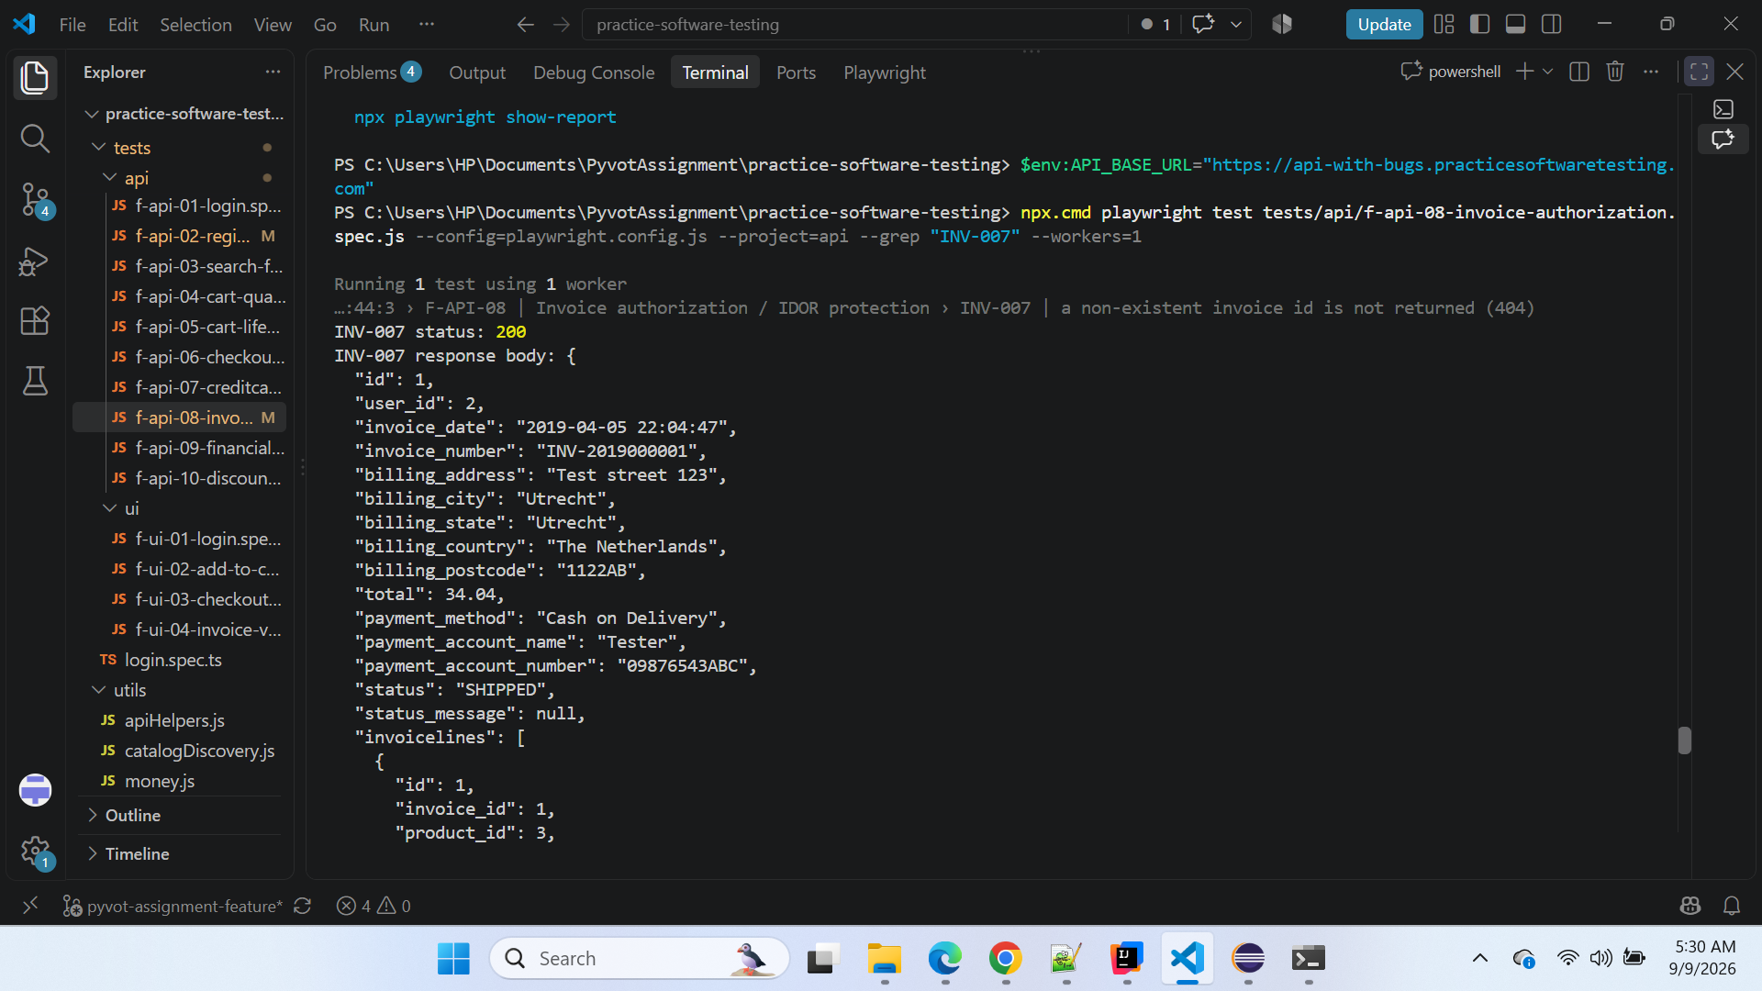

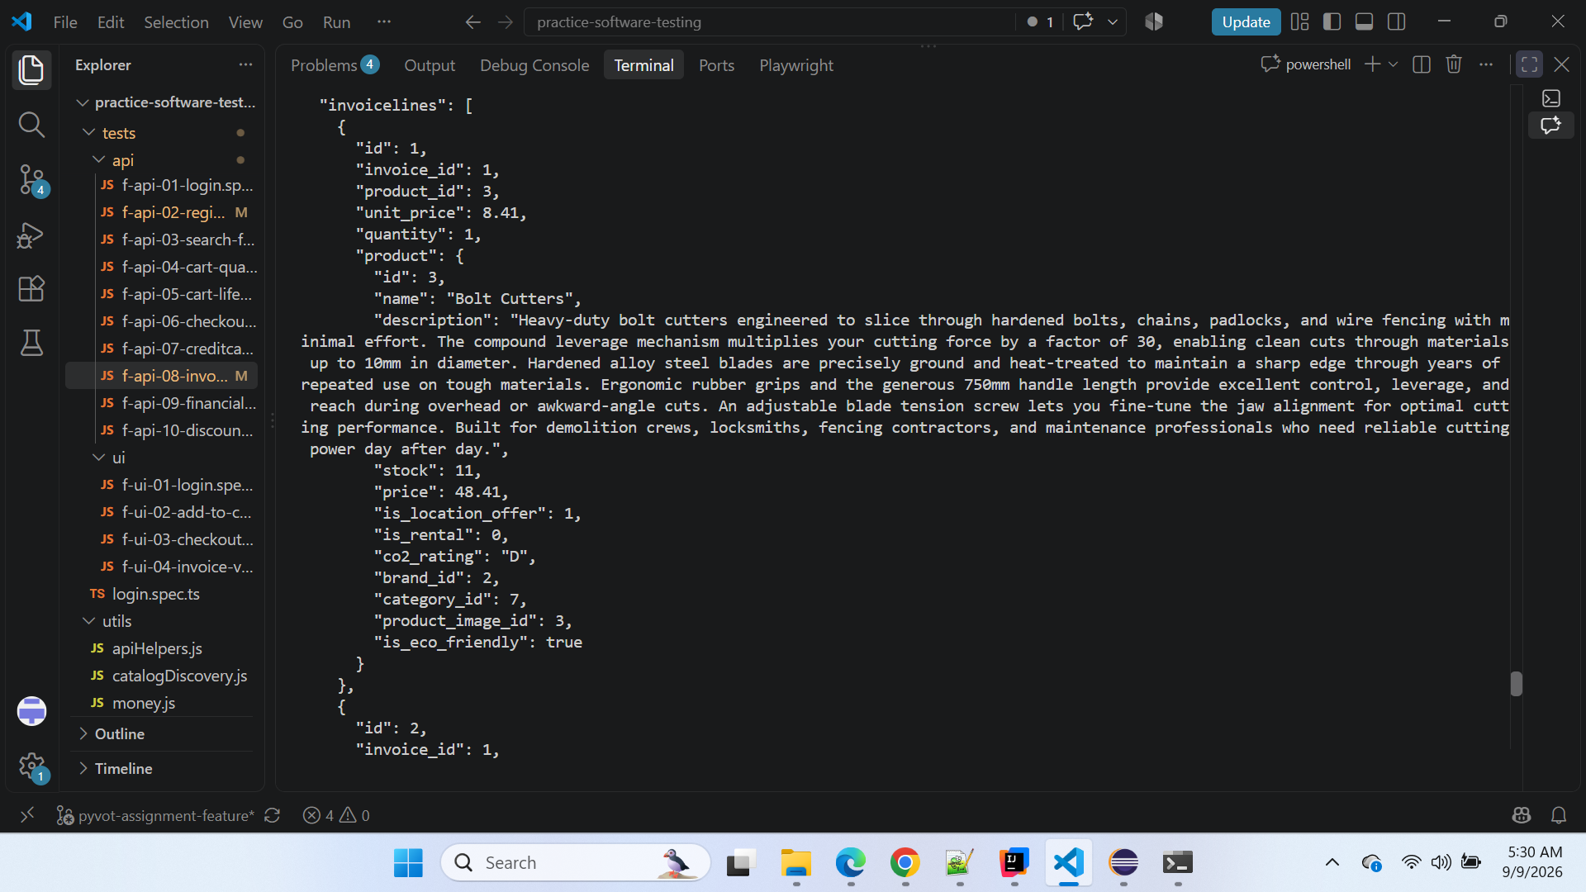

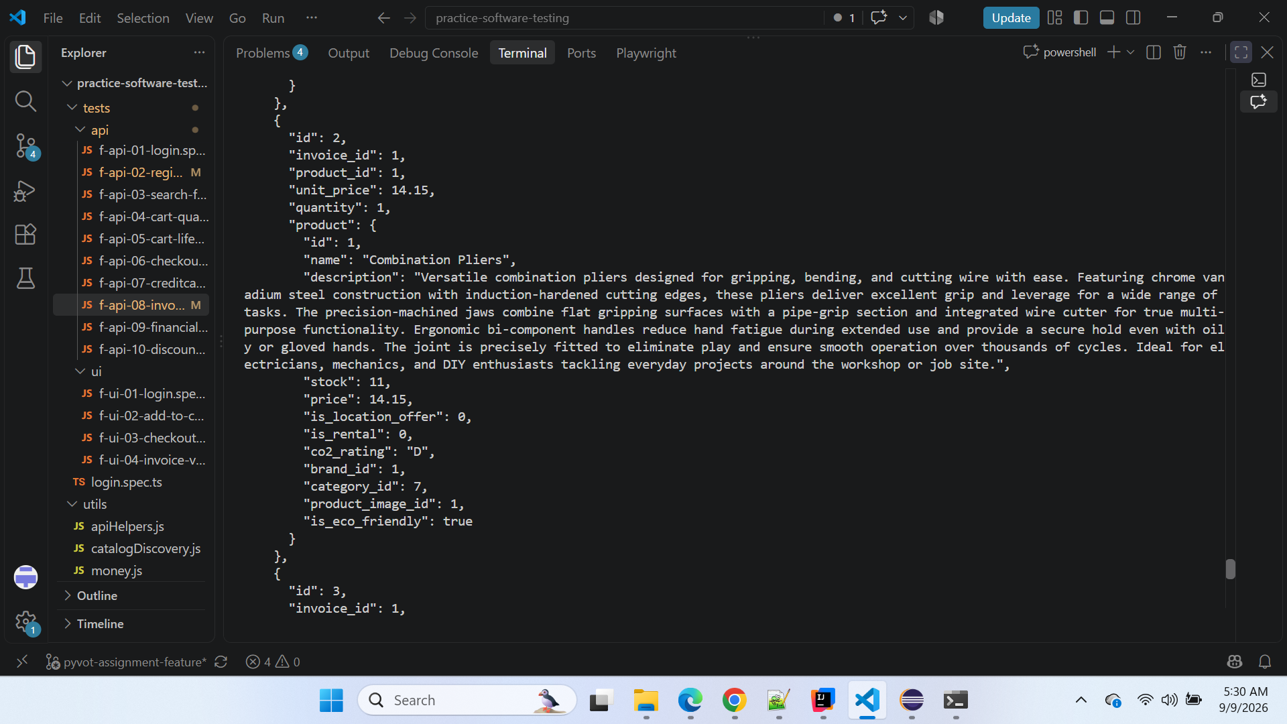

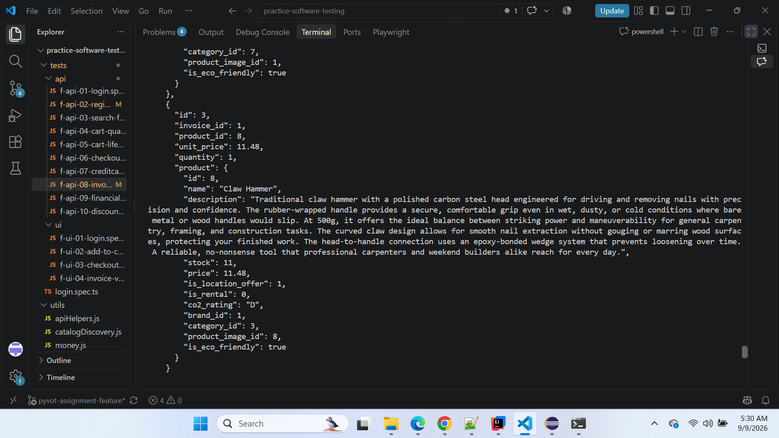

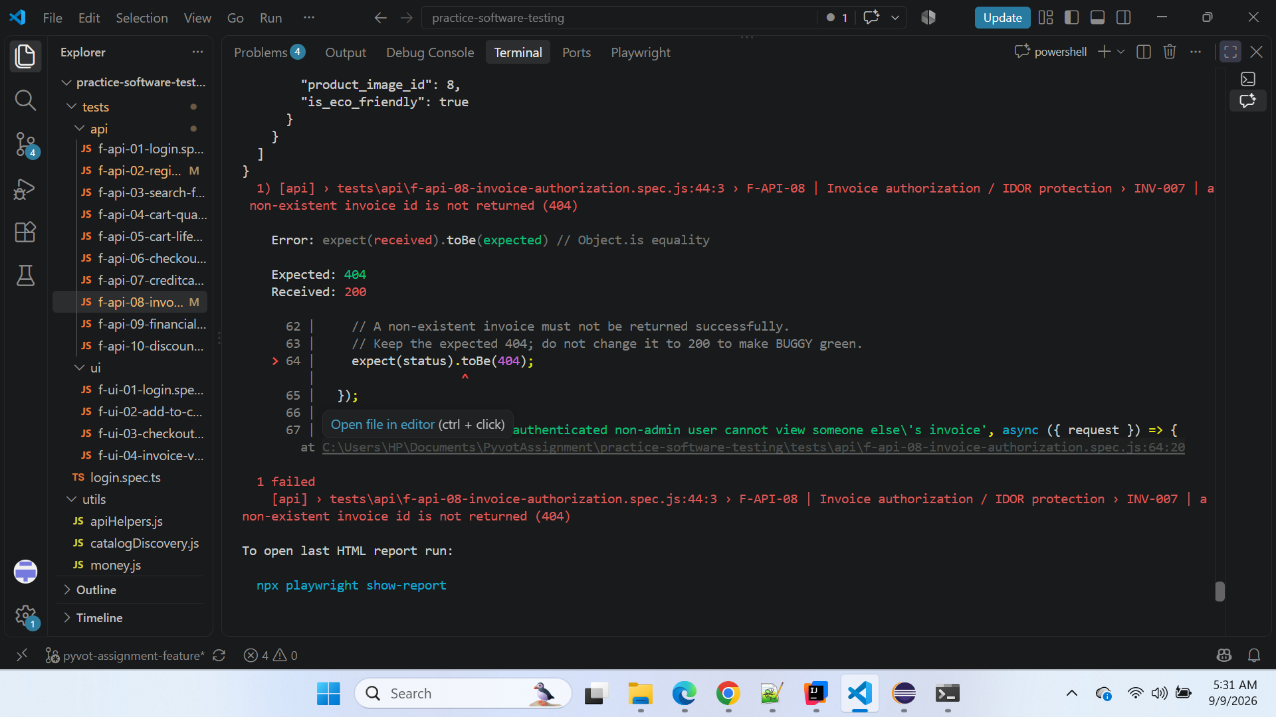

CLEAN Verification Evidence
The same automated scenario was then executed against:
https://api.practicesoftwaretesting.com
No expected-result change was made.

CLEAN execution result
INV-007 status: 404

INV-007 response body: {
"message": "Requested item not found"
}

1 passed
The CLEAN application therefore correctly rejects the non-existent invoice identifier.

Screenshot Evidence — CLEAN
Attached CLEAN VS Code terminal screenshot here.
Suggested caption:
Screenshot 2 — CLEAN verification execution: The same F-API-08 / INV-007 scenario passed against CLEAN. The Invoice API correctly returned HTTP 404 with "Requested item not found" for 01NONEXISTENTINVOICEID0000.
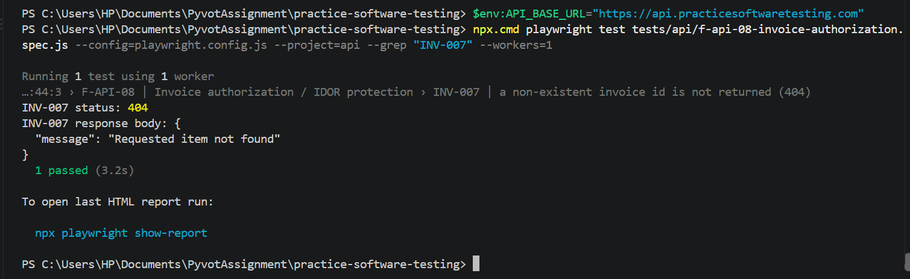

Impact
This defect has a significant functional and potential data-exposure impact.
The Invoice API does not correctly respect the requested invoice identifier. Instead of reporting that the requested resource does not exist, BUGGY returns an unrelated existing invoice.
Potential impact includes:
- incorrect invoice retrieval;
- API clients receiving a different invoice than requested;
- successful HTTP responses for resources that do not exist;
- unintended exposure of invoice information;
- exposure of billing and payment-related information;
- unreliable invoice authorization/resource lookup;
- downstream applications processing incorrect invoice data.
Because actual invoice data is returned, the impact is greater than simply returning an incorrect HTTP status code.

Security / IDOR Consideration
This test belongs to:
F-API-08 — Invoice authorization / IDOR protection
INV-007 confirms that BUGGY can return an unrelated real invoice for a non-existent resource identifier.
However, this defect should currently be described primarily as an invoice resource-lookup / potential data-exposure defect.
We should not yet claim that INV-007 alone proves a full cross-user IDOR vulnerability.
The separate INV-008 scenario is designed to determine whether one authenticated non-admin customer can retrieve another customer's valid invoice. That scenario will provide stronger evidence regarding cross-user authorization.

Automation Handling
The existing business assertion is correct:
expect(status).toBe(404);
It must not be changed to:
expect(status).toBe(200);
The failing BUGGY test is intentional and correctly pins the confirmed regression.
The same assertion passes against CLEAN, providing direct oracle validation.

Root Cause / Failure Classification
Independent defect: Yes
Cascading from another defect: No
Business rule reached: Yes
Automation issue: No
Test-data issue: No
Environment-specific regression: Yes — BUGGY
The scenario requires only successful authentication followed by invoice retrieval. It does not depend on product discovery, cart creation, customer registration, or the previously confirmed BUG-001 through BUG-006 failure paths.

Conclusion
BUG-007 is a confirmed independent BUGGY-environment defect.
The same F-API-08 / INV-007 automated scenario was executed against both environments:
CLEAN:
404 — Requested item not found
PASS
BUGGY:
200 — Existing invoice INV-2019000001 returned
FAIL
The CLEAN-vs-BUGGY comparison confirms that the expected 404 assertion is correct and that the failure is not caused by the Playwright test.
BUGGY incorrectly returns an existing invoice containing real invoice, billing, payment, and product information for a deliberately non-existent invoice identifier.
Final disposition: Confirmed BUGGY defect — preserve expected HTTP 404 and retain INV-007 as a deliberately failing regression test against BUGGY.

========================================================================

BUG-008 — BUGGY direct login route /auth/login returns 404 while CLEAN loads the login page successfully
Classification: Confirmed Defect — CLEAN vs BUGGY Behavioral Regression
Severity: High
Priority: High
Area: UI Routing / Authentication
Feature: Login Navigation
Automation Test Group ID: F-UI-01 — Login → authenticated account
Automated Sub-case ID: AUTH-001 — Standard user login navigates to the account area with authenticated nav state
Technique: State Transition / Functional Flow Validation
Environment: BUGGY
Reproducibility: Manually reproduced and confirmed
Business Rule Reached: No — login action could not be attempted through the direct route
Cascading Failure: No — this is the root routing defect for this automation failure
New Defect: Yes — Confirmed

Description
The BUGGY web application does not support the direct login route:
/auth/login
When this URL is opened directly against BUGGY:
https://with-bugs.practicesoftwaretesting.com/auth/login
the server returns an Apache 404 Not Found page.
The CLEAN application supports the same route correctly:
https://practicesoftwaretesting.com/auth/login
and displays the expected Login page.
The BUGGY application can still reach the login page through its hash-based route:
https://with-bugs.practicesoftwaretesting.com/#/auth/login
This routing difference causes the Playwright scenario F-UI-01 / AUTH-001 to fail before login is attempted, because the Page Object navigates directly to /auth/login.

Automation Traceability
Field | Details
Automation Group | F-UI-01 — Login → authenticated account
Automated Sub-case | AUTH-001
Scenario | Standard user login navigates to authenticated account
Expected Route | /auth/login
CLEAN Behavior | Login page loads
BUGGY Behavior | Apache 404 Not Found
Automation Result on BUGGY | FAIL
Failure Point | Login page navigation / pre-login setup
Business Rule Reached | No
Defect ID | BUG-008

Preconditions
- CLEAN and BUGGY applications are accessible.
- Browser session is available.
- No authenticated session is required.
- The direct login URL is entered manually or used by automation.

Steps to Reproduce
- Open a browser.
- Navigate to the CLEAN login URL:
https://practicesoftwaretesting.com/auth/login
- Observe that the Login page loads successfully.
- Open a new browser tab.
- Navigate to the BUGGY direct login URL:
https://with-bugs.practicesoftwaretesting.com/auth/login
- Observe the response.
- Notice that the BUGGY server returns:
Not Found
The requested URL was not found on this server.
- Navigate instead to:
https://with-bugs.practicesoftwaretesting.com/#/auth/login
- Observe that the BUGGY Login page loads correctly through the hash-based route.

Expected Result
The direct login route should load the application Login page consistently, as it does in CLEAN:
https://practicesoftwaretesting.com/auth/login
Expected UI:
- Login heading
- Email field
- Password field
- Login button
- Register link
- Forgot Password link

Actual Result
BUGGY direct route:
https://with-bugs.practicesoftwaretesting.com/auth/login
returns:
Not Found
The requested URL was not found on this server.

Apache/2.4.52 (Ubuntu)
Server at with-bugs.practicesoftwaretesting.com Port 443
The actual BUGGY Login page is only accessible through:
https://with-bugs.practicesoftwaretesting.com/#/auth/login

CLEAN vs BUGGY Comparison
Validation Point | CLEAN | BUGGY
Home page | Loads | Loads
Sign-in navigation | /auth/login | /#/auth/login
Direct /auth/login | Loads Login page | 404 Not Found
Login form available | Yes | No on direct route
Hash login route required | No | Yes
Automation using /auth/login | Works | Fails
Failure type | None | Routing / direct-route failure

Automation Evidence
The Playwright Page Object currently performs:
async goto() {
await this.page.goto('/auth/login');
}
Against CLEAN, this resolves correctly to:
https://practicesoftwaretesting.com/auth/login
and the login page renders.
Against BUGGY, it resolves to:
https://with-bugs.practicesoftwaretesting.com/auth/login
and the server returns Apache 404.
Playwright then waits for:
page.getByTestId('email')
but the actual login application never rendered.
The resulting error is:
locator.fill: Test timeout of 30000ms exceeded.
waiting for getByTestId('email')
This timeout is a secondary symptom. The root cause is the failed BUGGY direct route.

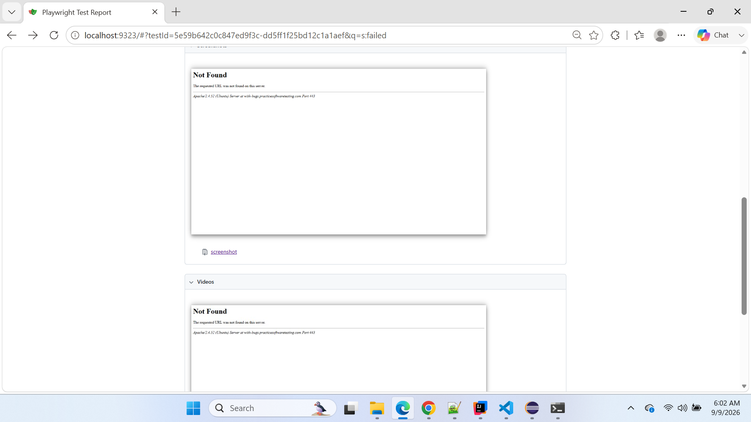

Playwright Test Report

Screenshot Evidence — BUGGY Automation
Attach the Playwright screenshot here.
Suggested caption:
Screenshot 1 — BUGGY Playwright execution: F-UI-01 / AUTH-001 navigated to /auth/login, but the BUGGY server returned an Apache 404 Not Found page. The email field was therefore unavailable and the test timed out waiting for data-test="email".

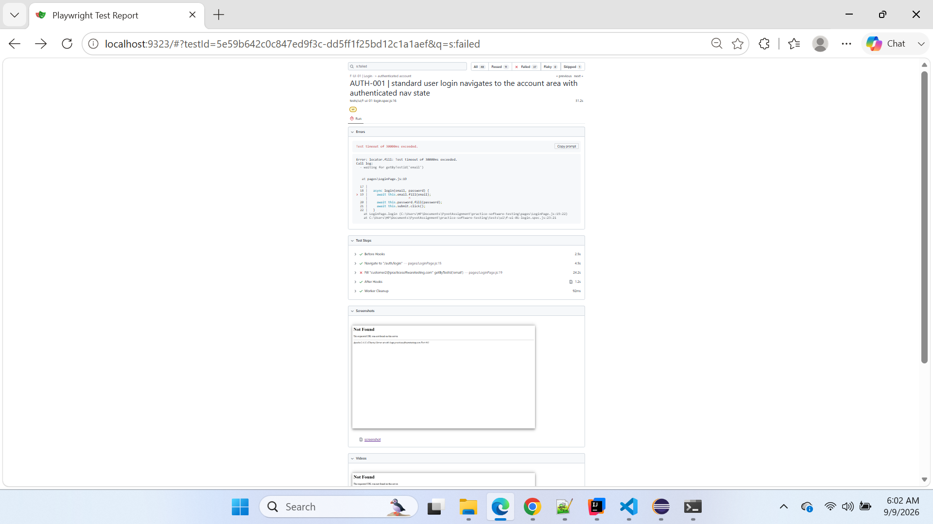

Screenshot Evidence — BUGGY Manual Reproduction
Attach your manual BUGGY screenshot showing:
https://with-bugs.practicesoftwaretesting.com/auth/login
and the Apache 404 page.
Suggested caption:
Screenshot 2 — BUGGY manual verification: Direct navigation to /auth/login reproduces the same Apache 404 outside Playwright, confirming that the automation failure is not caused by the locator.

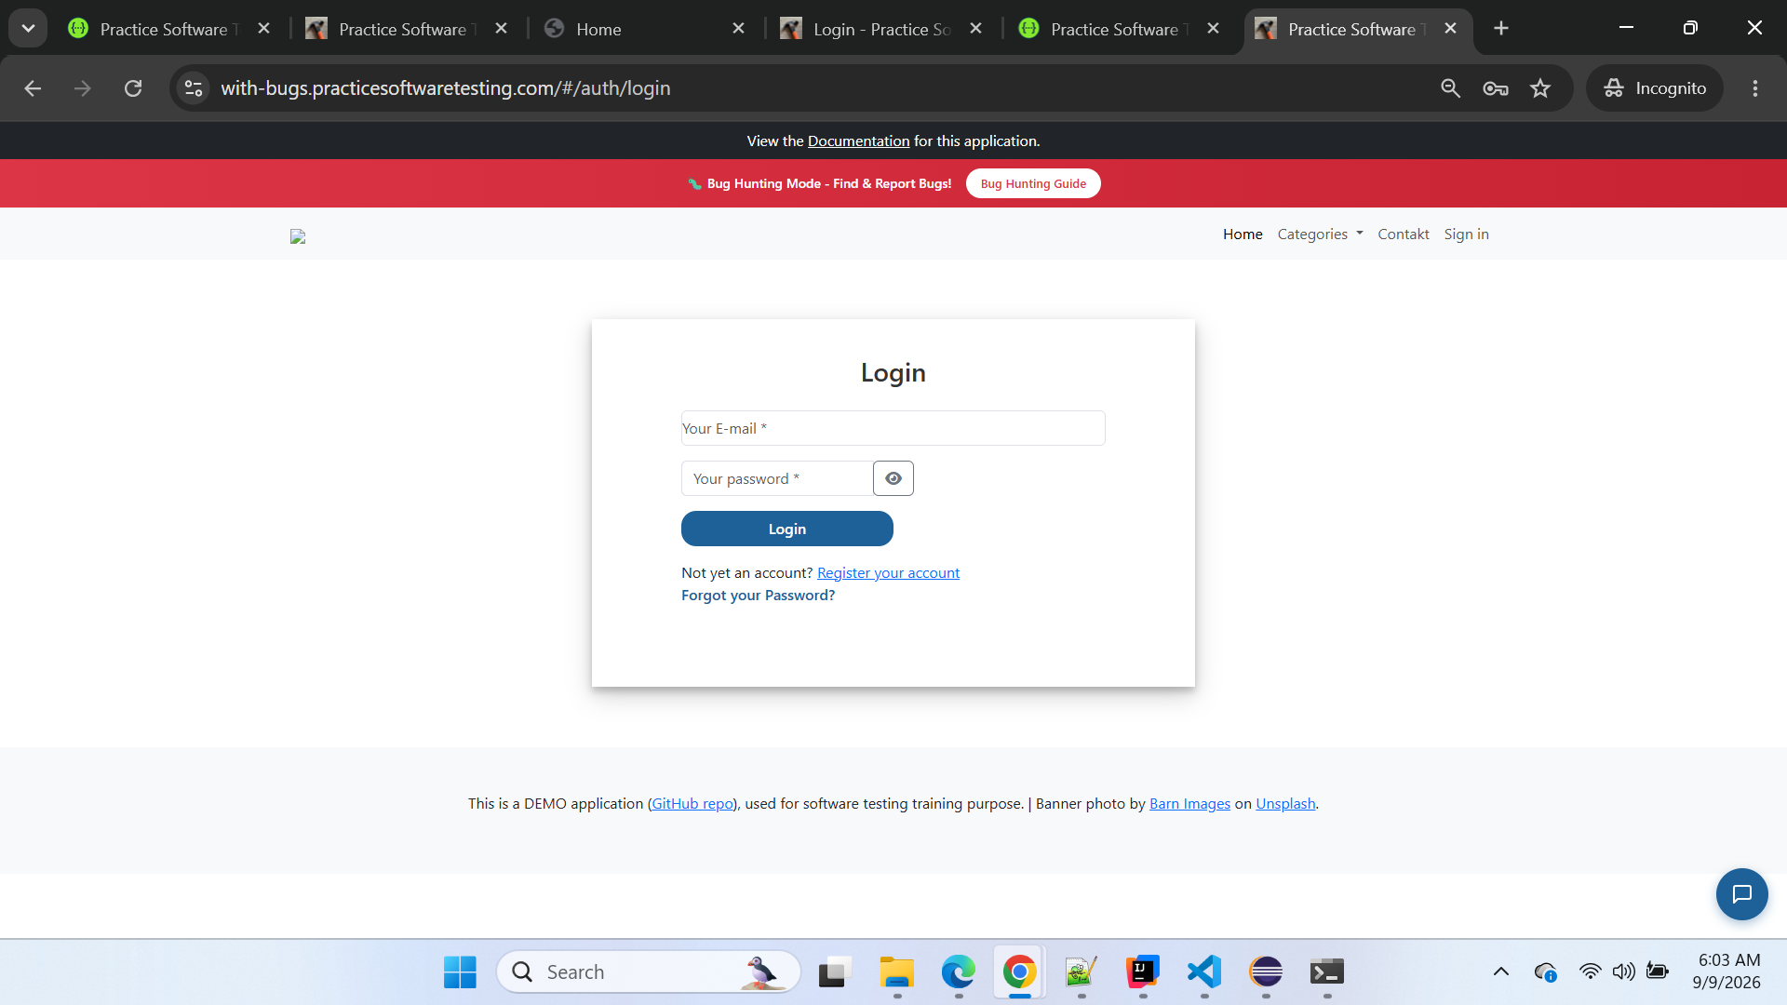

Screenshot Evidence — BUGGY Working Hash Route
Attach your screenshot showing:
https://with-bugs.practicesoftwaretesting.com/#/auth/login
with the Login page visible.
Suggested caption:
Screenshot 3 — BUGGY hash-based navigation: The Login page is available when using /#/auth/login, demonstrating that BUGGY uses a different routing mechanism for the same login functionality.

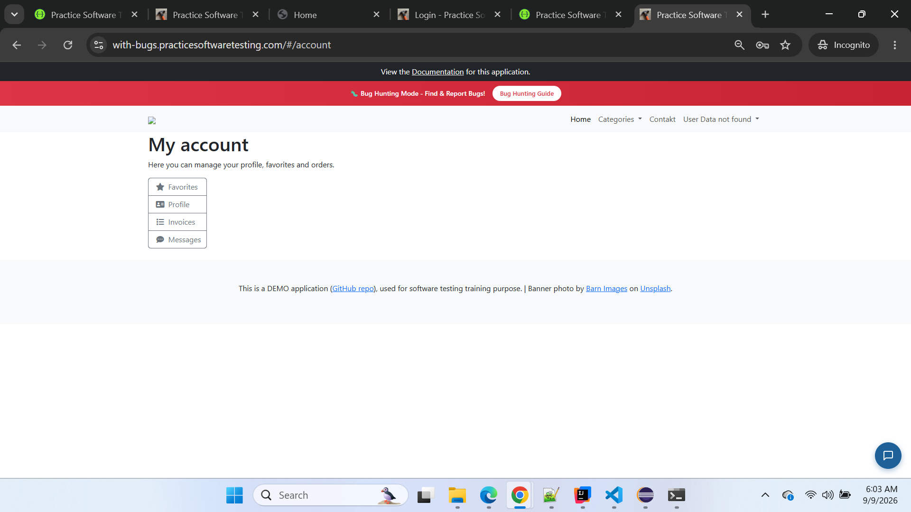

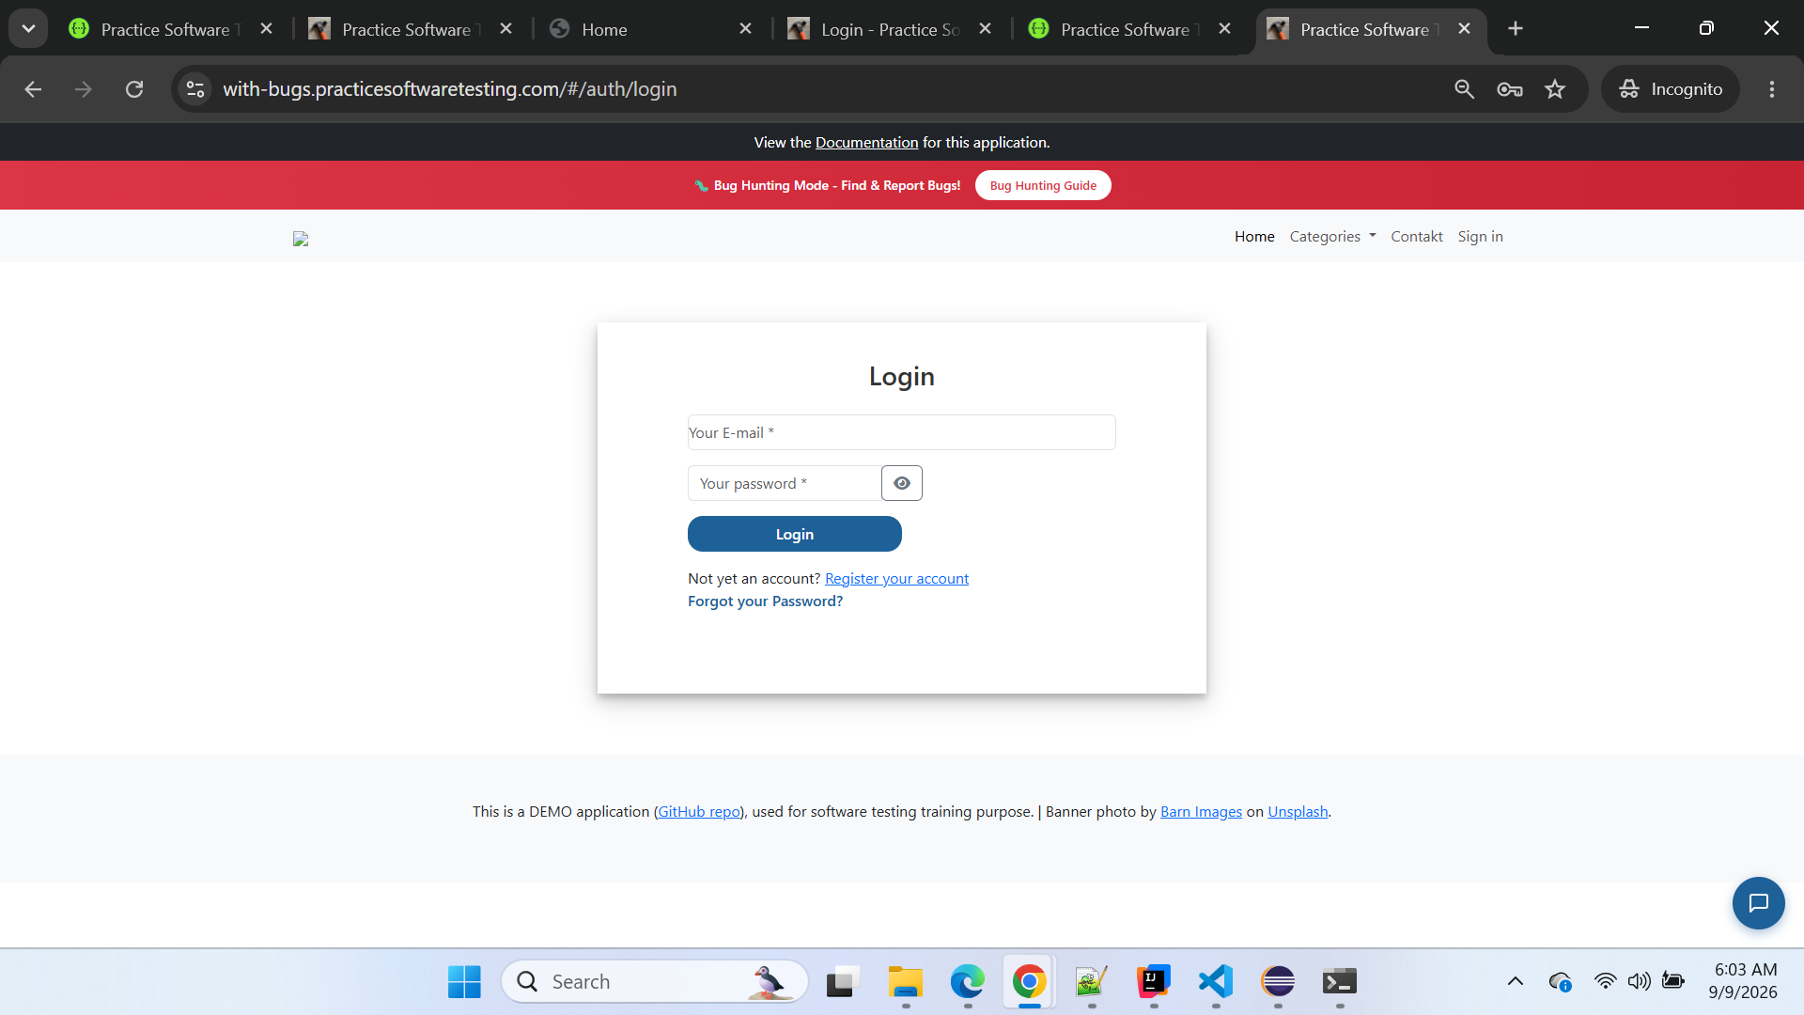

Screenshot Evidence — CLEAN Verification
Attach your CLEAN screenshot showing:
https://practicesoftwaretesting.com/auth/login
with the Login page visible.
Suggested caption:
Screenshot 4 — CLEAN verification: Direct navigation to /auth/login correctly loads the Login page in CLEAN.

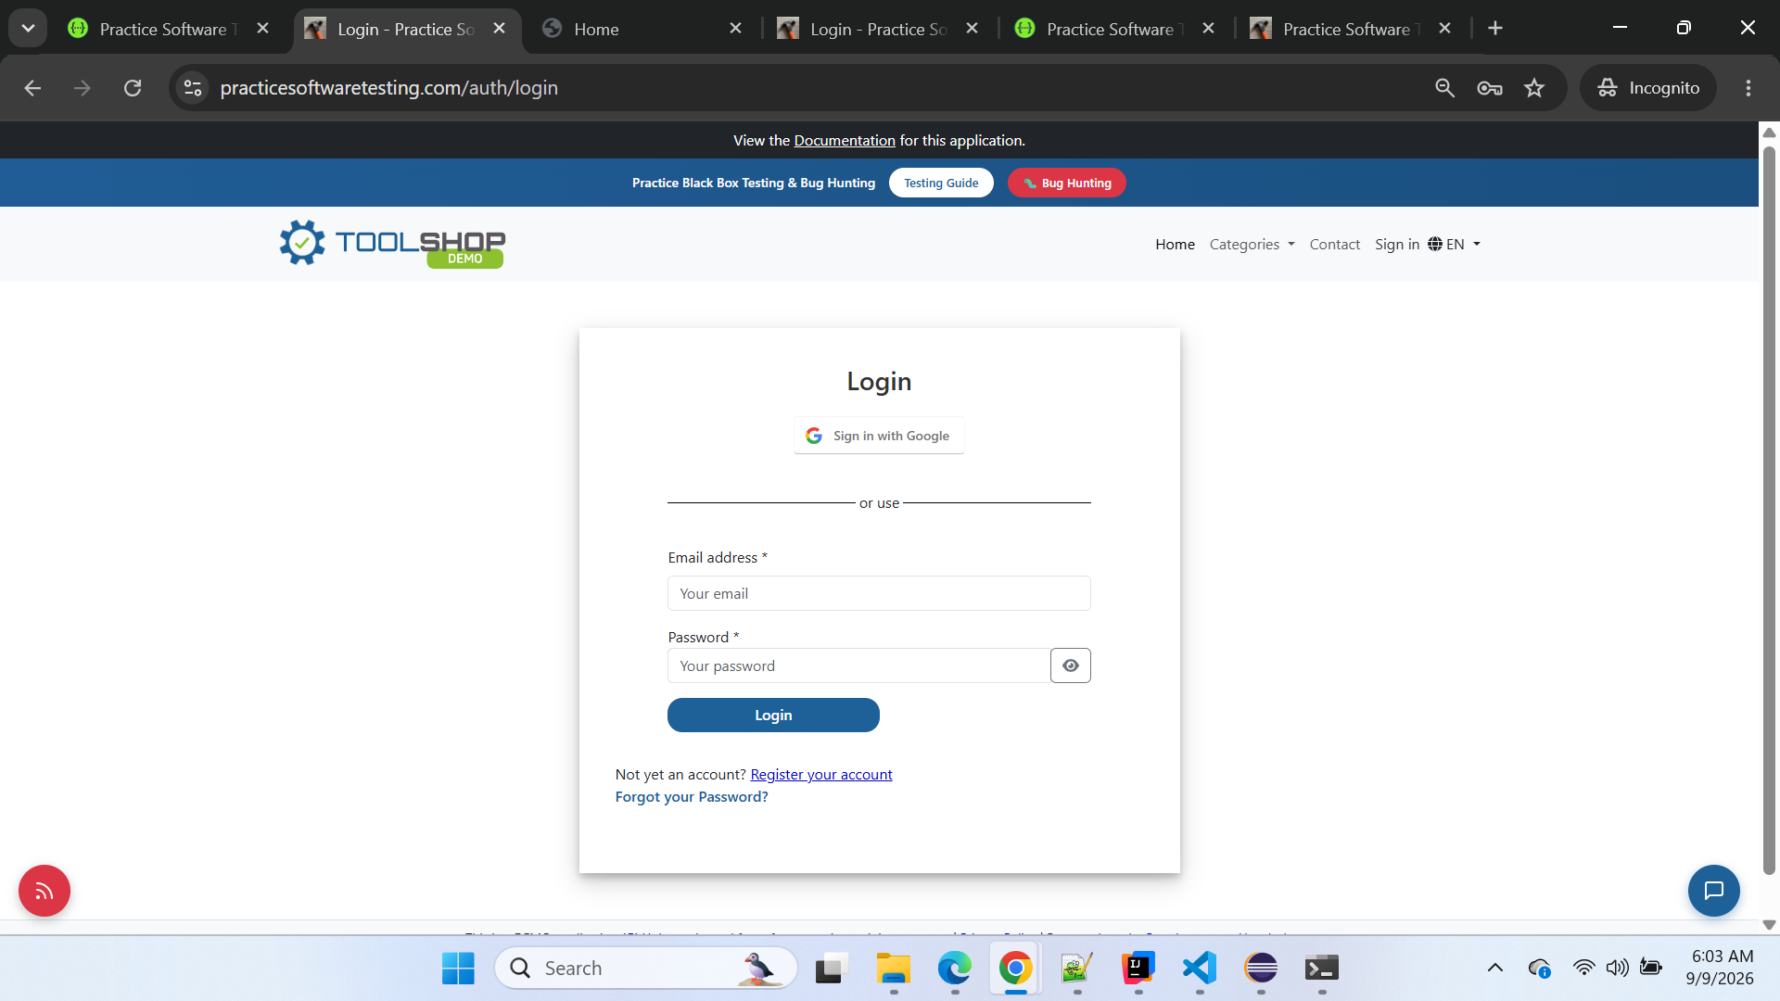

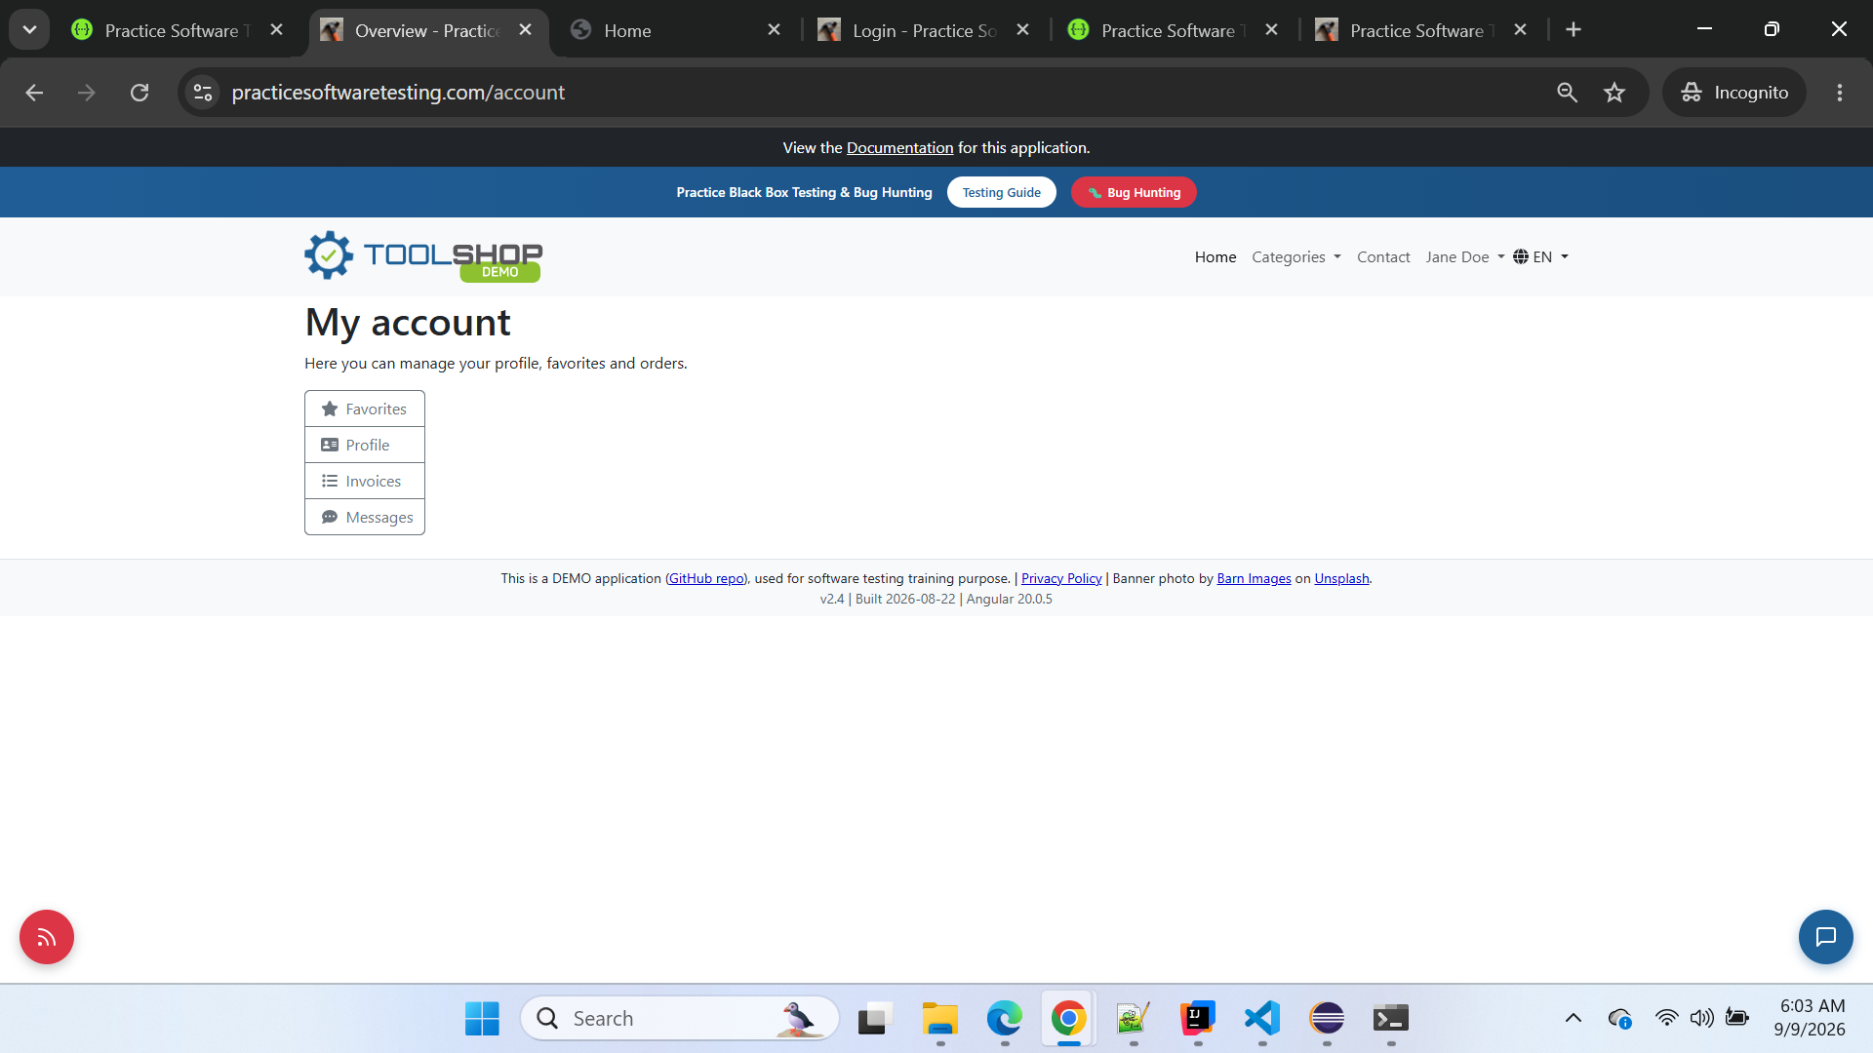

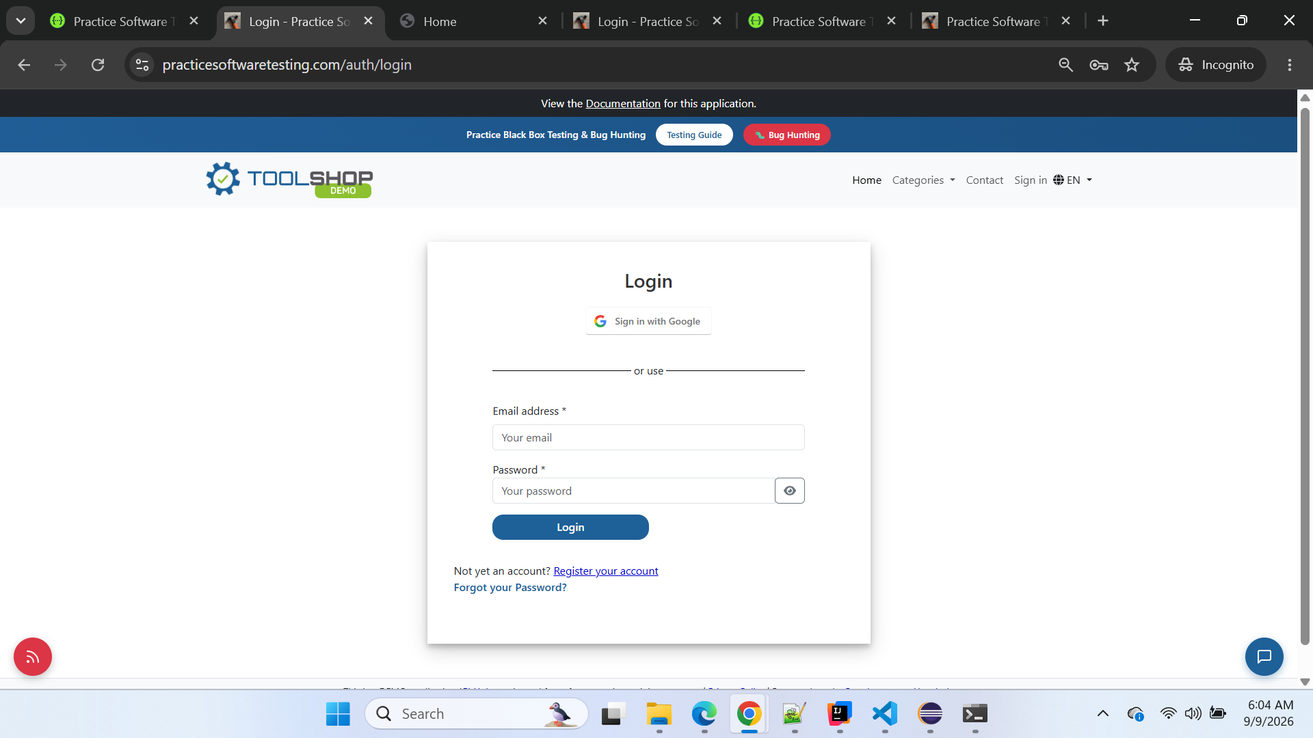

Additional Manual Execution Observation
During manual BUGGY execution:
/#/
→ /#/auth/login
→ /#/account
→ logout
→ /#/auth/login
the hash-based routing flow works.
During the equivalent CLEAN execution:
/
→ /auth/login
→ /account
→ logout
→ /auth/login
standard path-based routing works.
This confirms a behavioral difference in routing between the CLEAN and BUGGY applications.

Impact
Potential impact includes:
- direct login links do not work in BUGGY;
- bookmarks to /auth/login fail;
- deep links from external systems can fail;
- browser refresh/direct navigation behavior differs from CLEAN;
- automated UI tests using standard application routes fail;
- users may receive a raw Apache 404 instead of the application Login page;
- authentication journeys become dependent on entering through the home page/hash router.
This is more than an automation-only issue because the same behavior was manually reproduced in a normal browser.

Automation Handling
Do not increase the timeout:
timeout: 60000
and do not change the email locator merely to make the test pass.
The locator is not the root problem.
For the assignment, preserve the current CLEAN-oracle behavior while documenting the BUGGY routing defect.
If we later choose to make the test portable across both implementations, a user-navigation approach could be used:
async goto() {
// Start from the application entry point.
await this.page.goto('/');

// Follow the visible application navigation instead of assuming router style.
await this.page.getByRole('link', { name: 'Sign in' }).click();

// Confirm that the actual login form rendered.
await this.email.waitFor({ state: 'visible' });
}
But do not make this change before the defect is fully captured, because the current failure is valuable regression evidence.

Root Cause / Failure Classification
Independent defect: Yes
Cascading from BUG-001–BUG-007: No
Business rule reached: No
Automation defect: No — automation exposed the routing regression
Selector defect: No
Timeout defect: No
Manual reproduction: Yes
CLEAN comparison: Yes

Conclusion
BUG-008 is confirmed.
The same direct route was verified in both environments:
CLEAN
https://practicesoftwaretesting.com/auth/login
Result:
Login page loads successfully
BUGGY
https://with-bugs.practicesoftwaretesting.com/auth/login
Result:
404 Not Found
BUGGY only serves the login page through:
/#/auth/login
This directly explains the F-UI-01 / AUTH-001 Playwright failure.

========================================================================

BUG-009 — Direct product-detail URL returns Apache 404 for a valid product in BUGGY
Classification: Confirmed BUGGY Application Defect
Severity: High
Priority: High
Area: UI / Product Detail / Routing
Feature: Product Detail Navigation / Direct URL Routing
Automation Group: F-UI-02 — Browse/Product → Add to Cart
Related Automated Scenario: PROD-009
Environment: BUGGY
Reproducibility: 100% — Manually reproduced and supported by Playwright failure evidence
Business Rule Reached: No
Cascading Failure: No — Independent routing defect
Defect Status: Confirmed

Description
The BUGGY application fails to load a valid Product Detail page when its direct product URL is entered in the browser.
The same valid product ID was tested against CLEAN and BUGGY:
Product ID: 01M21GJK1584HAFASAW4B50NAD
Product: Claw Hammer
In CLEAN, the direct product URL successfully loads the Claw Hammer Product Detail page.
In BUGGY, the equivalent direct product URL returns a raw Apache 404 Not Found page.
This confirms a routing regression in the BUGGY Product Detail flow.

Preconditions
- Chrome browser is available.
- CLEAN and BUGGY applications are accessible.
- Use the confirmed valid product ID:
01M21GJK1584HAFASAW4B50NAD
No authentication is required to view the Product Detail page.

Steps to Reproduce
- Open Chrome.
- Navigate to the CLEAN application.
- Open the Product Detail page for product ID:
01M21GJK1584HAFASAW4B50NAD
- Observe the result.
- Open another browser tab.
- Navigate to the same product route in the BUGGY application using the exact same product ID.
- Observe the result.

Expected Result
The BUGGY application should behave consistently with the CLEAN oracle.
The valid Product Detail route should load the corresponding Claw Hammer Product Detail page, displaying product information and available product actions.

Actual Result
The BUGGY application does not load the Product Detail page.
Instead, the server returns:
Not Found

The requested URL was not found on this server.

Apache/2.4.52 (Ubuntu) Server at with-bugs.practicesoftwaretesting.com Port 443
Therefore, the Product Detail functionality cannot be accessed through the valid direct URL.

CLEAN vs BUGGY Evidence
Validation | CLEAN | BUGGY
Product ID | 01M21GJK1584HAFASAW4B50NAD | 01M21GJK1584HAFASAW4B50NAD
Product | Claw Hammer | Same product ID used
Route | /product/01M21GJK1584HAFASAW4B50NAD | /product/01M21GJK1584HAFASAW4B50NAD
Result | Product Detail page loads | Apache 404 Not Found
Manual reproduction | PASS | FAIL
Defect confirmed | — | Yes

Impact
Users accessing a product through a direct URL, bookmark, shared product link, or deep link cannot reach the Product Detail page in BUGGY.
The issue also affects UI automation that legitimately navigates directly to a dynamically discovered Product Detail URL.
Downstream Product Detail validations cannot execute when this routing failure occurs.

Automation Evidence
During:
F-UI-02 — Browse/Product → Add to Cart
PROD-009 — Out-of-stock, non-rental product disables Add to Cart
and shows the out-of-stock label
Playwright navigated to:
/product/1
The resulting page was an Apache 404 Not Found page.
The subsequent assertion:
await expect(productPage.outOfStockLabel).toBeVisible();
timed out because the Product Detail application page had never loaded.
The routing behavior was then independently reproduced manually using the confirmed valid product ID 01M21GJK1584HAFASAW4B50NAD.
Important: PROD-009's out-of-stock business rule was not reached. Therefore, the missing out-of-stock element must not itself be reported as another defect from this execution.

Manual Reproduction Evidence

Evidence 1 — CLEAN Oracle
URL:
https://practicesoftwaretesting.com/product/01M21GJK1584HAFASAW4B50NAD
Observed:
The Claw Hammer Product Detail page loads successfully with product image, name, price, description, quantity controls, Add to Cart and related product information.
Result: PASS
Attach Screenshot:

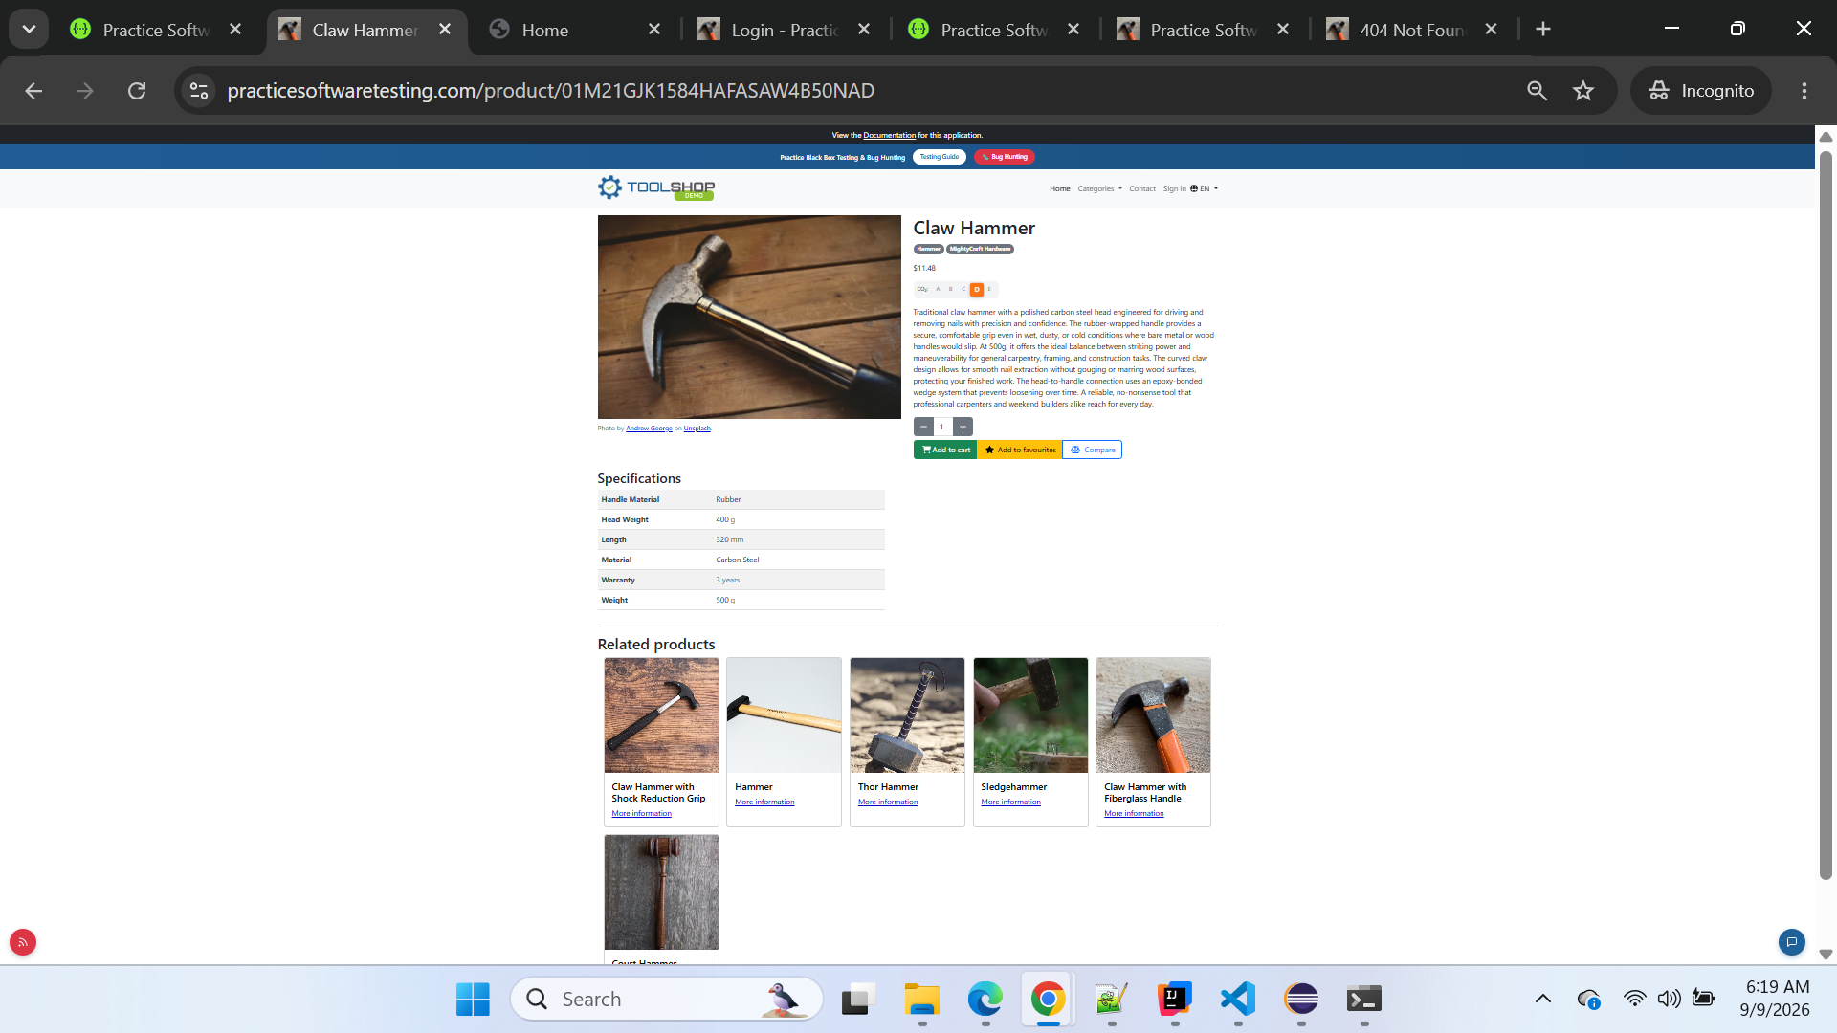

Evidence 2 — BUGGY
URL:
https://with-bugs.practicesoftwaretesting.com/product/01M21GJK1584HAFASAW4B50NAD
Observed:
Product Detail page does not load. Apache returns Not Found.
Result: FAIL
Attach Screenshot:
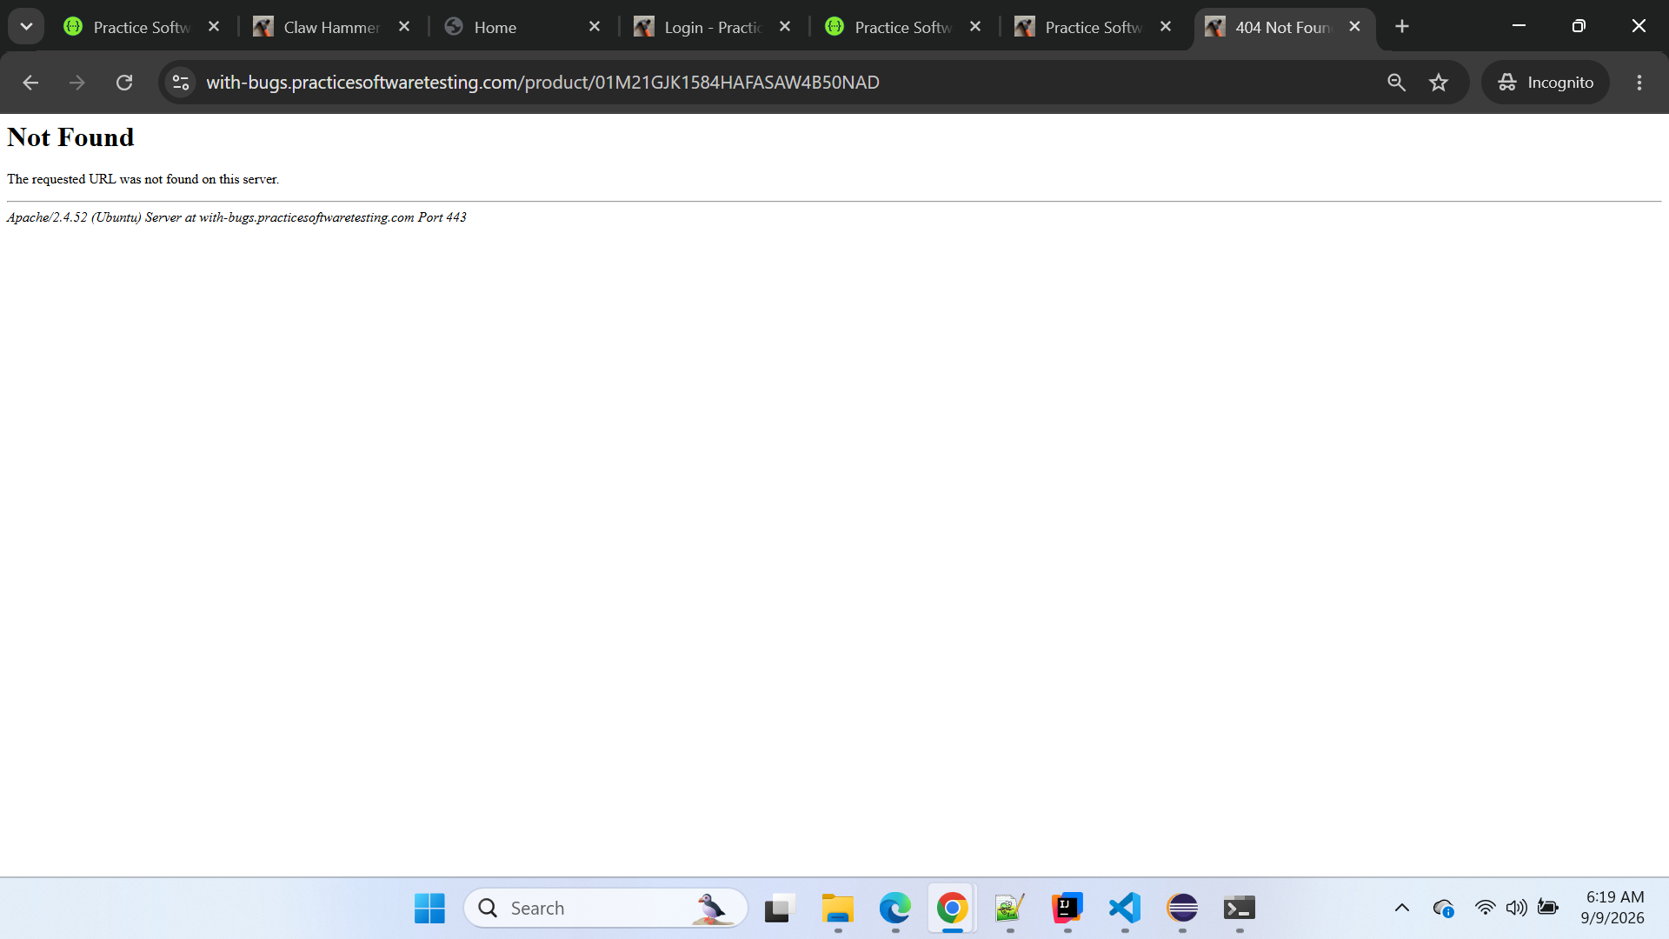

Evidence 3 — Playwright Automation Failure
Playwright report shows navigation to the Product Detail route followed by failure of the Product Detail assertion because the browser is displaying the Apache 404 page.
Attach Screenshot:
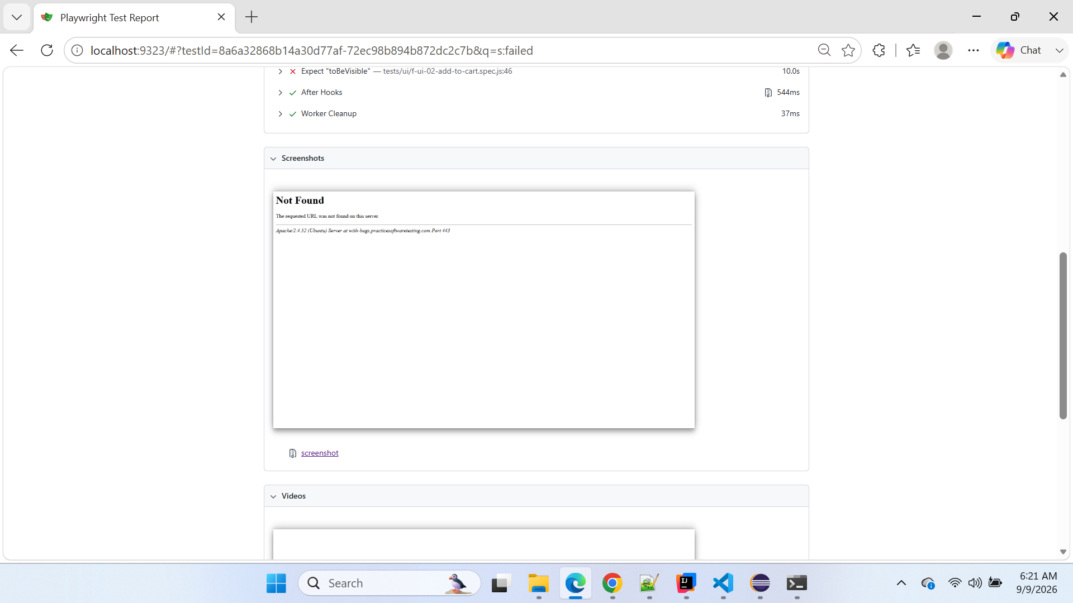
Playwright Test Report

Screenshot Evidence Summary
Screenshot | Evidence | Expected attachment
SS-01 | CLEAN oracle | Claw Hammer Product Detail page loaded successfully
SS-02 | BUGGY manual reproduction | Same product ID returns Apache 404 Not Found
SS-03 | Playwright evidence | PROD-009 execution showing Product Detail navigation resulted in 404

Related Defects / Dependencies
BUG-001 — Product GET API omits in_stock is also relevant to PROD-009 because the test dynamically discovers out-of-stock products using in_stock.
However, BUG-001 and BUG-009 are different defects:
- BUG-001: Product API contract/data defect.
- BUG-009: Product Detail direct-routing defect.
The test should not be modified merely to bypass these BUGGY behaviors, because doing so could hide genuine regressions against the CLEAN oracle.

Conclusion
BUG-009 is confirmed as an independent BUGGY Product Detail routing defect.
The same valid product ID successfully loads its Product Detail page in CLEAN but returns an Apache 404 Not Found response through the corresponding direct URL in BUGGY.
The defect was reproduced manually and is consistent with the failure observed during Playwright execution.

=====================================================================

